Big Data Project 2 Write Up:

*Note: for this project, due to time constraints, we took a subset of 1000 records. This was approved by the professor.

**Question 1/2:**

We decided to merge question 1 and 2 as we discovered that we needed to create a numeric mapping of the elements in order to pairwise plot the data.

First, we loaded the data using the function read.csv, and then assigned the following names to the columns: "age", "workclass", "fnlwgt", "education", "education-num", "marital-status", "occupation","relationship","race","sex","capital-gain","capital-loss","hours-per-week","native-country","income" using the names function.

Next, we created a numeric mapping of every value in order to plot and analyze it. We realized that the following values were alphanumeric, or numeric ASCII strings: age, fnlwgt, education-num, capital-gain, capital loss, hours-per-week. We used the as.numeric function in order to convert these alphanumeric values to numeric values.

We noticed that education was directly correlated to education-num, so we took the column out by running the command [-c(4)], which took the 4th column (education) out of the table.

We also noticed that the attributes workclass, education, marital status, occupation, relationship,

race, sex, income are not alphanumeric, so we converted them to numeric values and made the following value-integer mapping for these attributes:

workclass:

#1 for State-gov

#2 for Self-emp-not-inc

#3 for Private

#4 for Federal-gov

#5 for Local-gov

#6 for Self-emp-inc

#NA for unknown values

marital-status:

#1 for Never-married

#2 for Married-civ-spouse

#3 for Divorced

#4 for Married-spouse-absent

#5 for Separated

#6 for Married-AF-spouse

#7 for Widowed

#NA for unknown values

occupation:

#1 for Adm-clerical

#2 for Exec-managerial

#3 for Handlers-cleaners

#4 for Prof-specialty

#5 for Other-service

#6 for Sales

#7 for Craft-repair

#8 for Transport-moving

#9 for Farming-fishing

#10 for Machine-op-inspect

#11 for Tech-support

#12 for Protective-serv

#13 for Armed-Forces

#14 for Priv-house-serv

#NA for unknown values

relationship:

#1 for Not-in-family

#2 for Husband

#3 for Wife

#4 for Own-child

#5 for Unmarried

#6 for Other-relative

#NA for unknown values

race:

#1 for White

#2 for Black

#3 for Asian-Pac-Islander

#4 for Amer-Indian-Eskimo

#5 for Other

#NA for unknown values

sex:

#1 for Male

#2 for Female

#NA for unknown values

native-country:

#1 for United-States

#2 for Cuba

#3 for Jamaica

#4 for India

#5 for Mexico

#6 for South

#7 for Puerto-Rico

#8 for Honduras

#9 for England

#10 for Canada

#11 for Germany

#12 for Iran

#13 for Philippines

#14 for Italy

#15 for Poland

#16 for Columbia

#17 for Cambodia

#18 for Thailand

#19 for Ecuador

#20 for Laos

#21 for Taiwan

#22 for Haiti

#23 for Portugal

#24 for Dominican-Republic

#25 for El-Salvador

#26 for France

#27 for Guatemala

#28 for China

#NA for unknown values

income:

#1 for <=50K

#2 for >50K

#NA for unknown values

We implemented these mappings through the following commands in R:

* For each attribute, we used the unique command to identify the unique values of each attribute
* For each unique attribute, we ran if statements on each record to check its value and assigned a number based on the mapping above to the attribute
* If the value was unknown, we used the function na_if to convert the unknown to NA so we could remove the record later on

After we had all the attributes as numeric values, we removed rows with NA values by using the na.omit function. We then pairwise plotted every attribute against every other using the plot function.

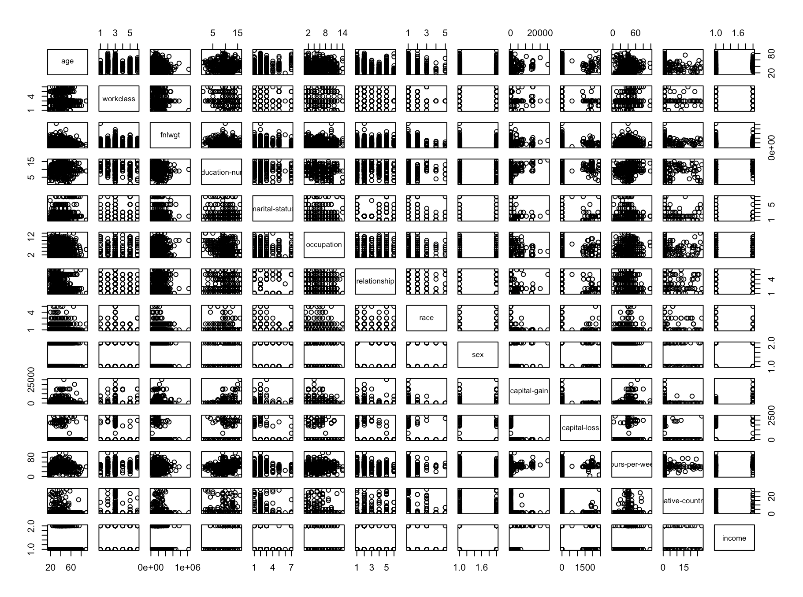

We also ran 3D plots amongst income, education, age, occupation, and relationship using the scatterplot3d function. 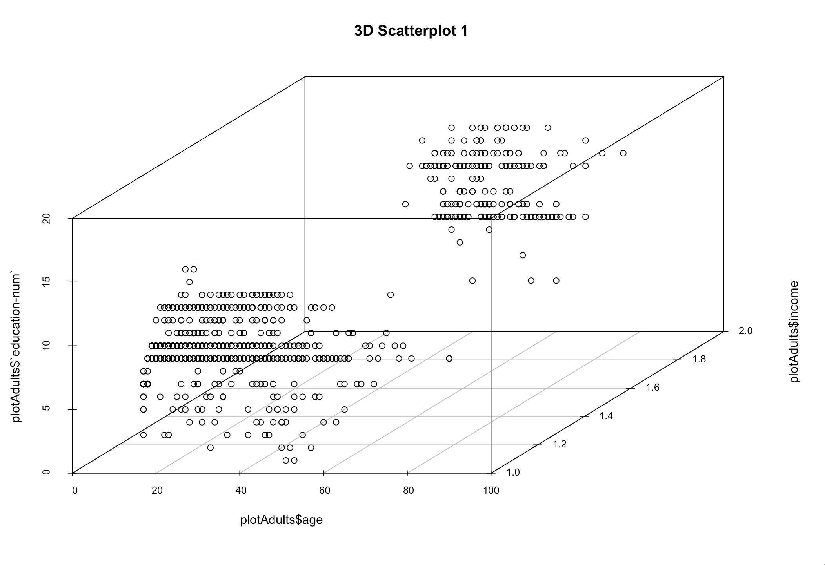

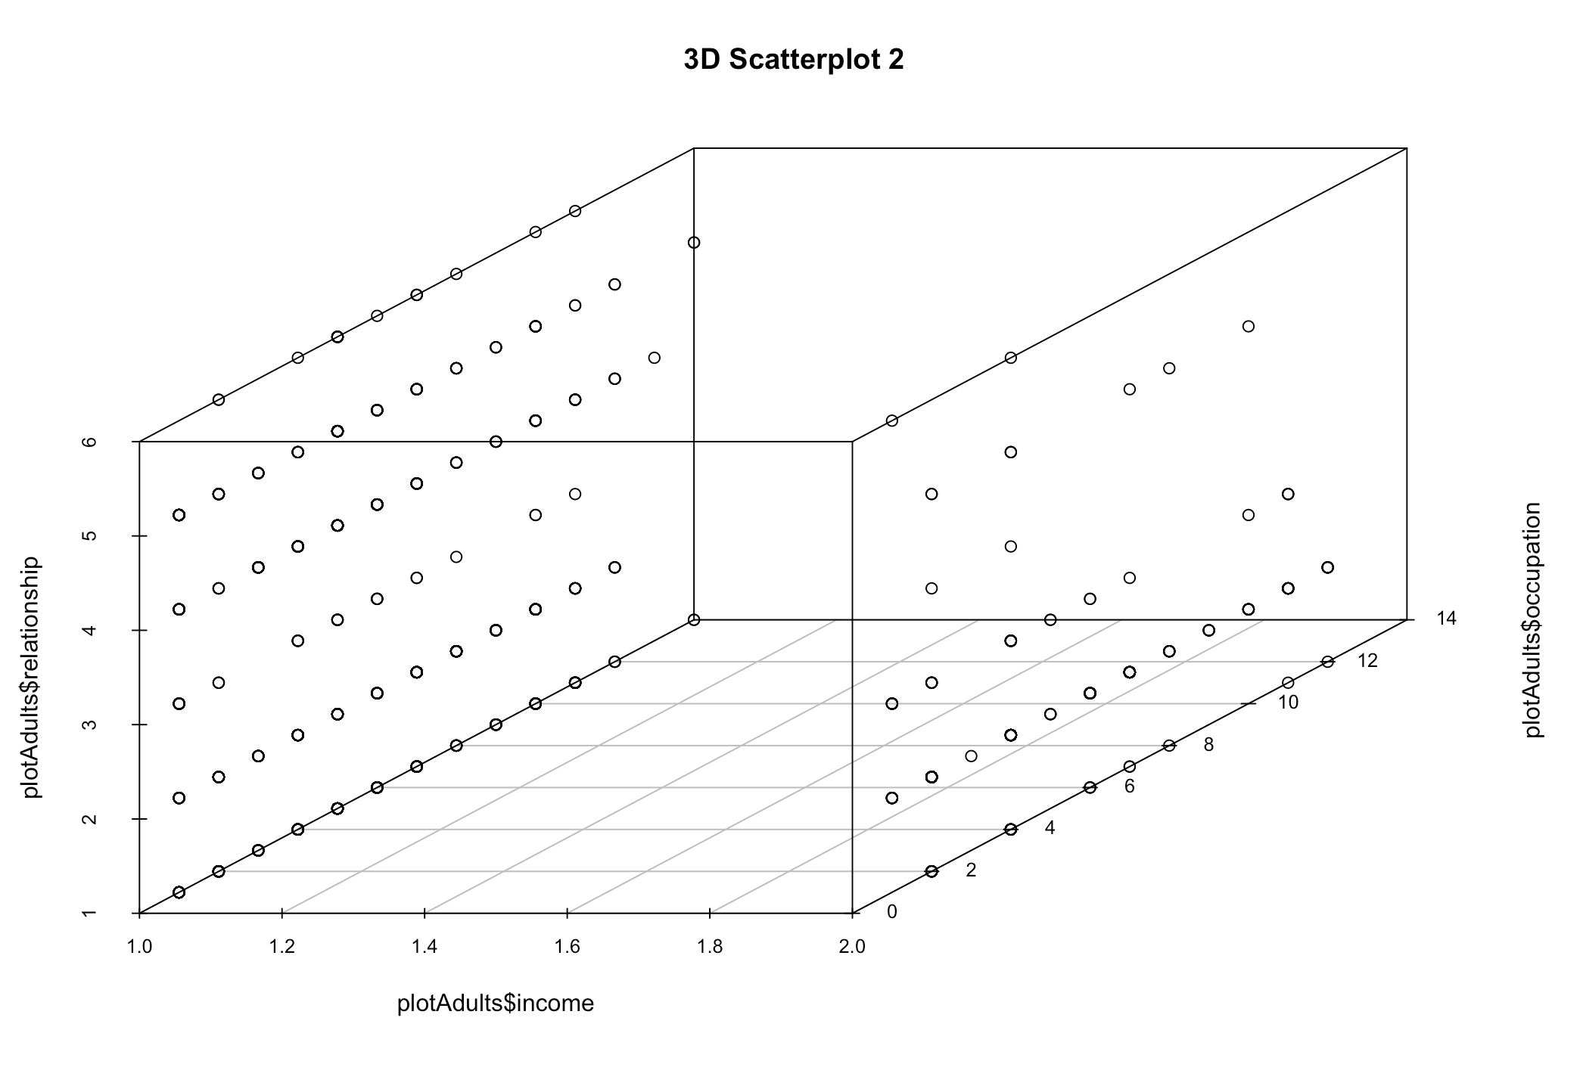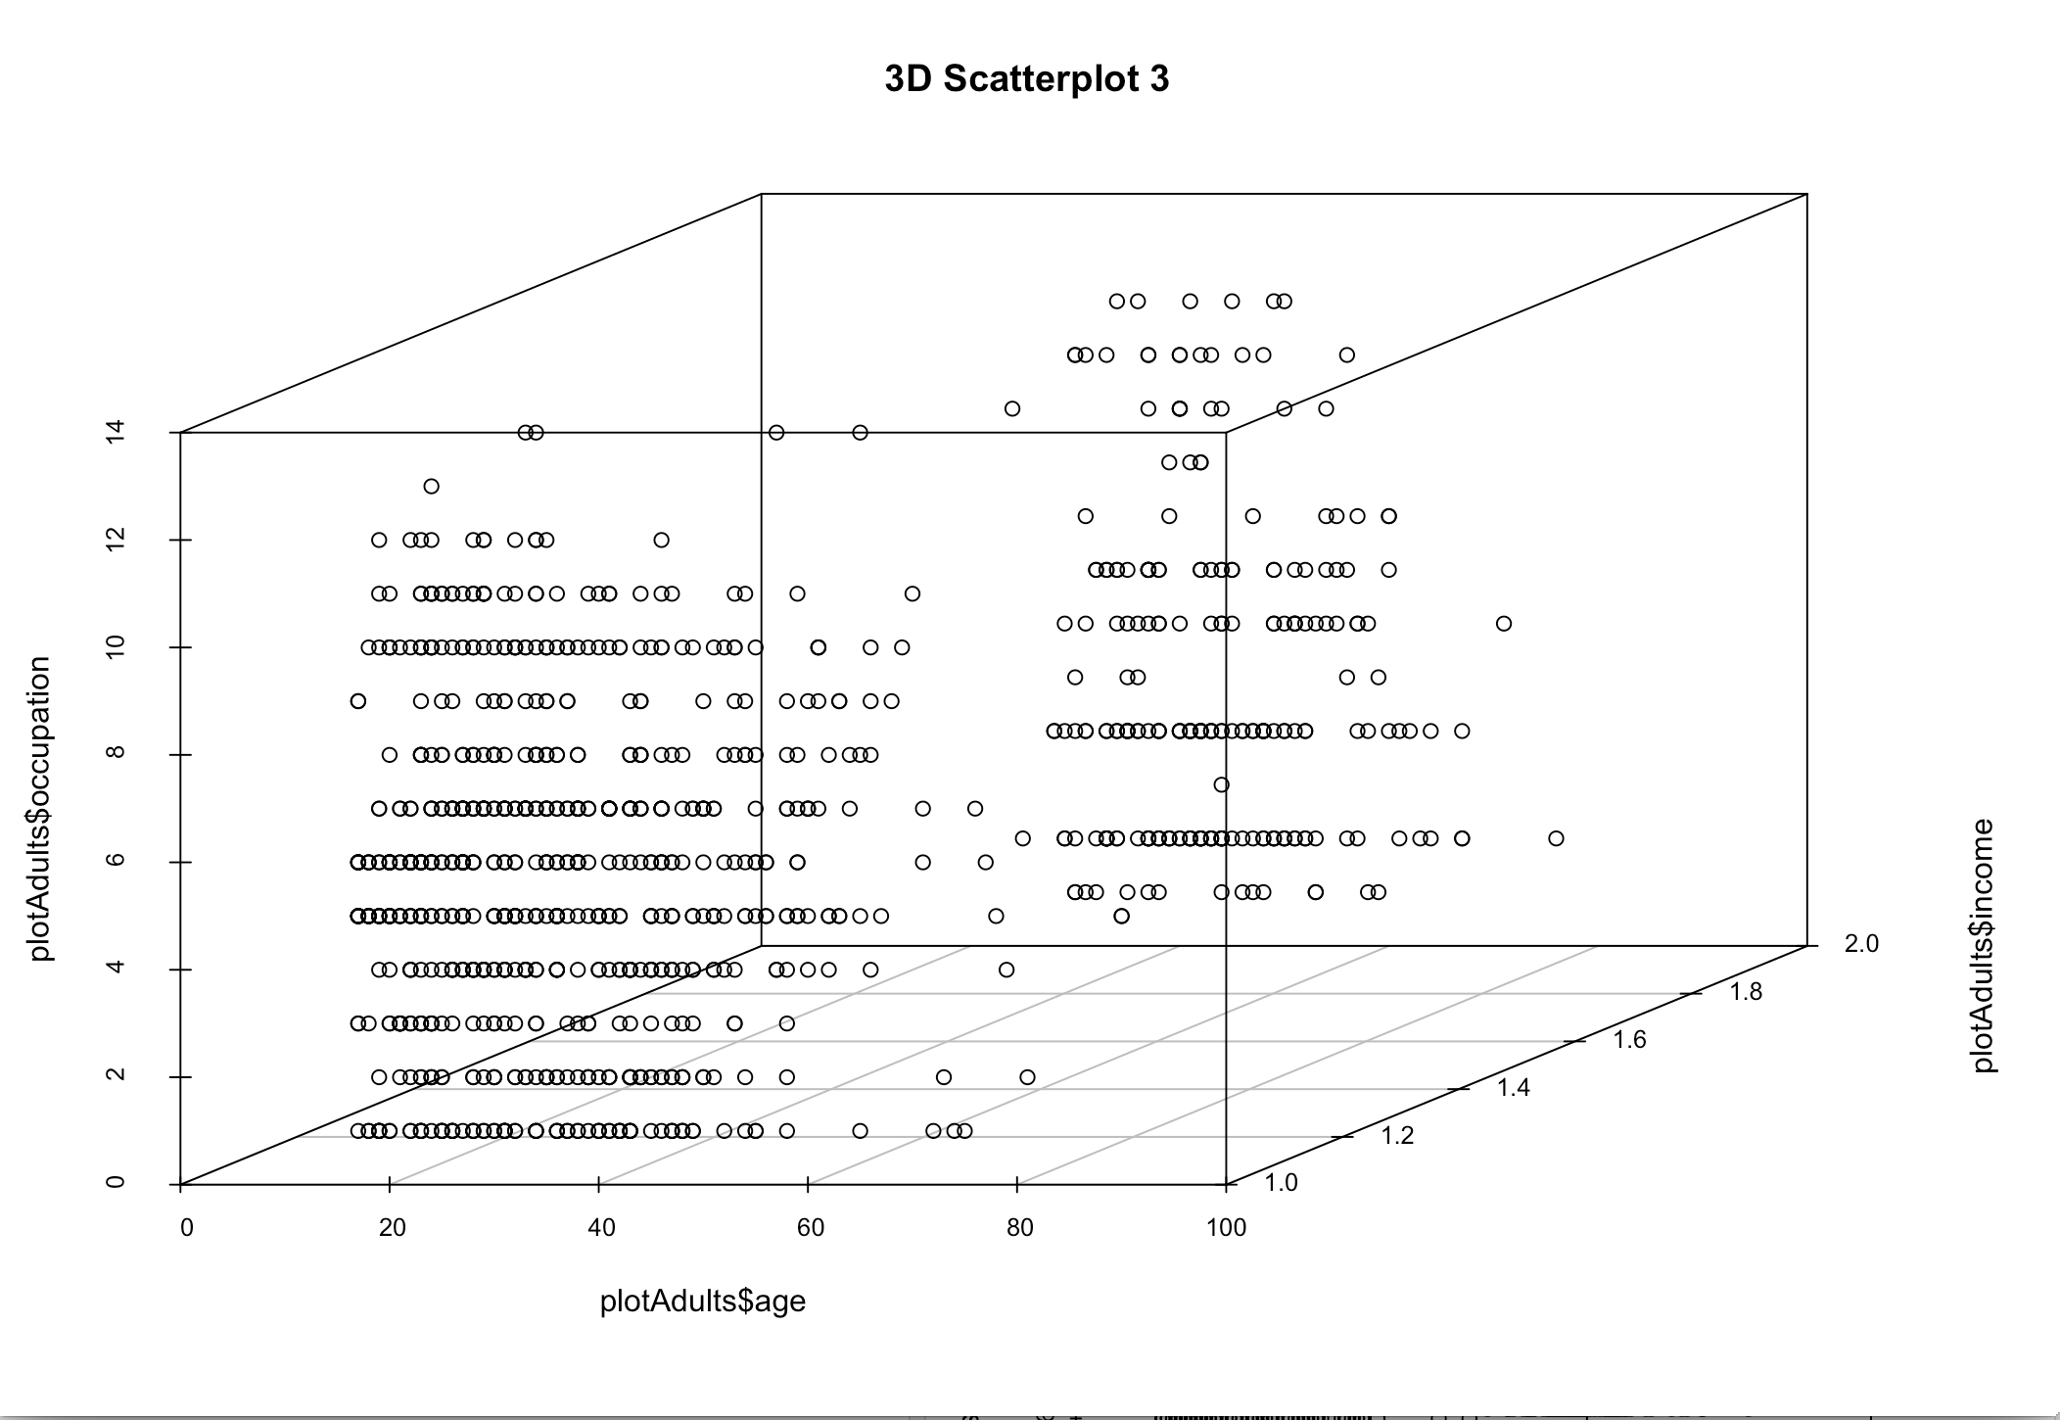

While we could not see much of a correlation amongst the variables, we seemed to see somewhat of a correlation between education level and capital gain, as well as hours-per-week and capital gain. We also seemed to notice that whites from the United States seemed to earn a higher capital gain and income, which we explored further in question 4.

We also investigated statistics of the data by running the describe function. Our results were as follows:

vars n mean sd median trimmed mad min max range

age 1 1000 37.91 12.89 36.5 37.07 14.08 17 90 73

workclass 2 1000 3.11 0.92 3.0 3.01 0.00 1 6 5

fnlwgt 3 1000 192158.67 107974.77 180892.0 182758.45 97454.26 21174 1033222 1012048

education-num 4 1000 10.20 2.50 10.0 10.29 1.48 1 16 15

marital-status 5 1000 2.06 1.23 2.0 1.84 1.48 1 7 6

occupation 6 1000 5.47 3.02 5.0 5.34 2.97 1 14 13

relationship 7 1000 2.46 1.40 2.0 2.30 1.48 1 6 5

race 8 1000 1.20 0.56 1.0 1.05 0.00 1 5 4

sex 9 1000 1.32 0.47 1.0 1.28 0.00 1 2 1

capital-gain 10 1000 567.72 2432.13 0.0 0.00 0.00 0 25236 25236

capital-loss 11 1000 102.53 431.96 0.0 0.00 0.00 0 2415 2415

hours-per-week 12 1000 40.69 11.80 40.0 40.77 2.97 1 99 98

native-country 13 1000 1.86 3.60 1.0 1.00 0.00 1 28 27

income 14 1000 1.24 0.43 1.0 1.18 0.00 1 2 1

skew kurtosis se

age 0.61 0.20 0.41

workclass 1.09 2.80 0.03

fnlwgt 1.40 5.09 3414.46

education-num -0.30 0.79 0.08

marital-status 2.16 5.72 0.04

occupation 0.35 -0.63 0.10

relationship 0.80 -0.52 0.04

race 3.71 16.47 0.02

sex 0.76 -1.43 0.01

capital-gain 5.37 32.29 76.91

capital-loss 4.08 15.11 13.66

hours-per-week 0.17 2.53 0.37

native-country 4.97 25.65 0.11

income 1.19 -0.58 0.01

**Question 3:**

To analyze the information we had to normalize everything within our dataset. After we used a subset of information in order to get accurate results for our cluster. We used a subset of about 1000 entries for analysis by running the command [1:1000,]. The normalization process helped limit redundancy and contributed to the efficiency of clustering plots. The function used in the image below. It applied to the attributes within the data set and then used within the data



Using kmeans, knn, and iClust on k values from 2 to 10 we were able to get an intuition on attributes that are related to each other based on the clusters. To calculate kmeans we used the kmeans function which clustered on a matrix. We had to specify the k value each time. The factoextra function was used to have a visual representation of the clustering. For knn we had to divide up the data to get a test and a training set of data. That was determined by a simple mathematical equation. To get the knn clustering we used the knn function on the test data set.

For example when analyzing clusters using the k-means algorithm, for 2 clusters being created sex was the determing factor in creating these cluster groups. Looking at the first 14 people within the dataset, everyone in cluster 2 has a sex value of 1 illustrating that they are all within the same group. This was the defining attribute for this cluster set.

Age WrkClass fnlwgt edu-num marital occupation relationship race sex C. gain C. loss hours/wk native

|  |  |  |  |  |  |  |  |  |  |  |  |  |  |
| --- | --- | --- | --- | --- | --- | --- | --- | --- | --- | --- | --- | --- | --- |
| **1** | 39 | 1 | 77516 | 13 | 1 | 1 | 1 | 1 | 1 | 2174 | 0 | 40 | 1 |
| **2** | 50 | 2 | 83311 | 13 | 2 | 2 | 2 | 1 | 1 | 0 | 0 | 13 | 1 |
| **3** | 38 | 3 | 215646 | 9 | 3 | 3 | 1 | 1 | 1 | 0 | 0 | 40 | 1 |
| **4** | 53 | 3 | 234721 | 7 | 2 | 3 | 2 | 2 | 1 | 0 | 0 | 40 | 1 |
| **5** | 28 | 3 | 338409 | 13 | 2 | 4 | 3 | 2 | 2 | 0 | 0 | 40 | 2 |
| **6** | 37 | 3 | 284582 | 14 | 2 | 2 | 3 | 1 | 2 | 0 | 0 | 40 | 1 |
| **7** | 49 | 3 | 160187 | 5 | 4 | 5 | 1 | 2 | 2 | 0 | 0 | 16 | 3 |
| **8** | 52 | 2 | 209642 | 9 | 2 | 2 | 2 | 1 | 1 | 0 | 0 | 45 | 1 |
| **9** | 31 | 3 | 45781 | 14 | 1 | 4 | 1 | 1 | 2 | 14084 | 0 | 50 | 1 |
| **10** | 42 | 3 | 159449 | 13 | 2 | 2 | 2 | 1 | 1 | 5178 | 0 | 40 | 1 |
| **11** | 37 | 3 | 280464 | 10 | 2 | 2 | 2 | 2 | 1 | 0 | 0 | 80 | 1 |
| **12** | 30 | 1 | 141297 | 13 | 2 | 4 | 2 | 3 | 1 | 0 | 0 | 40 | 4 |
| **13** | 23 | 3 | 122272 | 13 | 1 | 1 | 4 | 1 | 2 | 0 | 0 | 30 | 1 |
| **14** | 32 | 3 | 205019 | 12 | 1 | 6 | 1 | 2 | 1 | 0 | 0 | 50 | 1 |

The table above is the first 14 people of the data set. The list below is the correlated cluster grouping to the data set.

Cluster Set: 1 1 1 1 2 2 2 1 2 1 1 1 2 1

Data Set: 1 2 3 4 5 6 7 8 9 10 11 12 13 14

All the 2 in the cluster set matches all the sex values of 1. That in fact is the only attribute that defines this clustering algorithm.

For k means clustering when the k value is 3, we noticed the attributes race, sex, capital loss, and native country were all similar in the following data set. (1, 60, 119)

1:

|  |  |  |  |  |  |  |  |  |  |  |  |  |
| --- | --- | --- | --- | --- | --- | --- | --- | --- | --- | --- | --- | --- |
| 39 | 1 | 77516 | 13 | 1 | 1 | 1 | 1 | 1 | 2174 | 0 | 40 | 1 |

60:

|  |  |  |  |  |  |  |  |  |  |  |  |  |
| --- | --- | --- | --- | --- | --- | --- | --- | --- | --- | --- | --- | --- |
| 30 | 3 | 188146 | 9 | 2 | 10 | 2 | 1 | 1 | 5013 | 0 | 40 | 1 |

119:

|  |  |  |  |  |  |  |  |  |  |  |  |  |
| --- | --- | --- | --- | --- | --- | --- | --- | --- | --- | --- | --- | --- |
| 55 | 3 | 247552 | 10 | 2 | 6 | 2 | 1 | 1 | 0 | 0 | 56 | 1 |

For k means clustering when the k value is 4, I noticed the attributes sex, capital gain and capital loss were all similar in the following data set. (16, 65, 116) Indicating why they’re in the same clustering group.

16:

|  |  |  |  |  |  |  |  |  |  |  |  |  |
| --- | --- | --- | --- | --- | --- | --- | --- | --- | --- | --- | --- | --- |
| 34 | 3 | 245487 | 4 | 2 | 8 | 2 | 4 | 1 | 0 | 0 | 45 | 5 |

65:

|  |  |  |  |  |  |  |  |  |  |  |  |  |
| --- | --- | --- | --- | --- | --- | --- | --- | --- | --- | --- | --- | --- |
| 29 | 3 | 105598 | 10 | 3 | 11 | 1 | 1 | 1 | 0 | 0 | 58 | 1 |

116:

|  |  |  |  |  |  |  |  |  |  |  |  |  |
| --- | --- | --- | --- | --- | --- | --- | --- | --- | --- | --- | --- | --- |
| 53 | 3 | 95647 | 5 | 2 | 3 | 2 | 1 | 1 | 0 | 0 | 50 | 1 |

For k means clustering when the k value is 5, I noticed the attributes race, sex, capital loss, native country were all similar in cluster group 5 in the following data set indicating why they are in the same cluster group.

60:

|  |  |  |  |  |  |  |  |  |  |  |  |  |
| --- | --- | --- | --- | --- | --- | --- | --- | --- | --- | --- | --- | --- |
| 30 | 3 | 188146 | 9 | 2 | 10 | 2 | 1 | 1 | 5013 | 0 | 40 | 1 |

120:

|  |  |  |  |  |  |  |  |  |  |  |  |  |
| --- | --- | --- | --- | --- | --- | --- | --- | --- | --- | --- | --- | --- |
| 22 | 3 | 102632 | 9 | 1 | 7 | 1 | 1 | 1 | 0 | 0 | 41 | 1 |

180:

|  |  |  |  |  |  |  |  |  |  |  |  |  |
| --- | --- | --- | --- | --- | --- | --- | --- | --- | --- | --- | --- | --- |
| 33 | 3 | 37274 | 13 | 2 | 4 | 2 | 1 | 1 | 0 | 0 | 65 | 1 |

For k means clustering when the k value is 6, I noticed the attributes sex, capital loss, and native country are similar in cluster 2 for the following data set which may explain why they are in the same cluster group.

60:

|  |  |  |  |  |  |  |  |  |  |  |  |  |
| --- | --- | --- | --- | --- | --- | --- | --- | --- | --- | --- | --- | --- |
| 30 | 3 | 188146 | 9 | 2 | 10 | 2 | 1 | 1 | 5013 | 0 | 40 | 1 |

120:

|  |  |  |  |  |  |  |  |  |  |  |  |  |
| --- | --- | --- | --- | --- | --- | --- | --- | --- | --- | --- | --- | --- |
| 22 | 3 | 102632 | 9 | 1 | 7 | 1 | 1 | 1 | 0 | 0 | 41 | 1 |

178:

|  |  |  |  |  |  |  |  |  |  |  |  |  |
| --- | --- | --- | --- | --- | --- | --- | --- | --- | --- | --- | --- | --- |
| 34 | 3 | 483777 | 9 | 1 | 3 | 1 | 2 | 1 | 0 | 0 | 40 | 1 |

For k means clustering when the k value is 7, I noticed the attributes race, sex, capital loss, and native country are similar in cluster 3 for the following data set which may explain why they are in the same cluster group.

1:

|  |  |  |  |  |  |  |  |  |  |  |  |  |
| --- | --- | --- | --- | --- | --- | --- | --- | --- | --- | --- | --- | --- |
| 39 | 1 | 77516 | 13 | 1 | 1 | 1 | 1 | 1 | 2174 | 0 | 40 | 1 |

63:

|  |  |  |  |  |  |  |  |  |  |  |  |  |
| --- | --- | --- | --- | --- | --- | --- | --- | --- | --- | --- | --- | --- |
| 48 | 3 | 149640 | 9 | 2 | 8 | 2 | 1 | 1 | 0 | 0 | 40 | 1 |

119:

|  |  |  |  |  |  |  |  |  |  |  |  |  |
| --- | --- | --- | --- | --- | --- | --- | --- | --- | --- | --- | --- | --- |
| 55 | 3 | 247552 | 10 | 2 | 6 | 2 | 1 | 1 | 0 | 0 | 56 | 1 |

For k means clustering when the k value is 8, I noticed the attributes sex, capital loss and native country were cimilar in cluster 6 for the following data set which may explain why they are in the same cluster group.

1:

|  |  |  |  |  |  |  |  |  |  |  |  |  |
| --- | --- | --- | --- | --- | --- | --- | --- | --- | --- | --- | --- | --- |
| 39 | 1 | 77516 | 13 | 1 | 1 | 1 | 1 | 1 | 2174 | 0 | 40 | 1 |

67:

|  |  |  |  |  |  |  |  |  |  |  |  |  |
| --- | --- | --- | --- | --- | --- | --- | --- | --- | --- | --- | --- | --- |
| 28 | 3 | 183175 | 10 | 3 | 1 | 1 | 1 | 2 | 0 | 0 | 40 | 1 |

119:

|  |  |  |  |  |  |  |  |  |  |  |  |  |
| --- | --- | --- | --- | --- | --- | --- | --- | --- | --- | --- | --- | --- |
| 55 | 3 | 247552 | 10 | 2 | 6 | 2 | 1 | 1 | 0 | 0 | 56 | 1 |

For k means clustering when the k value is 9, the attributes race, sex, capital loss, and native country were similar in cluster 2 for the following data set which may explain why they are in the same cluster group.

65:

|  |  |  |  |  |  |  |  |  |  |  |  |  |
| --- | --- | --- | --- | --- | --- | --- | --- | --- | --- | --- | --- | --- |
| 29 | 3 | 105598 | 10 | 3 | 11 | 1 | 1 | 1 | 0 | 0 | 58 | 1 |

69:

|  |  |  |  |  |  |  |  |  |  |  |  |  |
| --- | --- | --- | --- | --- | --- | --- | --- | --- | --- | --- | --- | --- |
| 49 | 6 | 191681 | 10 | 2 | 2 | 2 | 1 | 1 | 0 | 0 | 50 | 1 |

133:

|  |  |  |  |  |  |  |  |  |  |  |  |  |
| --- | --- | --- | --- | --- | --- | --- | --- | --- | --- | --- | --- | --- |
| 38 | 2 | 120985 | 9 | 2 | 7 | 2 | 1 | 1 | 4386 | 0 | 35 | 1 |

For k means clustering when the k value is 10, I noticed the attributes sex, capital gain, capital loss, native country were all similar for the following data and that may explain why there are all in the same cluster group (7).

87:

|  |  |  |  |  |  |  |  |  |  |  |  |  |
| --- | --- | --- | --- | --- | --- | --- | --- | --- | --- | --- | --- | --- |
| 49 | 5 | 268234 | 9 | 2 | 12 | 2 | 1 | 1 | 0 | 0 | 40 | 1 |

131:

|  |  |  |  |  |  |  |  |  |  |  |  |  |
| --- | --- | --- | --- | --- | --- | --- | --- | --- | --- | --- | --- | --- |
| 28 | 3 | 69621 | 12 | 1 | 6 | 1 | 1 | 2 | 0 | 0 | 60 | 1 |

261:

|  |  |  |  |  |  |  |  |  |  |  |  |  |
| --- | --- | --- | --- | --- | --- | --- | --- | --- | --- | --- | --- | --- |
| 36 | 3 | 150042 | 13 | 3 | 4 | 4 | 1 | 2 | 0 | 0 | 40 | 1 |

K-Means:

k = 2:

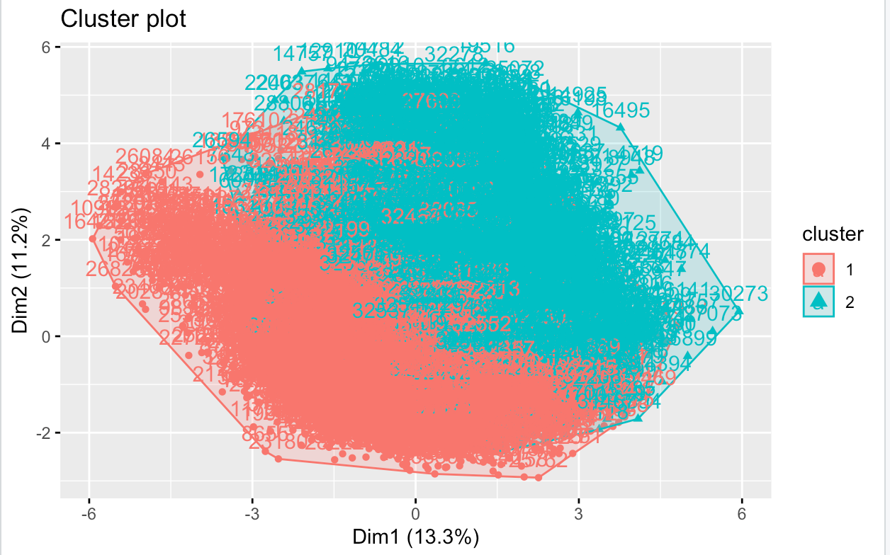

k = 3:

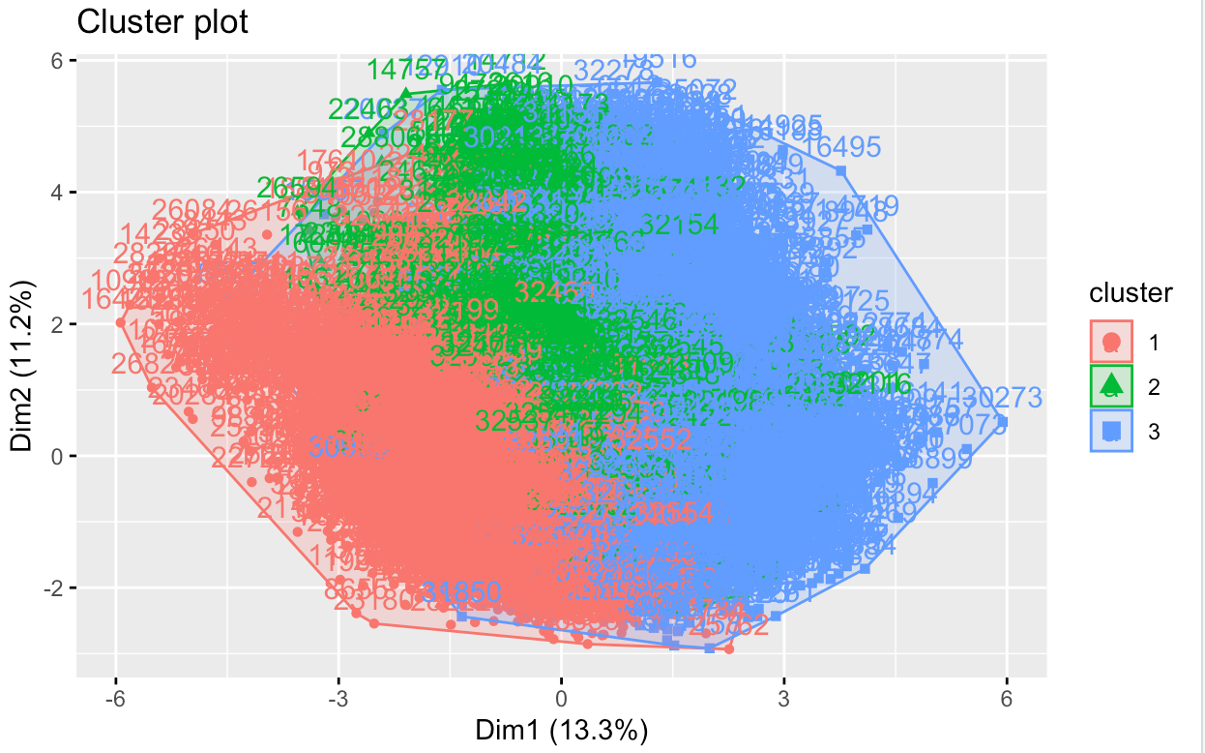

k = 4:

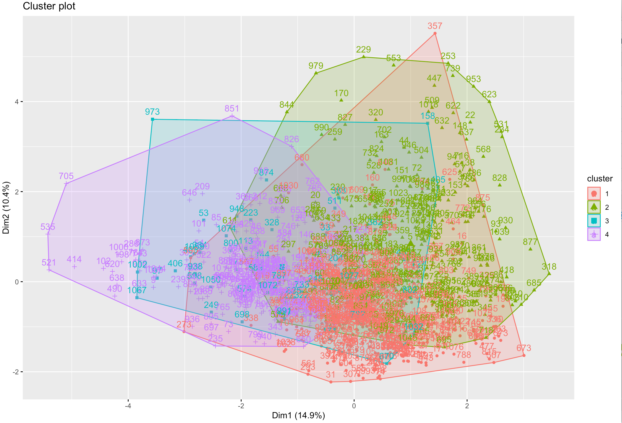

k = 5:

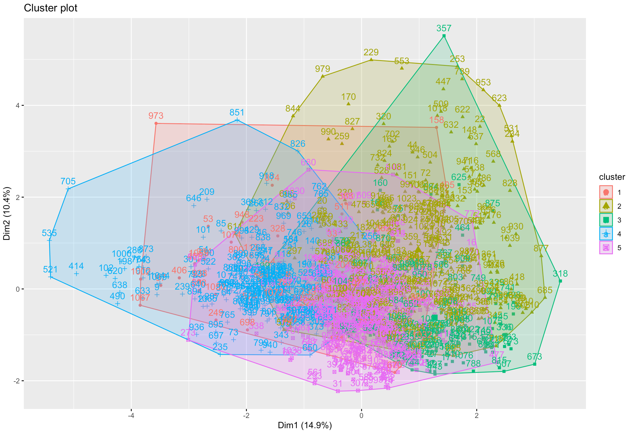

k = 6:

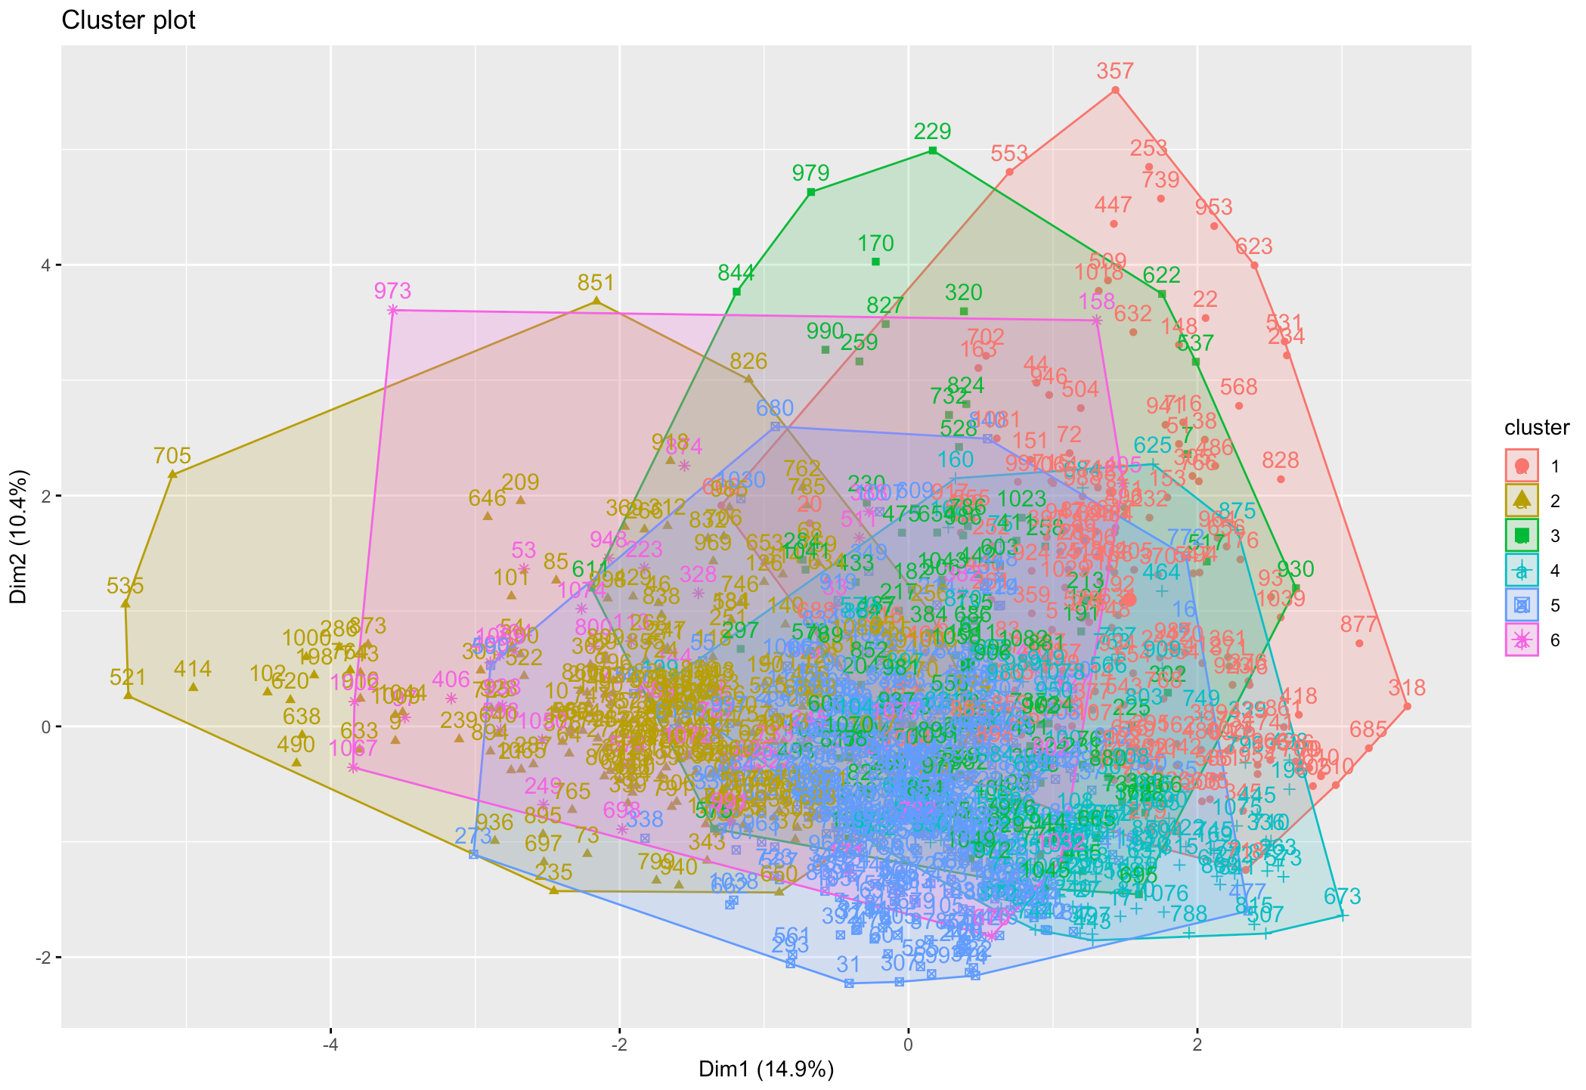

k = 7:

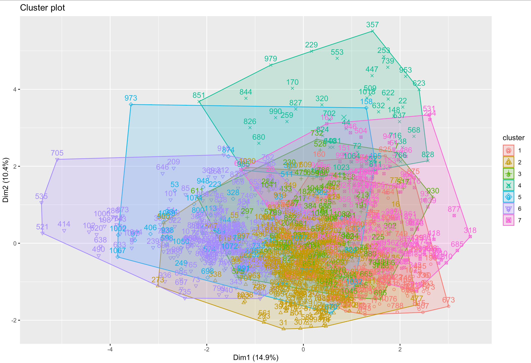

k = 8:

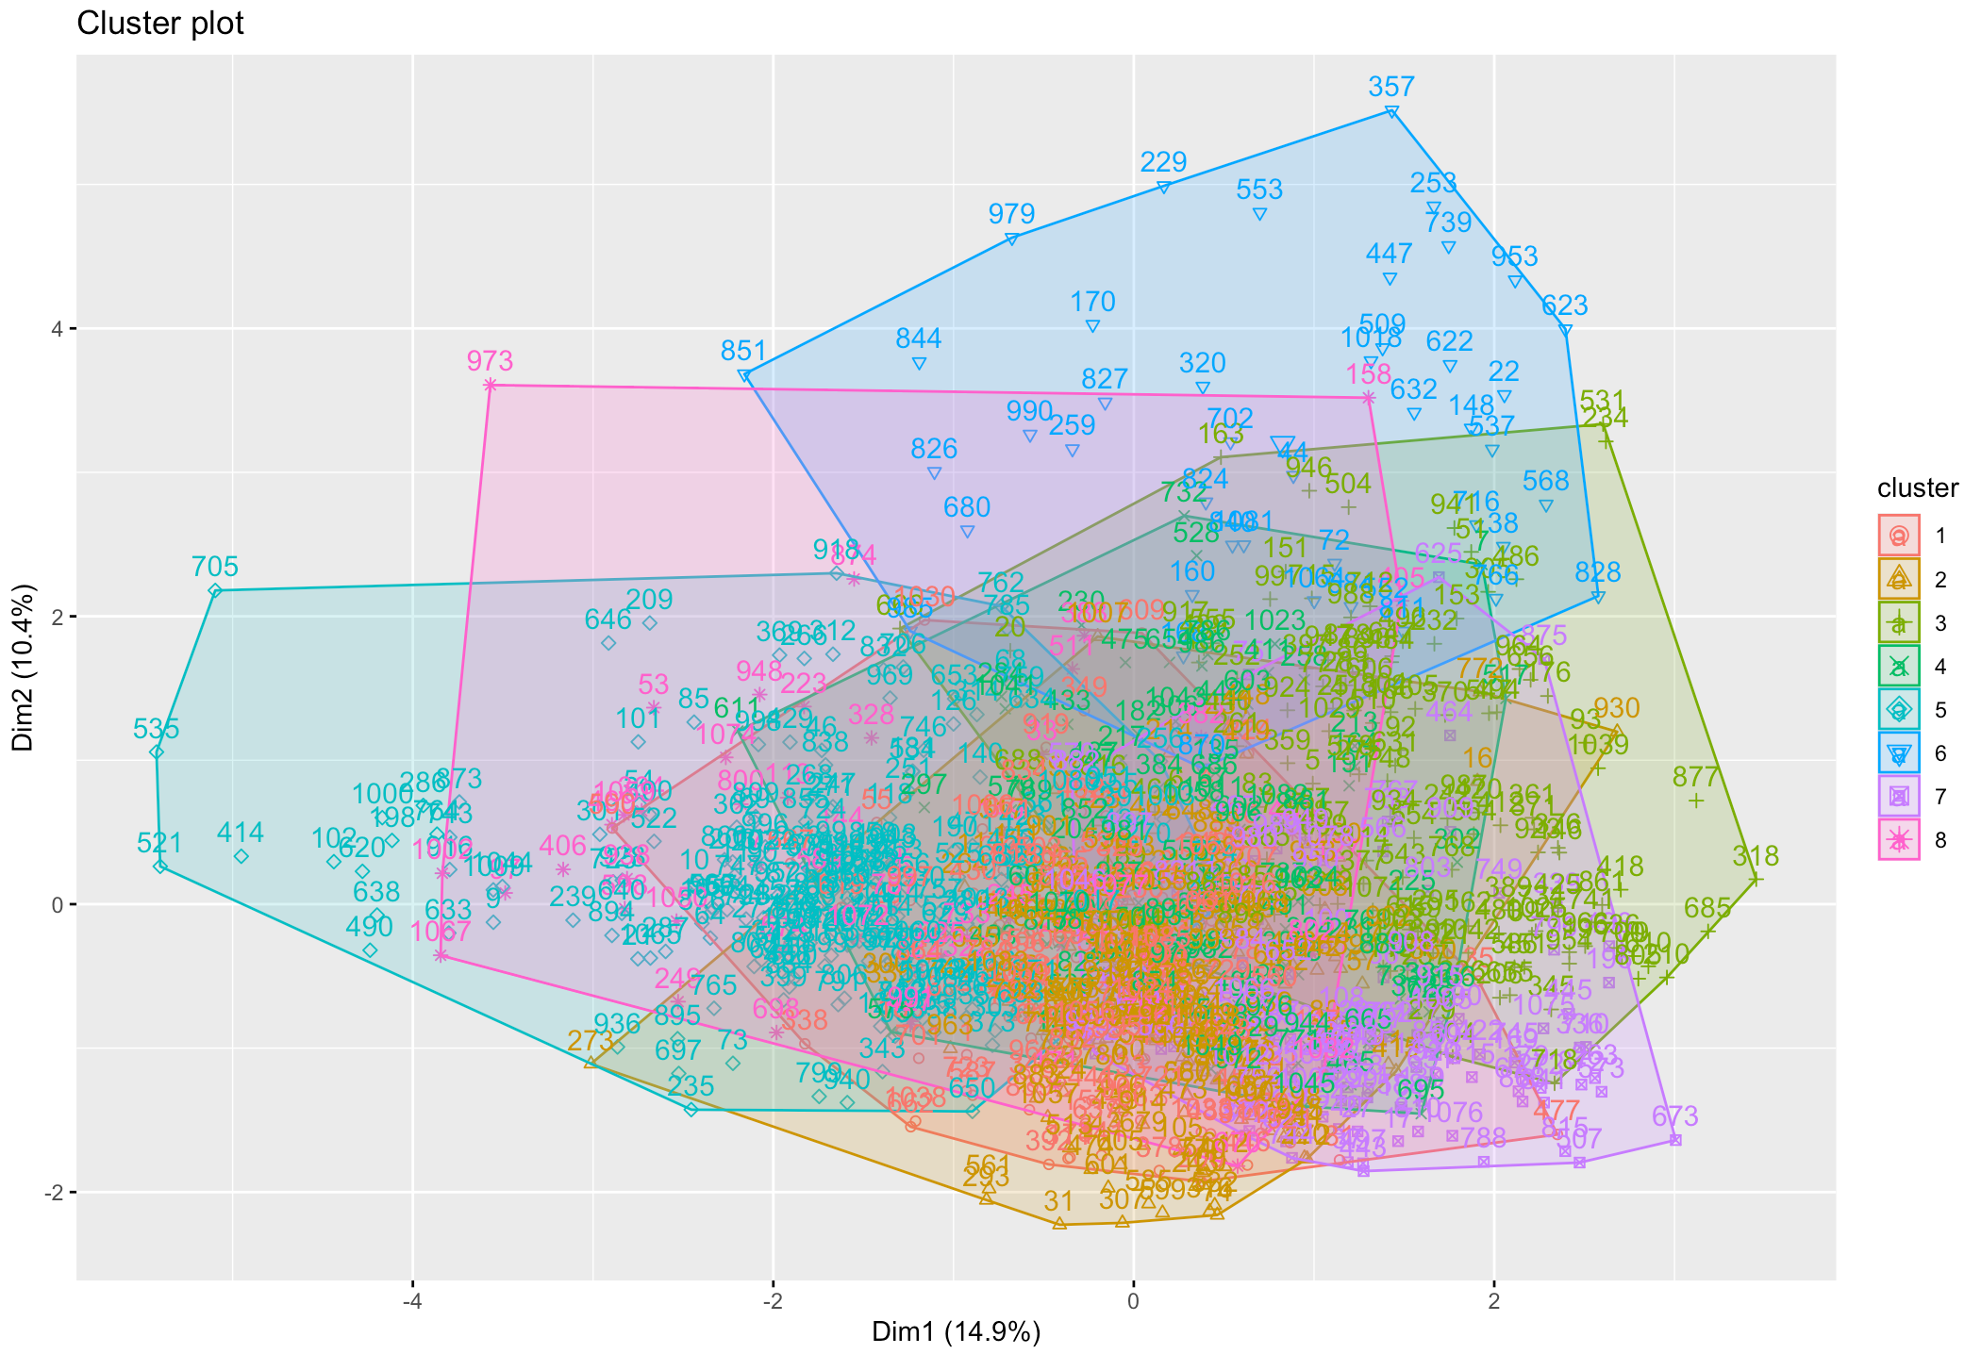

k = 9:

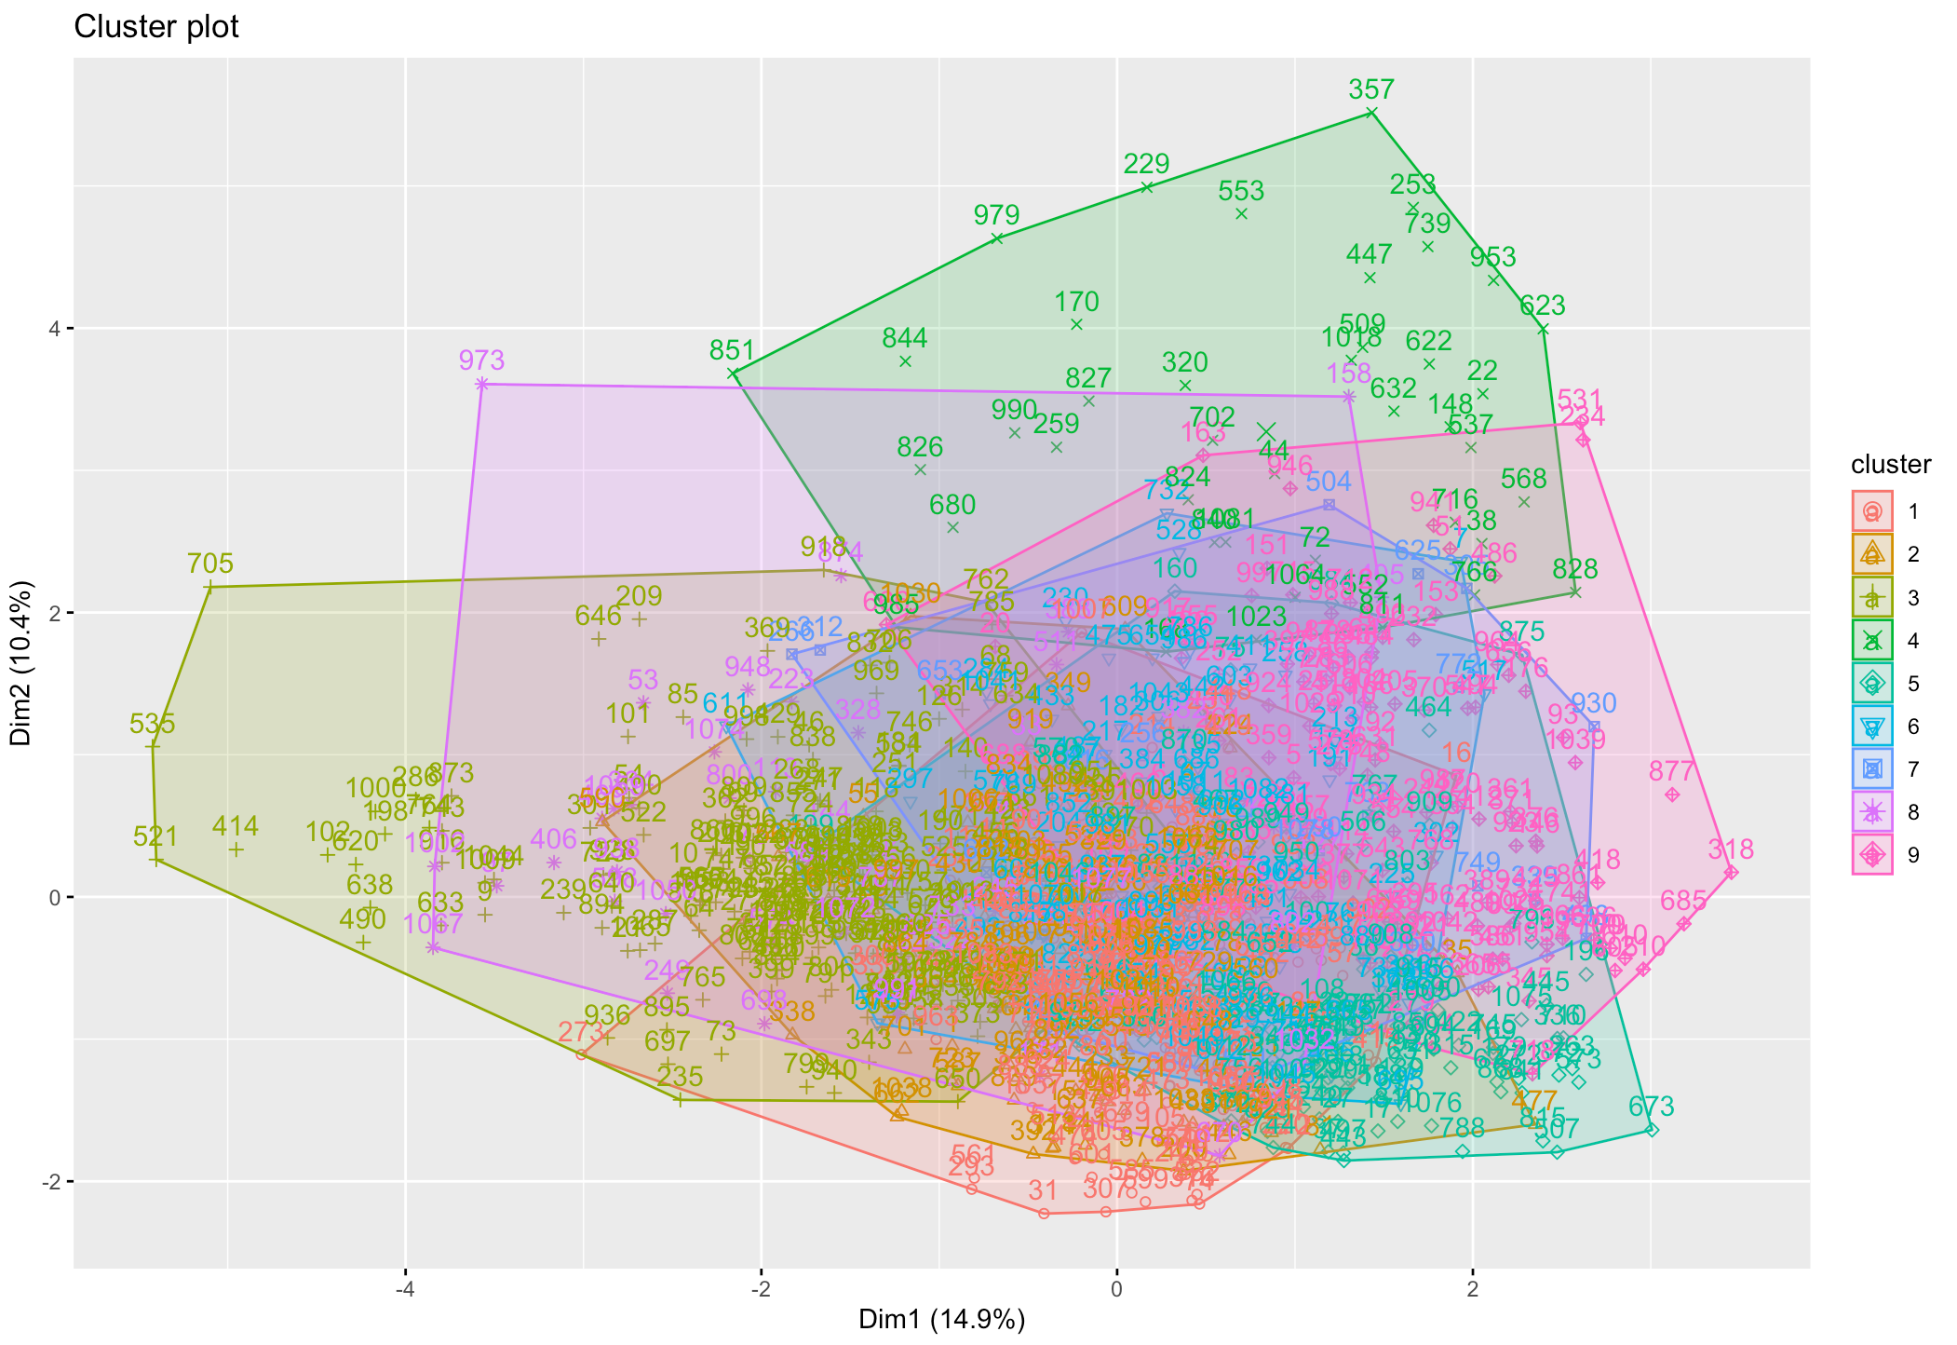

k = 10:

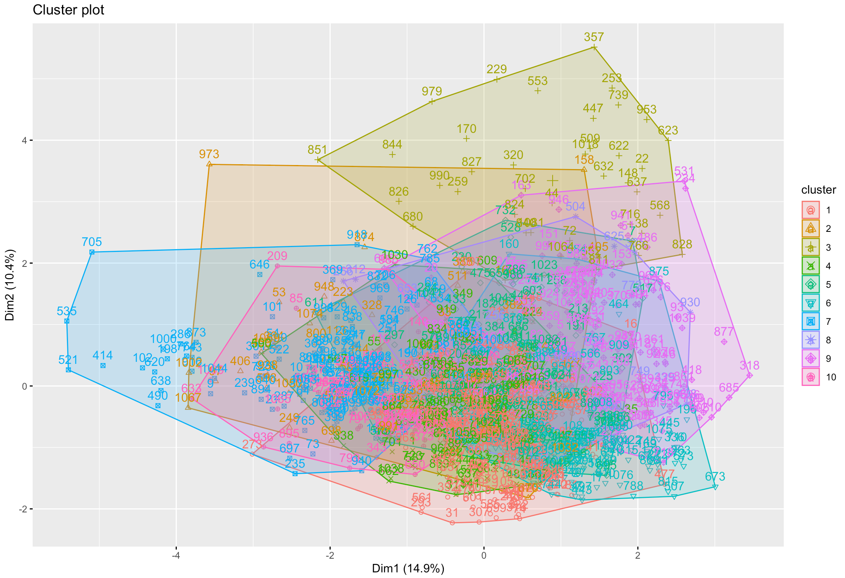

KnN:

70-30:

k=2:

Train:

995 827 832 557 825 558 589 638 953 629 941 494 978 404 116 171 968 879 904

1 2 2 2 1 2 2 2 2 2 2 1 2 2 1 2 2 1 1

143 353 277 178 361 748 849 493 880 698 573 545 317 757 919 454 337 284 102

1 2 1 2 1 1 1 2 2 1 1 2 2 1 2 2 2 1 1

132 266 925 175 471 514 732 903 850 41 1 267 456 370 526 8 264 711 191

1 2 1 1 1 1 2 1 1 1 2 2 1 2 1 2 1 1 1

63 690 982 329 166 969 699 362 549 56 381 52 73 128 131 34 99 769 635

1 2 2 2 1 2 1 1 2 2 1 2 2 1 2 1 1 2 1

442 929 96 774 104 719 975 20 915 146 927 375 912 861 651 581 204 835 806

1 2 1 2 2 2 2 2 2 1 1 1 1 2 2 1 2 1 1

292 862 796 311 445 21 922 127 138 788 169 303 874 542 988 331 964 82 763

1 1 2 2 2 1 2 2 1 1 1 2 1 2 1 2 2 2 1

194 900 741 613 244 695 147 220 88 226 170 309 724 247 837 916 731 809 735

1 1 2 1 2 2 2 1 2 2 2 2 1 2 2 2 1 1 2

587 911 65 7 46 488 163 497 13 336 380 889 946 887 51 68 620 811 696

2 1 1 1 2 1 1 2 1 2 2 2 2 2 2 2 2 1 1

951 10 455 597 117 203 957 77 571 125 665 663 276 708 291 714 692 513 340

2 2 1 1 1 2 1 2 1 1 2 2 1 1 2 1 1 2 2

83 167 122 508 295 899 352 487 943 37 426 59 176 799 598 187 181 341 92

2 2 1 1 1 1 2 2 1 2 1 2 2 1 2 1 2 1 1

431 654 762 345 421 140 596 846 980 617 623 662 23 999 958 854 215 489 532

1 1 2 1 1 1 2 2 2 2 1 1 2 2 2 2 1 2 1

364 522 707 393 283 359 785 795 821 124 223 673 555 481 798 357 296 87 307

1 2 1 1 1 1 1 2 1 2 1 1 2 2 2 1 1 2 2

535 528 805 844 630 824 643 490 259 531 938 962 282 392 628 729 713 859 926

2 1 2 1 1 2 1 2 1 2 2 1 2 1 2 1 1 1 1

491 701 750 229 31 779 631 517 24 815 225 814 325 603 808 19 33 458 749

1 1 1 1 1 2 1 2 1 2 1 2 2 1 1 1 2 1 1

736 981 856 730 648 342 123 700 72 907 592 103 703 424 781 485 474 836 519

2 2 1 2 2 2 2 2 1 2 2 2 1 2 1 1 2 1 1

756 108 11 561 842 253 29 794 677 812 30 436 134 902 882 27 462 553 32

1 2 2 1 1 1 2 2 1 1 1 2 2 1 2 2 2 1 1

316 84 4 615 179 606 721 422 162 18 744 786 834 515 237 288 479 892 153

2 2 2 2 2 2 2 2 2 2 1 2 2 2 1 2 2 2 1

556 275 789 693 687 330 773 624 47 894 387 966 183 768 287 704 97 792 435

1 2 2 2 2 1 2 2 2 2 2 2 2 2 2 2 2 1 1

86 372 675 172 570 582 74 107 17 775 165 207 733 429 965 149 164 382 66

1 1 1 2 2 1 2 2 1 1 2 2 2 1 2 1 1 1 1

524 787 67 536 642 411 40 177 85 190 150 935 101 548 997 443 432 944 771

2 1 2 2 2 1 2 1 1 1 1 2 2 2 2 2 1 2 2

234 376 407 681 249 502 453 588 778 869 232 621 428 961 315 759 319 148 530

1 2 2 1 1 1 1 2 1 1 1 2 2 2 1 2 2 1 1

500 38 231 872 290 754 670 475 76 333 28 641 864 599 586 460 1000 697 747

2 2 1 1 2 1 1 2 1 2 2 2 2 2 1 1 2 2 1

95 973 883 344 992 554 996 260 845 559 192 321 898 720 427 420 228 939 60

1 2 2 1 2 2 2 1 2 2 2 1 1 1 2 2 2 1 2

650 977 990 989 818 154 584 218 327 884 579 979 706 906 395 186 480 523 921

1 1 1 1 2 2 1 2 2 2 2 1 1 1 1 2 2 1 2

484 991 954 498 335 661 684 694 246 118 377 890 467 297 272 525 408 857 461

2 1 1 1 2 1 1 1 2 1 2 1 2 1 2 1 1 2 1

383 820 78 963 543 120 211 434 168 135 351 897 672 93 533 242 657 608 739

1 2 2 2 2 2 2 2 2 1 2 2 1 2 1 2 2 2 1

839 54 886 161 552 909 463 45 722 195 90 753 534 960 652 323 575 294 79

2 2 1 2 1 1 2 1 2 1 2 2 2 1 2 2 1 2 1

636 423 450 472 752 369 755 604 653 609 326 322 158 770 346 250 784 930 233

2 1 2 1 2 1 1 1 2 2 2 2 2 2 2 2 2 2 1

742 300 371 386 790 188 985 425 115 110 184 332 840 634 418 891 39 156 577

2 2 2 2 1 2 2 2 2 2 2 1 2 2 1 2 2 1 2

810 413 182 885 197 12 36 349 610 409 129 585 308 712 398 348 817 270 61

2 1 1 2 2 2 1 1 2 2 1 2 2 2 2 2 1 2 2

947 347 274 248 15 702 666 213 25 378 626 843 952 505 205 633 328 826 216

1 2 1 1 2 1 2 1 2 2 2 2 1 1 2 1 2 1 2

173 540 360 496 80 745 112 655 823 858 937 901 761 438 185 546 594 934 680

2 2 2 1 2 1 1 2 2 2 2 2 1 2 1 1 2 1 2

180 831 829 767 133 439 593 871 541 320 647 683 614 876 550 350 709 6 441

2 1 2 2 1 1 1 1 1 2 1 2 1 1 1 1 1 1 2

691 281 105 949 271 726 278 214 918 50 430 595 895 75 312 159 618 607 566

2 2 1 1 1 1 2 2 2 2 1 2 1 2 1 2 2 2 1

503 139 476 772 279 510 42 285 611 605 470 486 765 803 482 251 527 625 210

1 2 1 1 2 1 2 2 2 1 1 2 1 1 2 1 2 2 1

563 235 202 881 547 686 100 459 70 967 928 521 923 121 62 111 780 142 222

2 2 1 2 1 1 1 1 1 2 2 1 1 1 1 2 2 1 2

221 734 189 866 401 114 126 600 193 26 252 984 685 710 910 254

2 2 1 1 1 1 2 1 2 1 2 1 1 2 1 1

Test:

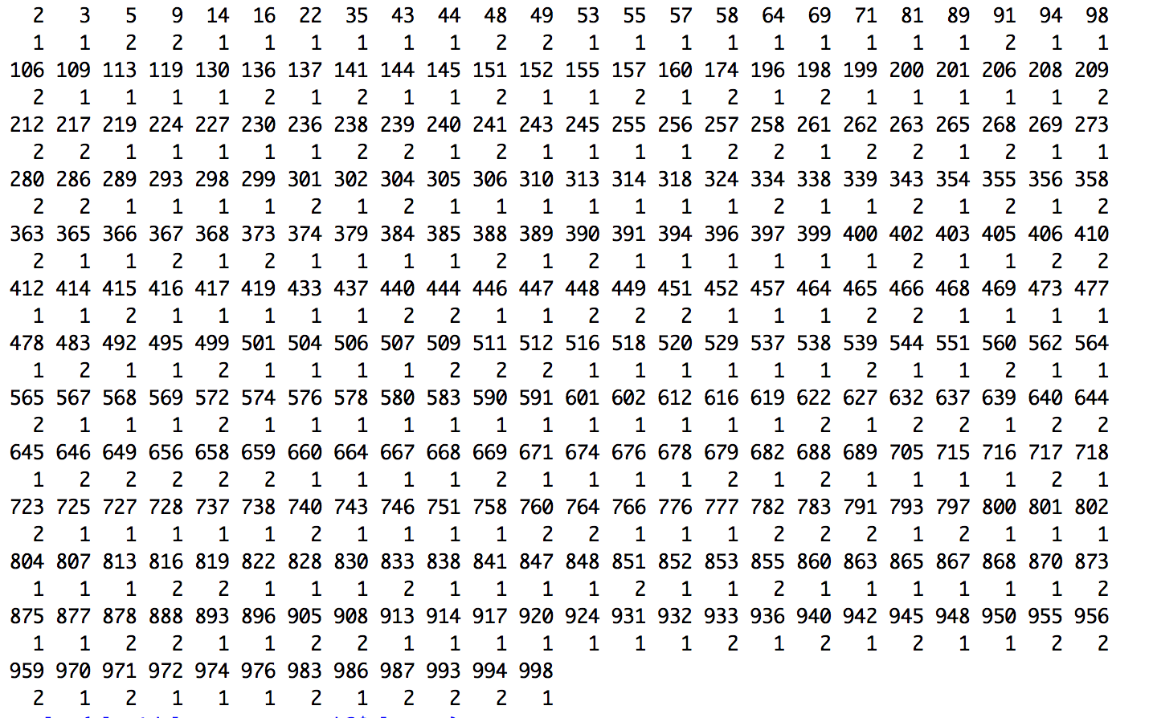

k=3:

Train:

995 827 832 557 825 558 589 638 953 629 941 494 978 404 116 171 968 879 904

2 1 1 1 1 1 1 1 1 1 1 2 1 1 1 1 3 2 2

143 353 277 178 361 748 849 493 880 698 573 545 317 757 919 454 337 284 102

1 1 1 1 2 1 1 1 1 2 2 1 1 2 1 1 1 2 1

132 266 925 175 471 514 732 903 850 41 1 267 456 370 526 8 264 711 191

2 1 2 2 2 2 1 1 2 2 1 1 2 1 1 1 1 2 2

63 690 982 329 166 969 699 362 549 56 381 52 73 128 131 34 99 769 635

2 1 1 1 1 1 2 2 1 1 2 1 1 2 1 1 1 2 1

442 929 96 774 104 719 975 20 915 146 927 375 912 861 651 581 204 835 806

1 1 2 1 1 1 1 1 1 1 1 2 2 1 1 2 1 1 1

292 862 796 311 445 21 922 127 138 788 169 303 874 542 988 331 964 82 763

1 2 1 1 3 2 1 1 2 2 2 1 1 1 1 1 1 1 1

194 900 741 613 244 695 147 220 88 226 170 309 724 247 837 916 731 809 735

2 2 1 2 1 1 1 2 1 1 1 1 2 1 1 1 1 2 1

587 911 65 7 46 488 163 497 13 336 380 889 946 887 51 68 620 811 696

1 1 1 2 1 2 2 1 2 1 1 1 1 1 1 1 1 2 1

951 10 455 597 117 203 957 77 571 125 665 663 276 708 291 714 692 513 340

1 1 2 2 2 3 2 1 2 2 1 1 2 2 2 2 1 1 1

83 167 122 508 295 899 352 487 943 37 426 59 176 799 598 187 181 341 92

2 1 2 2 2 2 1 1 2 1 1 1 1 1 1 2 1 2 1

431 654 762 345 421 140 596 846 980 617 623 662 23 999 958 854 215 489 532

2 1 1 1 2 2 1 1 1 1 1 2 1 1 1 1 2 1 2

364 522 707 393 283 359 785 795 821 124 223 673 555 481 798 357 296 87 307

2 1 1 2 3 2 2 1 2 1 1 2 1 1 1 2 2 1 1

535 528 805 844 630 824 643 490 259 531 938 962 282 392 628 729 713 859 926

1 1 3 2 1 1 2 1 2 1 1 2 1 1 3 2 1 2 2

491 701 750 229 31 779 631 517 24 815 225 814 325 603 808 19 33 458 749

2 2 2 2 1 1 2 1 2 1 2 1 1 2 2 2 1 2 2

736 981 856 730 648 342 123 700 72 907 592 103 703 424 781 485 474 836 519

1 1 3 1 1 2 1 1 2 1 1 1 3 1 1 2 1 1 2

756 108 11 561 842 253 29 794 677 812 30 436 134 902 882 27 462 553 32

1 1 1 2 1 1 1 1 2 2 1 1 2 2 1 1 3 2 1

316 84 4 615 179 606 721 422 162 18 744 786 834 515 237 288 479 892 153

1 1 1 1 1 1 1 1 1 1 1 1 1 1 2 1 1 1 2

556 275 789 693 687 330 773 624 47 894 387 966 183 768 287 704 97 792 435

2 1 1 1 1 1 1 1 1 1 1 1 1 1 1 1 1 2 2

86 372 675 172 570 582 74 107 17 775 165 207 733 429 965 149 164 382 66

2 1 2 1 1 2 1 1 1 2 1 1 1 1 1 2 1 2 2

524 787 67 536 642 411 40 177 85 190 150 935 101 548 997 443 432 944 771

1 1 1 1 1 1 1 2 2 2 2 1 1 1 1 1 1 1 1

234 376 407 681 249 502 453 588 778 869 232 621 428 961 315 759 319 148 530

1 3 1 2 2 2 2 1 2 2 2 1 1 1 3 1 1 1 2

500 38 231 872 290 754 670 475 76 333 28 641 864 599 586 460 1000 697 747

1 1 2 2 3 1 2 1 2 3 1 1 1 1 2 3 1 1 1

95 973 883 344 992 554 996 260 845 559 192 321 898 720 427 420 228 939 60

2 1 1 2 1 1 1 2 1 1 1 2 1 2 1 1 1 2 1

650 977 990 989 818 154 584 218 327 884 579 979 706 906 395 186 480 523 921

2 2 2 1 1 1 2 1 1 1 1 1 2 1 2 1 1 2 1

484 991 954 498 335 661 684 694 246 118 377 890 467 297 272 525 408 857 461

1 3 2 1 1 2 1 1 3 2 1 2 1 2 1 1 2 1 2

383 820 78 963 543 120 211 434 168 135 351 897 672 93 533 242 657 608 739

2 1 2 1 1 1 1 1 1 1 1 1 2 1 2 1 1 1 2

839 54 886 161 552 909 463 45 722 195 90 753 534 960 652 323 575 294 79

1 1 2 1 1 2 1 2 1 2 1 1 1 1 1 1 3 1 2

636 423 450 472 752 369 755 604 653 609 326 322 158 770 346 250 784 930 233

1 2 1 1 1 2 2 2 1 1 1 1 1 1 1 1 1 1 2

742 300 371 386 790 188 985 425 115 110 184 332 840 634 418 891 39 156 577

1 1 1 1 2 1 1 1 1 1 2 2 1 3 2 1 1 1 1

810 413 182 885 197 12 36 349 610 409 129 585 308 712 398 348 817 270 61

1 1 1 1 1 1 2 2 1 1 1 1 1 3 3 1 1 1 1

947 347 274 248 15 702 666 213 25 378 626 843 952 505 205 633 328 826 216

2 1 2 2 1 2 1 2 1 1 1 1 2 1 1 2 1 2 1

173 540 360 496 80 745 112 655 823 858 937 901 761 438 185 546 594 934 680

1 1 1 2 1 2 2 1 1 1 1 1 2 1 1 2 1 1 1

180 831 829 767 133 439 593 871 541 320 647 683 614 876 550 350 709 6 441

1 2 1 1 1 2 1 2 1 1 1 2 2 2 2 2 2 2 1

691 281 105 949 271 726 278 214 918 50 430 595 895 75 312 159 618 607 566

1 1 2 2 2 1 1 1 1 1 2 1 2 1 1 1 1 1 1

503 139 476 772 279 510 42 285 611 605 470 486 765 803 482 251 527 625 210

2 1 2 1 1 2 1 1 1 2 2 1 1 1 1 1 1 1 2

563 235 202 881 547 686 100 459 70 967 928 521 923 121 62 111 780 142 222

1 1 2 1 1 2 2 1 1 1 1 1 1 2 2 1 1 2 1

221 734 189 866 401 114 126 600 193 26 252 984 685 710 910 254

1 1 2 2 2 1 1 1 1 1 1 2 1 1 2 2

Test:

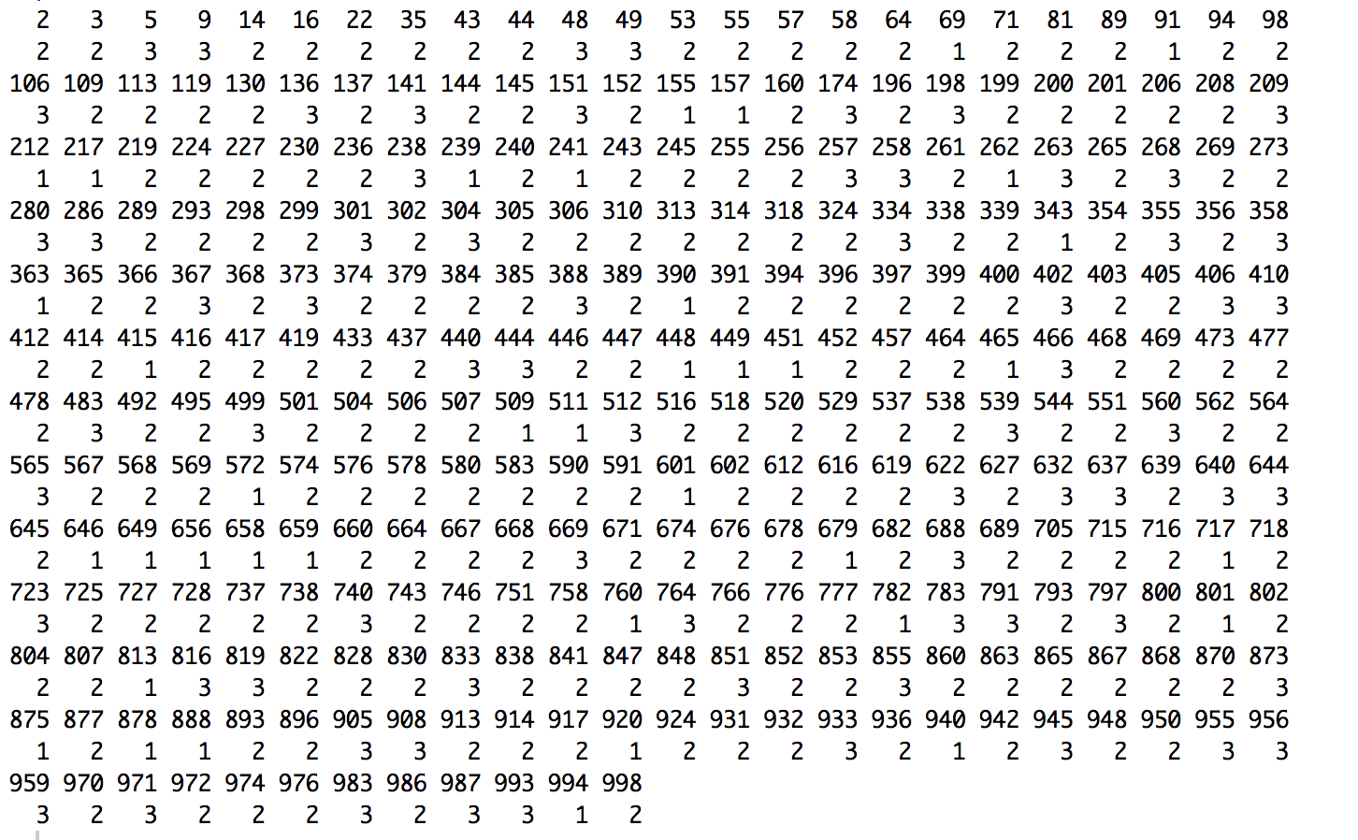

k=4:

Train:

995 827 832 557 825 558 589 638 953 629 941 494 978 404 116 171 968 879 904

3 1 4 1 2 4 4 4 4 1 4 3 1 1 2 1 4 2 3

143 353 277 178 361 748 849 493 880 698 573 545 317 757 919 454 337 284 102

2 4 2 4 1 2 2 4 4 3 2 1 4 3 4 4 1 3 2

132 266 925 175 471 514 732 903 850 41 1 267 456 370 526 8 264 711 191

2 1 1 3 2 3 4 2 3 2 4 4 2 1 2 1 2 3 2

63 690 982 329 166 969 699 362 549 56 381 52 73 128 131 34 99 769 635

1 4 4 1 2 4 1 2 4 4 3 1 4 3 4 2 2 1 2

442 929 96 774 104 719 975 20 915 146 927 375 912 861 651 581 204 835 806

2 4 2 1 1 4 4 1 4 2 2 3 3 1 4 2 4 2 2

292 862 796 311 445 21 922 127 138 788 169 303 874 542 988 331 964 82 763

2 3 4 4 4 2 1 4 2 2 3 4 2 1 2 1 4 4 2

194 900 741 613 244 695 147 220 88 226 170 309 724 247 837 916 731 809 735

1 3 1 3 4 4 4 3 4 4 4 4 3 1 4 1 2 2 1

587 911 65 7 46 488 163 497 13 336 380 889 946 887 51 68 620 811 696

4 2 2 3 4 2 2 4 2 4 4 4 1 4 4 4 1 3 2

951 10 455 597 117 203 957 77 571 125 665 663 276 708 291 714 692 513 340

4 1 3 2 1 4 3 4 2 3 4 1 3 3 1 1 2 4 4

83 167 122 508 295 899 352 487 943 37 426 59 176 799 598 187 181 341 92

1 4 3 2 2 3 4 4 3 4 2 1 1 2 4 3 4 3 2

431 654 762 345 421 140 596 846 980 617 623 662 23 999 958 854 215 489 532

3 2 4 2 1 2 1 4 1 4 2 2 4 4 1 1 2 4 2

364 522 707 393 283 359 785 795 821 124 223 673 555 481 798 357 296 87 307

1 4 2 1 3 3 3 4 3 4 2 3 4 1 4 3 3 1 4

535 528 805 844 630 824 643 490 259 531 938 962 282 392 628 729 713 859 926

1 2 1 3 2 4 2 4 1 1 4 3 1 2 1 3 2 3 2

491 701 750 229 31 779 631 517 24 815 225 814 325 603 808 19 33 458 749

1 3 3 3 2 1 2 1 2 1 3 4 1 3 2 1 4 2 3

736 981 856 730 648 342 123 700 72 907 592 103 703 424 781 485 474 836 519

4 4 3 1 4 1 4 4 2 1 4 1 2 4 2 3 1 2 2

756 108 11 561 842 253 29 794 677 812 30 436 134 902 882 27 462 553 32

2 4 1 3 2 2 4 4 3 3 2 1 1 3 4 4 4 3 2

316 84 4 615 179 606 721 422 162 18 744 786 834 515 237 288 479 892 153

4 4 4 4 4 4 1 1 1 4 2 1 4 4 2 1 1 4 2

556 275 789 693 687 330 773 624 47 894 387 966 183 768 287 704 97 792 435

2 4 1 4 1 2 4 4 4 1 4 1 4 4 1 1 4 2 1

86 372 675 172 570 582 74 107 17 775 165 207 733 429 965 149 164 382 66

2 2 2 1 1 2 4 4 2 3 4 4 4 2 1 2 2 2 2

524 787 67 536 642 411 40 177 85 190 150 935 101 548 997 443 432 944 771

4 2 1 4 1 2 4 3 2 2 2 1 4 1 1 4 2 4 4

234 376 407 681 249 502 453 588 778 869 232 621 428 961 315 759 319 148 530

2 4 4 2 1 3 3 1 3 3 3 1 4 4 2 1 1 2 3

500 38 231 872 290 754 670 475 76 333 28 641 864 599 586 460 1000 697 747

4 4 1 2 1 2 3 4 3 4 4 1 4 1 2 2 4 1 2

95 973 883 344 992 554 996 260 845 559 192 321 898 720 427 420 228 939 60

3 1 1 2 4 4 4 3 1 4 1 2 2 3 4 1 1 1 4

650 977 990 989 818 154 584 218 327 884 579 979 706 906 395 186 480 523 921

1 2 3 2 4 4 1 1 1 1 1 2 2 2 2 4 4 2 4

484 991 954 498 335 661 684 694 246 118 377 890 467 297 272 525 408 857 461

1 2 2 2 1 2 2 2 1 2 1 2 4 3 4 2 3 4 3

383 820 78 963 543 120 211 434 168 135 351 897 672 93 533 242 657 608 739

2 4 1 1 4 4 4 1 1 2 4 4 3 1 3 4 4 1 2

839 54 886 161 552 909 463 45 722 195 90 753 534 960 652 323 575 294 79

4 4 3 4 2 2 4 2 4 2 1 1 4 2 4 4 2 4 2

636 423 450 472 752 369 755 604 653 609 326 322 158 770 346 250 784 930 233

4 3 4 2 4 2 3 2 4 1 4 4 4 4 1 1 4 1 2

742 300 371 386 790 188 985 425 115 110 184 332 840 634 418 891 39 156 577

1 4 1 1 2 1 1 4 1 4 1 3 4 4 2 1 4 2 1

810 413 182 885 197 12 36 349 610 409 129 585 308 712 398 348 817 270 61

1 2 2 4 1 1 3 2 4 4 2 4 4 4 4 4 2 4 4

947 347 274 248 15 702 666 213 25 378 626 843 952 505 205 633 328 826 216

3 4 2 3 4 1 4 3 1 4 4 1 3 2 4 3 4 2 4

173 540 360 496 80 745 112 655 823 858 937 901 761 438 185 546 594 934 680

4 4 4 3 1 2 2 4 1 4 4 1 2 4 1 2 1 2 1

180 831 829 767 133 439 593 871 541 320 647 683 614 876 550 350 709 6 441

4 2 4 4 2 3 2 2 2 4 2 1 1 1 3 3 3 3 4

691 281 105 949 271 726 278 214 918 50 430 595 895 75 312 159 618 607 566

1 1 3 3 3 2 4 4 1 1 3 4 3 4 2 4 4 4 2

503 139 476 772 279 510 42 285 611 605 470 486 765 803 482 251 527 625 210

3 4 3 2 1 3 4 4 4 2 2 4 2 2 1 2 4 4 2

563 235 202 881 547 686 100 459 70 967 928 521 923 121 62 111 780 142 222

4 4 3 1 2 1 3 2 2 1 4 2 2 3 3 4 4 2 1

221 734 189 866 401 114 126 600 193 26 252 984 685 710 910 254

1 1 3 2 3 2 1 2 4 2 4 2 2 4 2 2

Test:

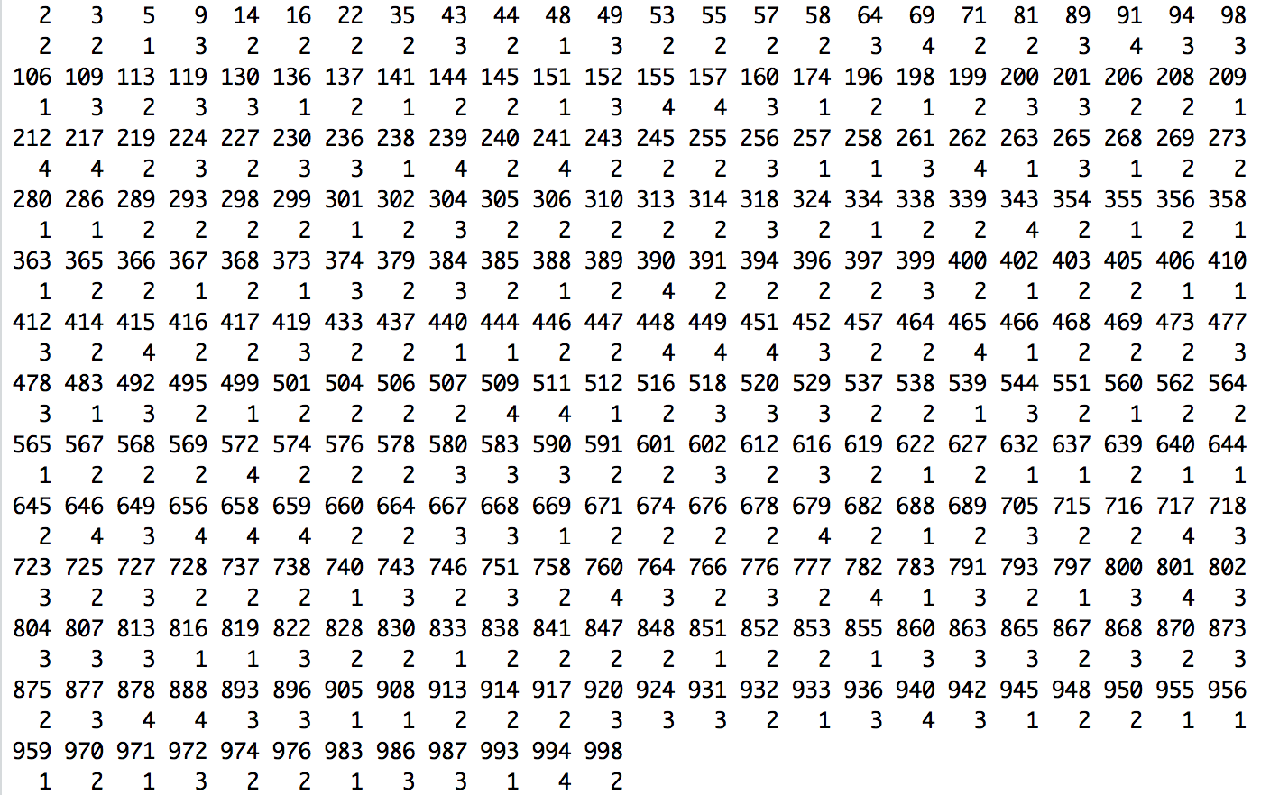

k=5:

Train:

Test: 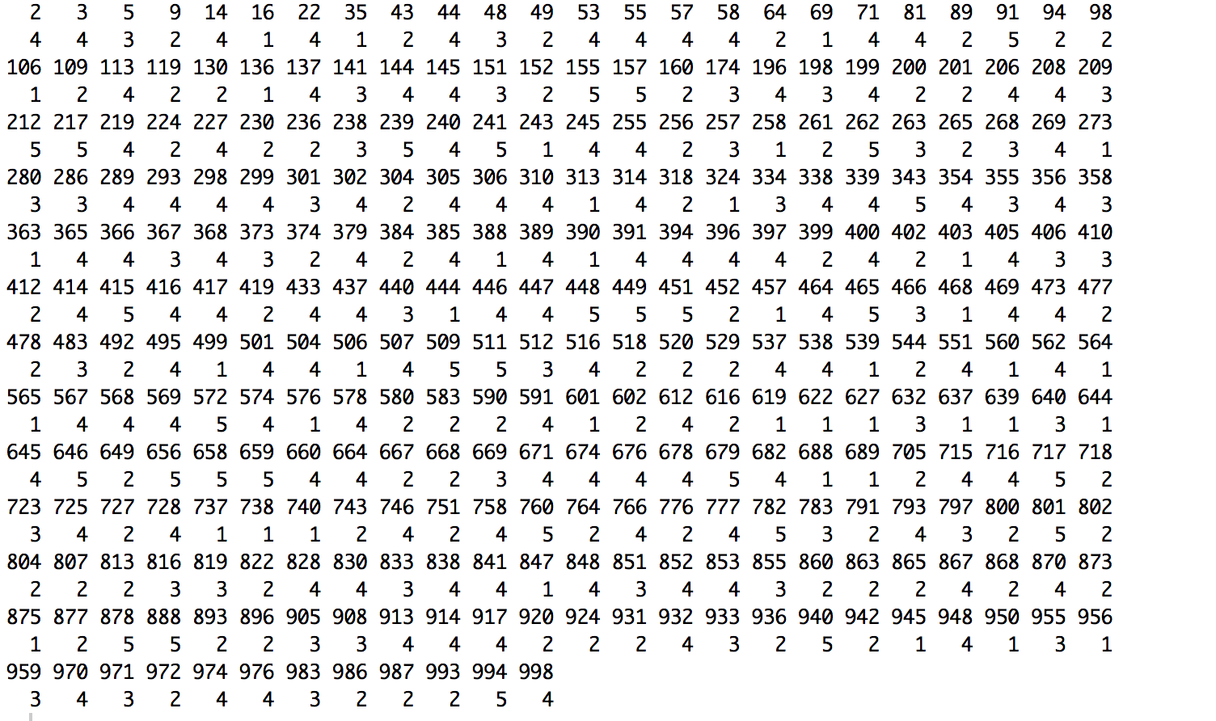

**k=6**

Train:

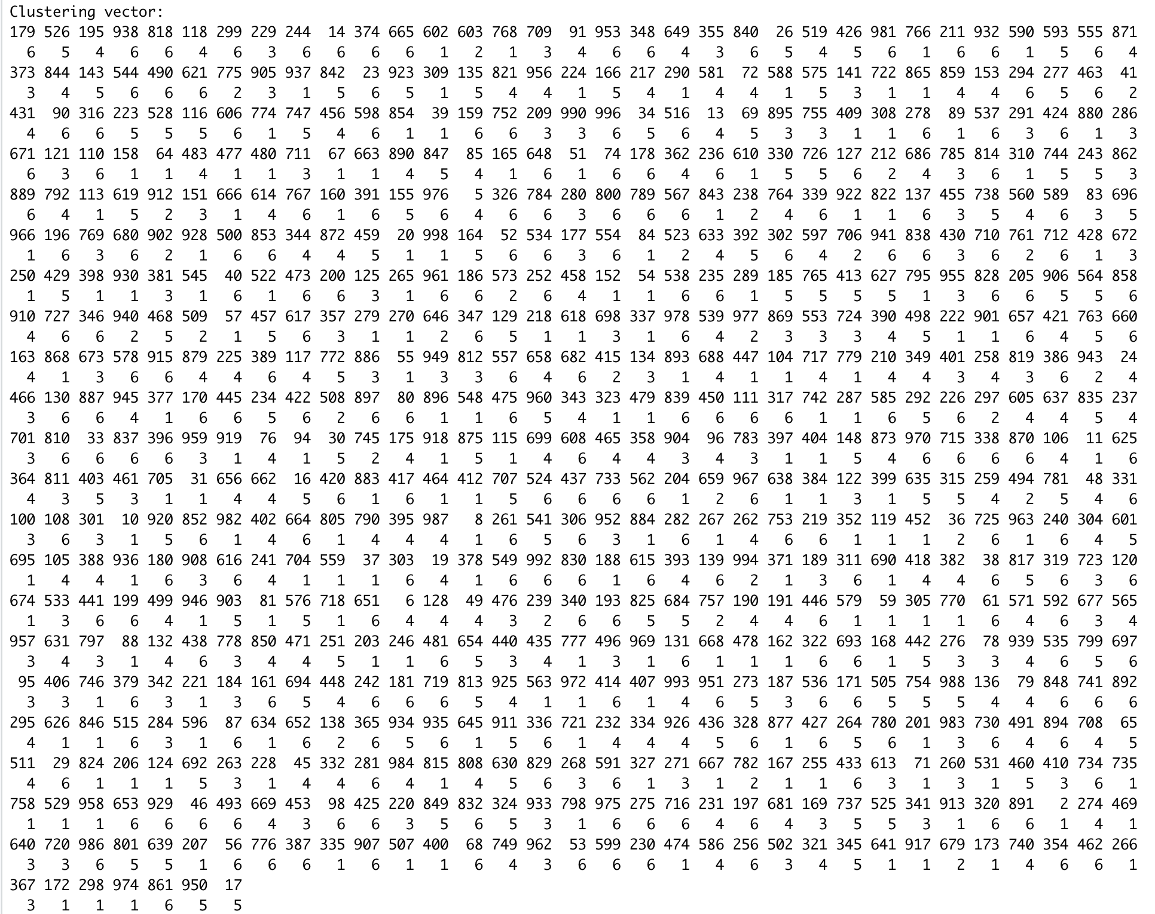

Test:

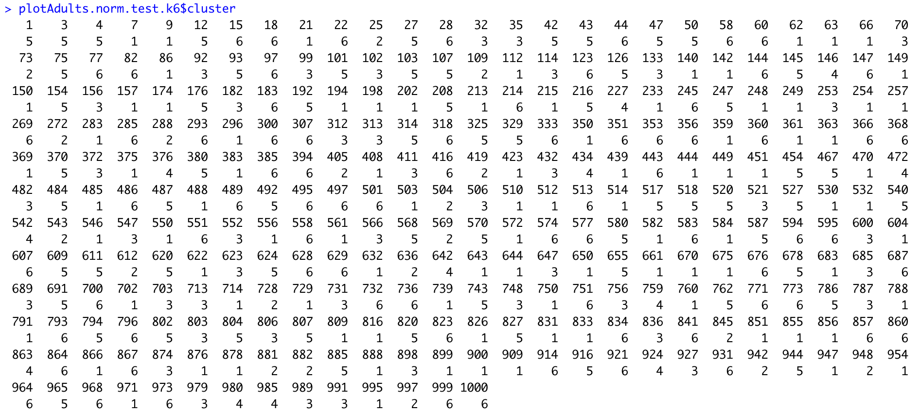

**k=7:**

Train: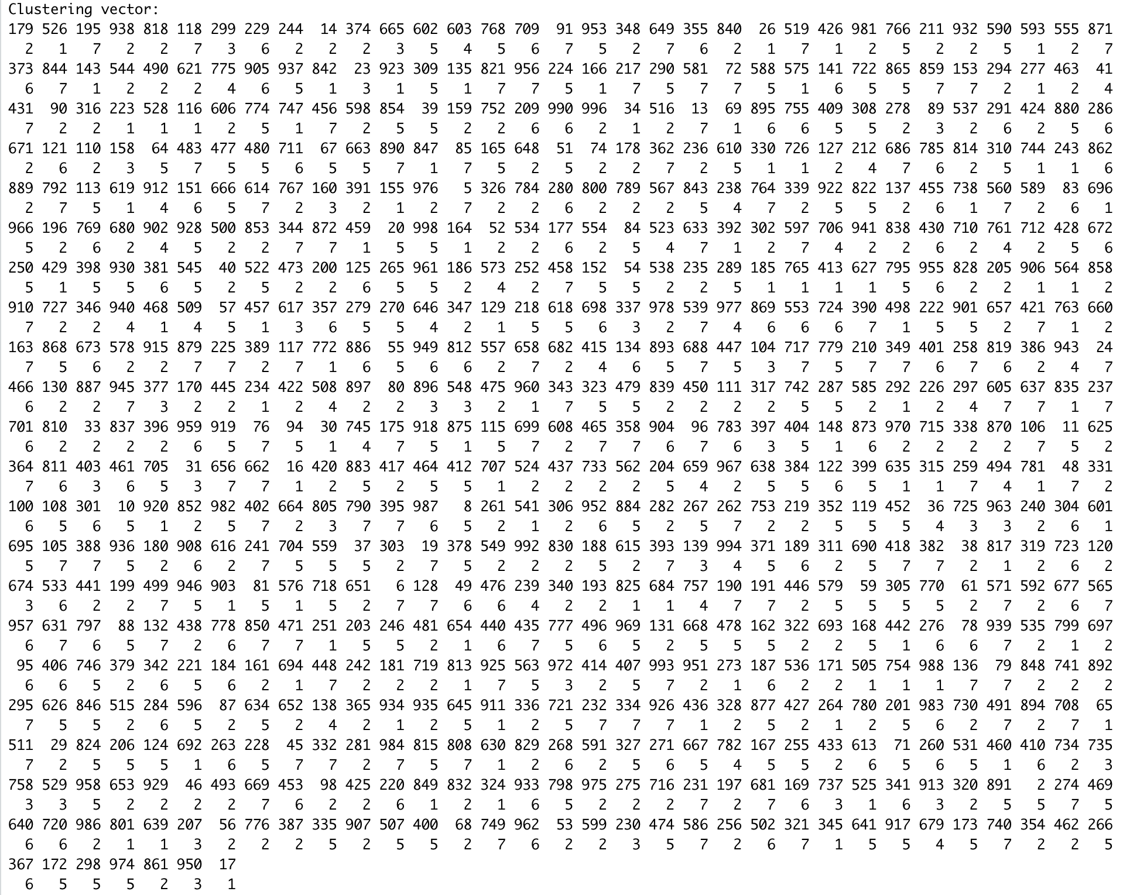

Test: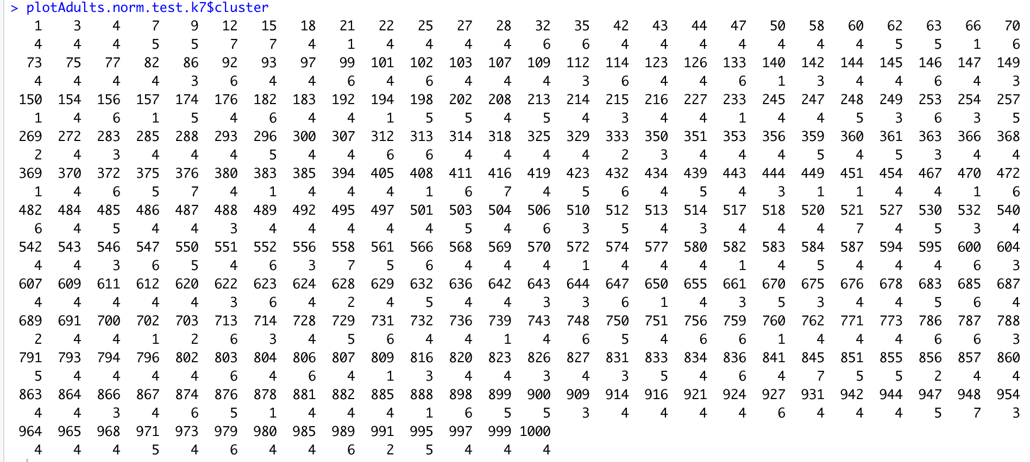

k=8:

Train: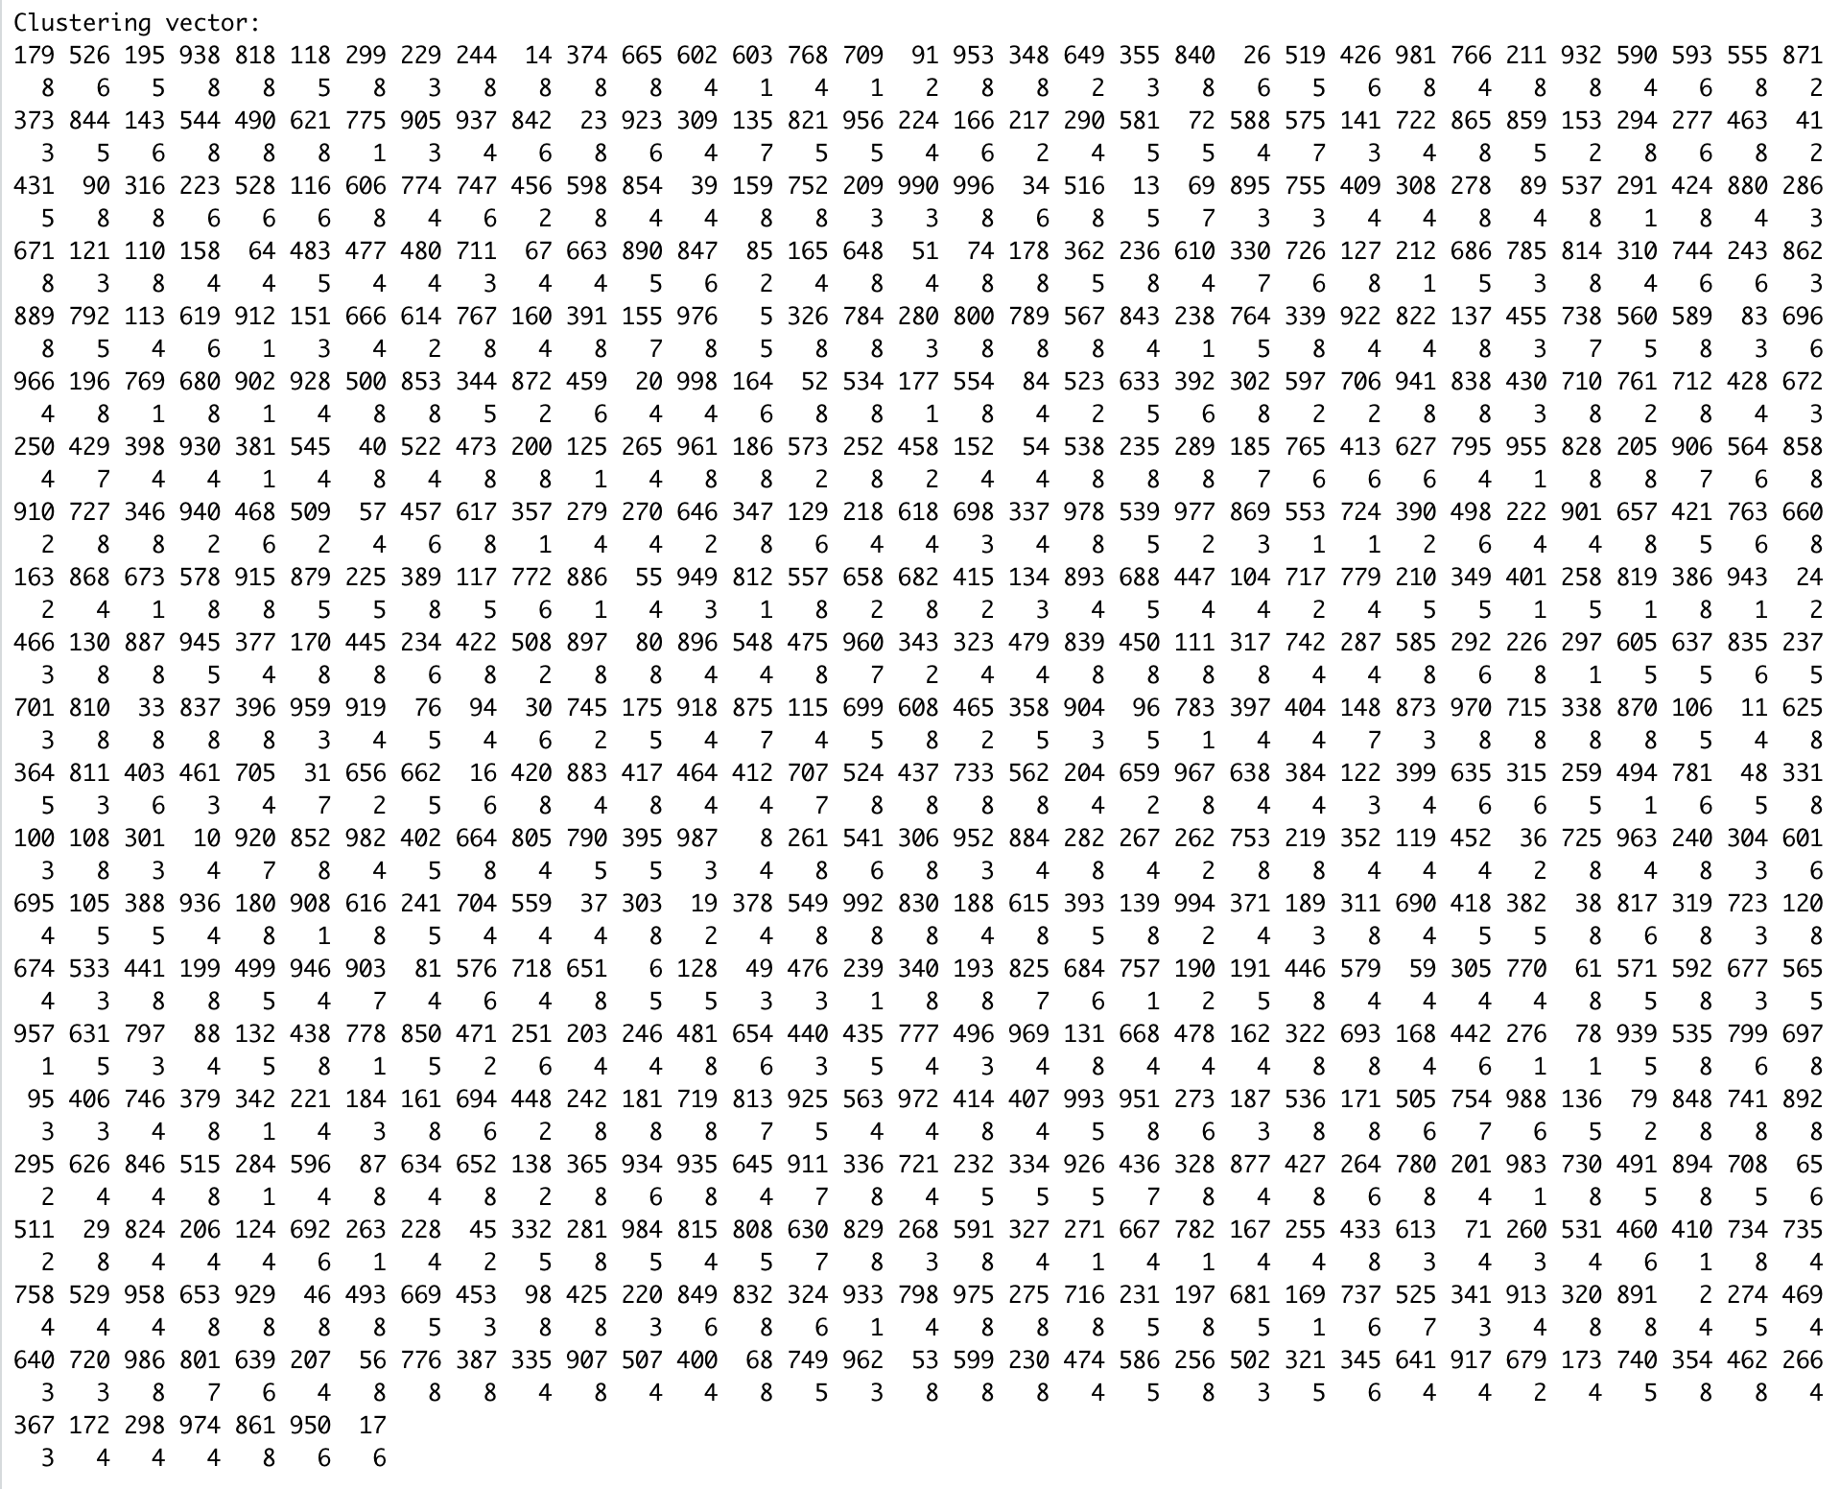

Test:

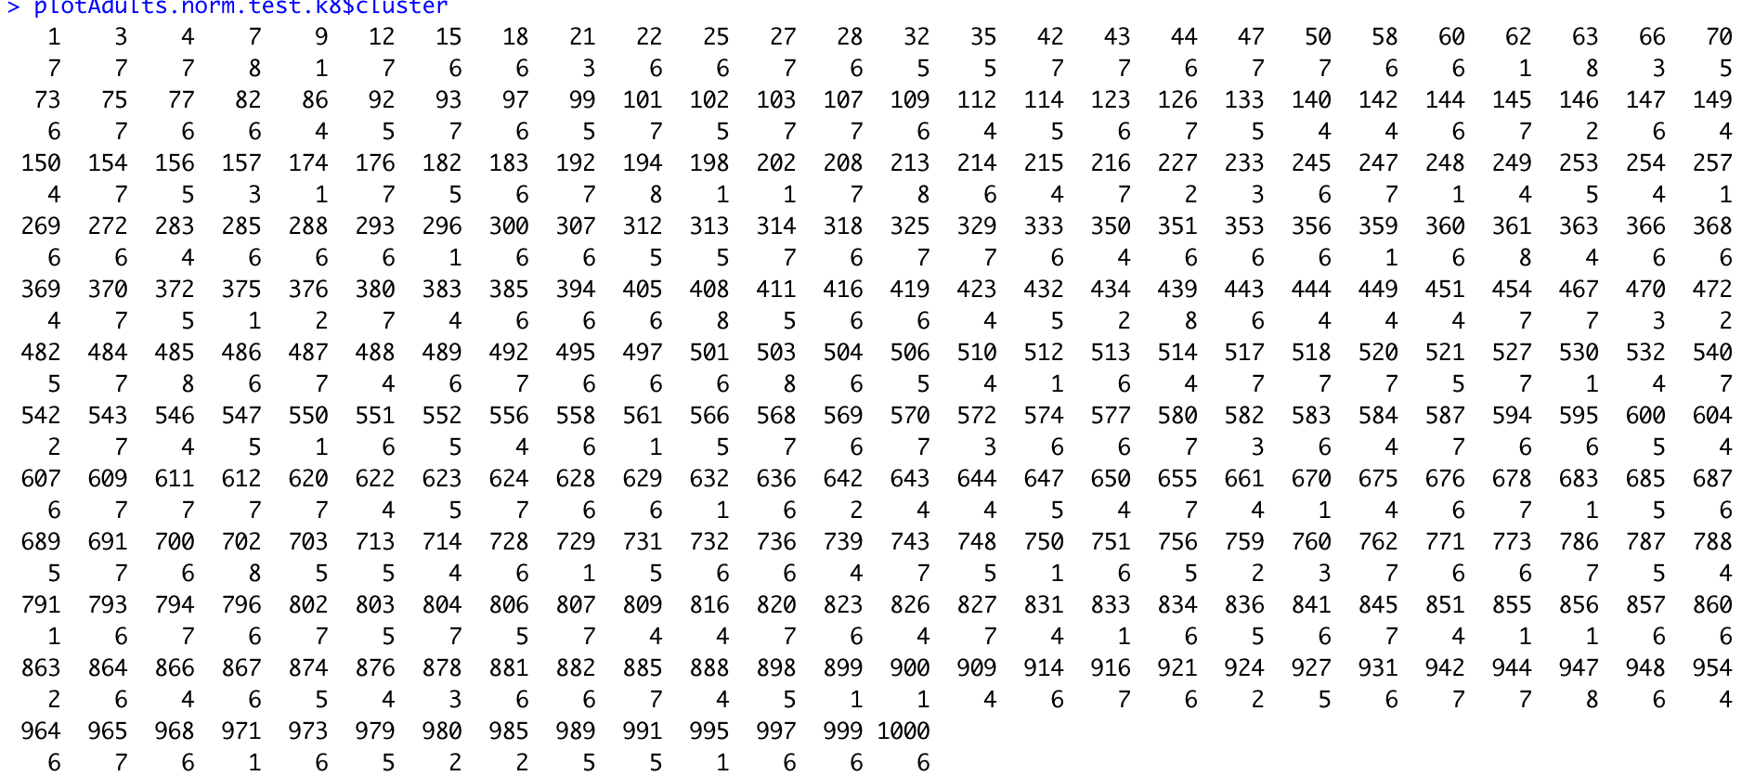

**k=9**

Train: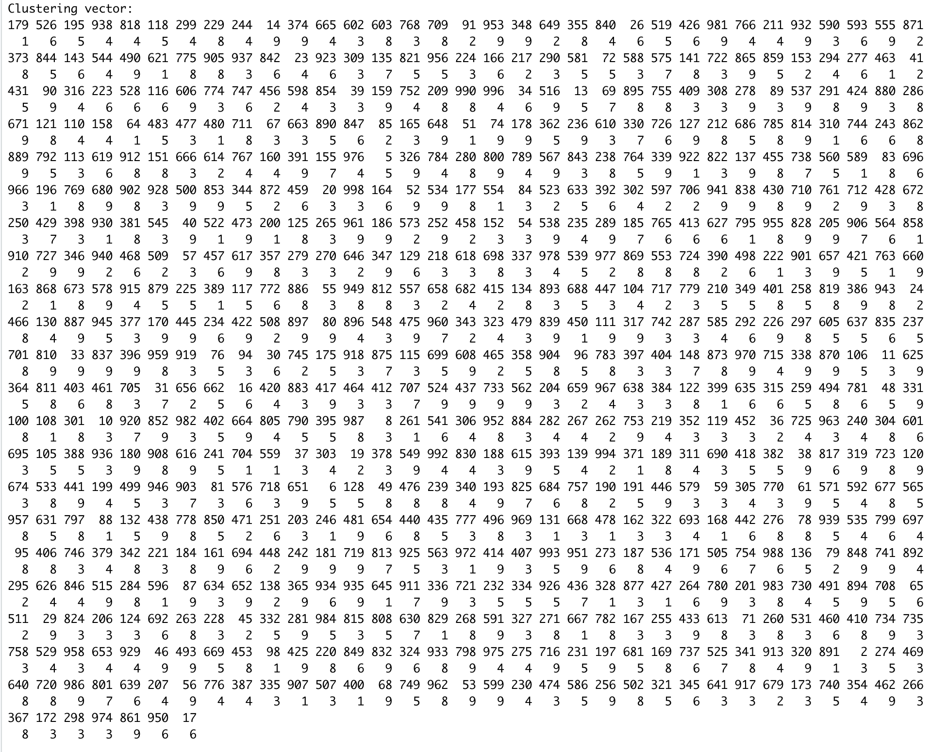

Test: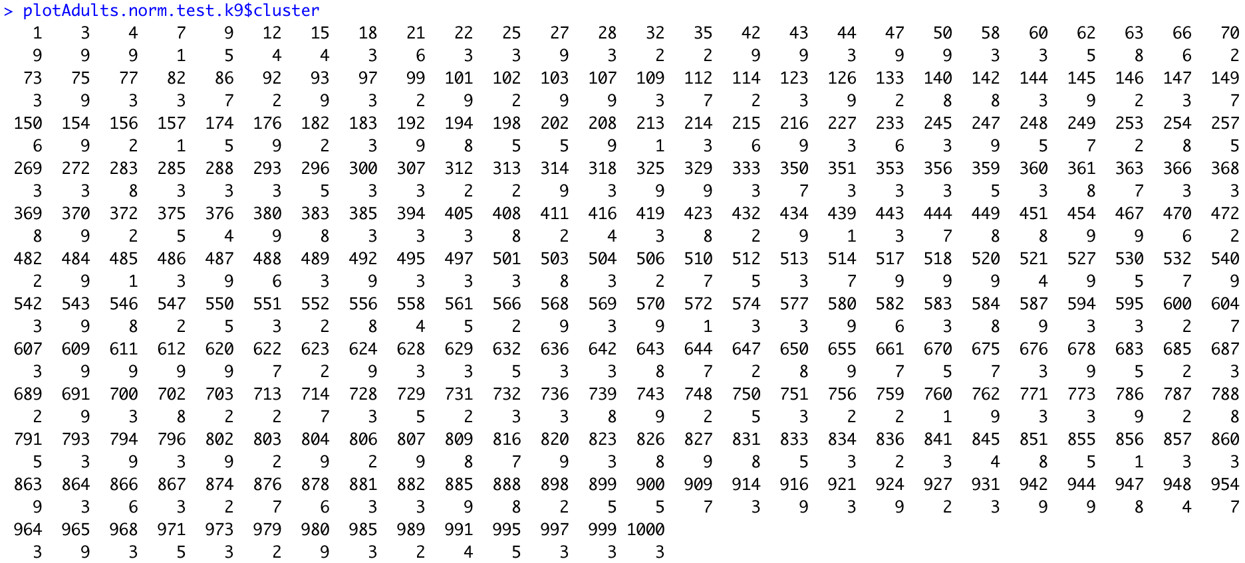

**k=10**

Train: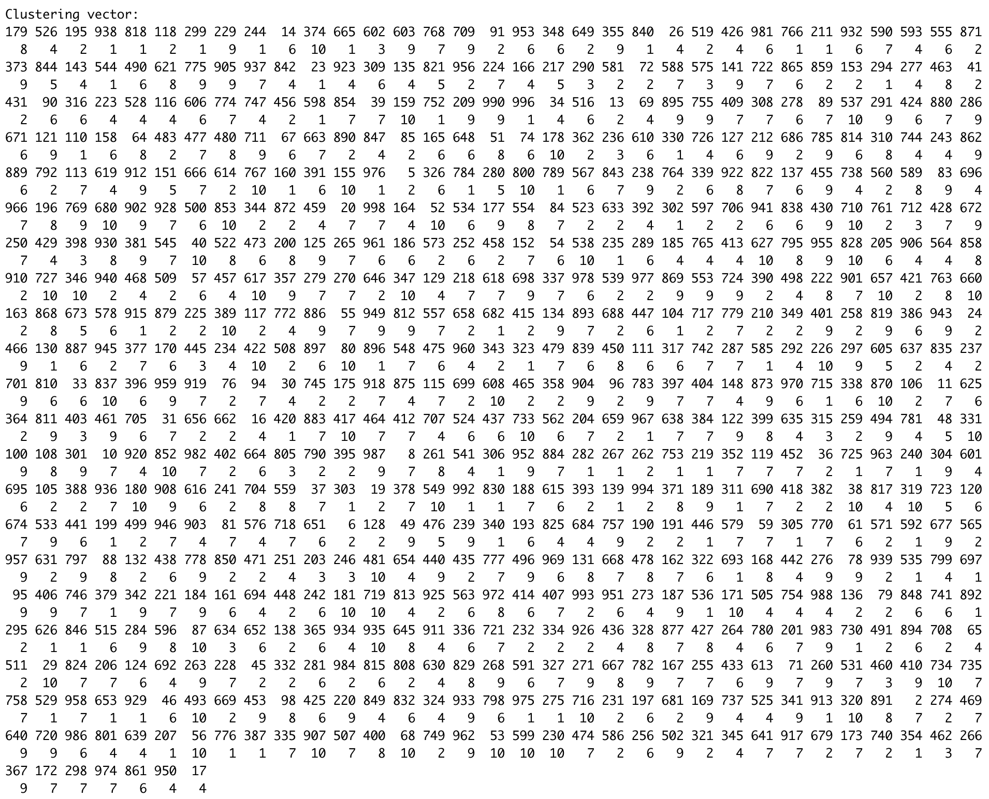

Test: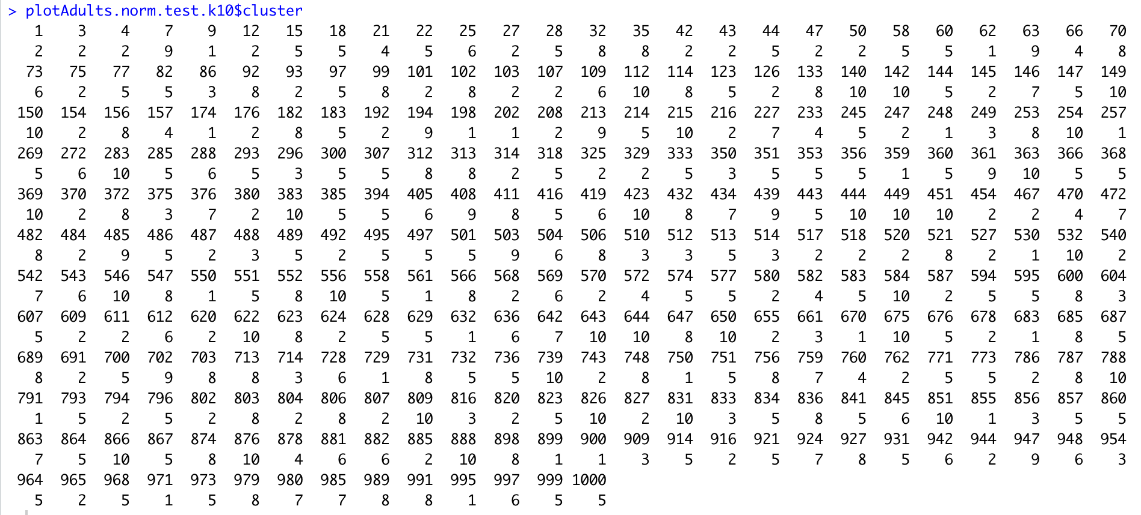

Knn 60-40 ratio

k=2

Train: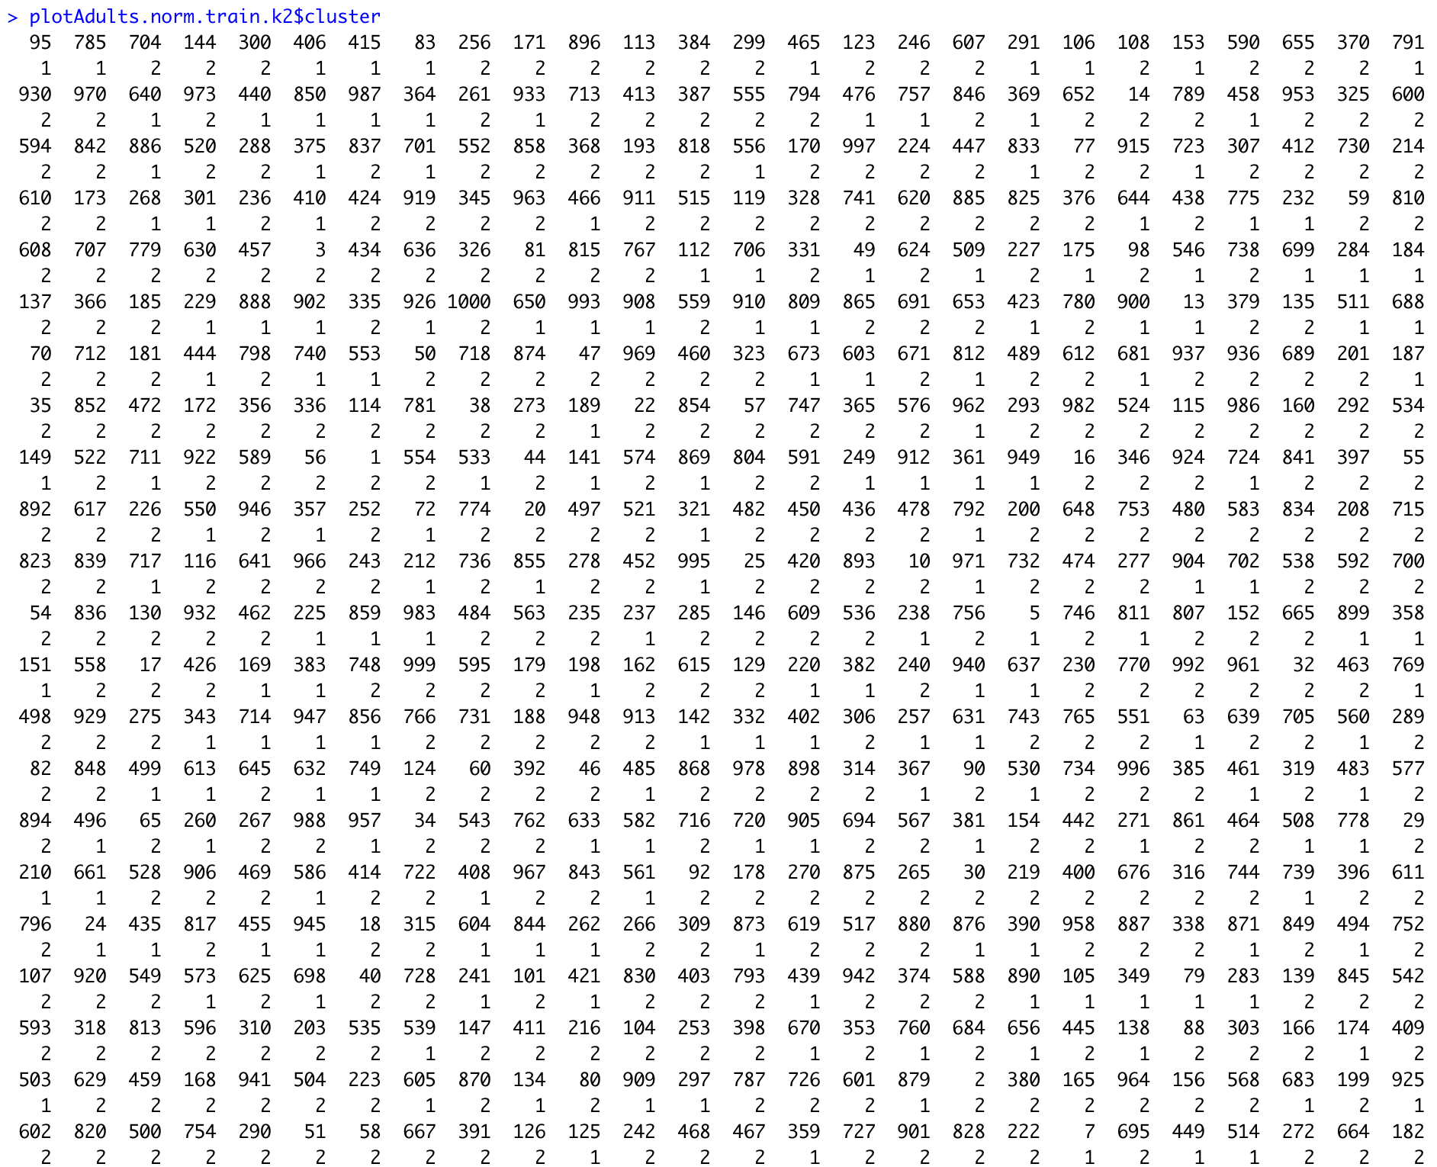

Test:

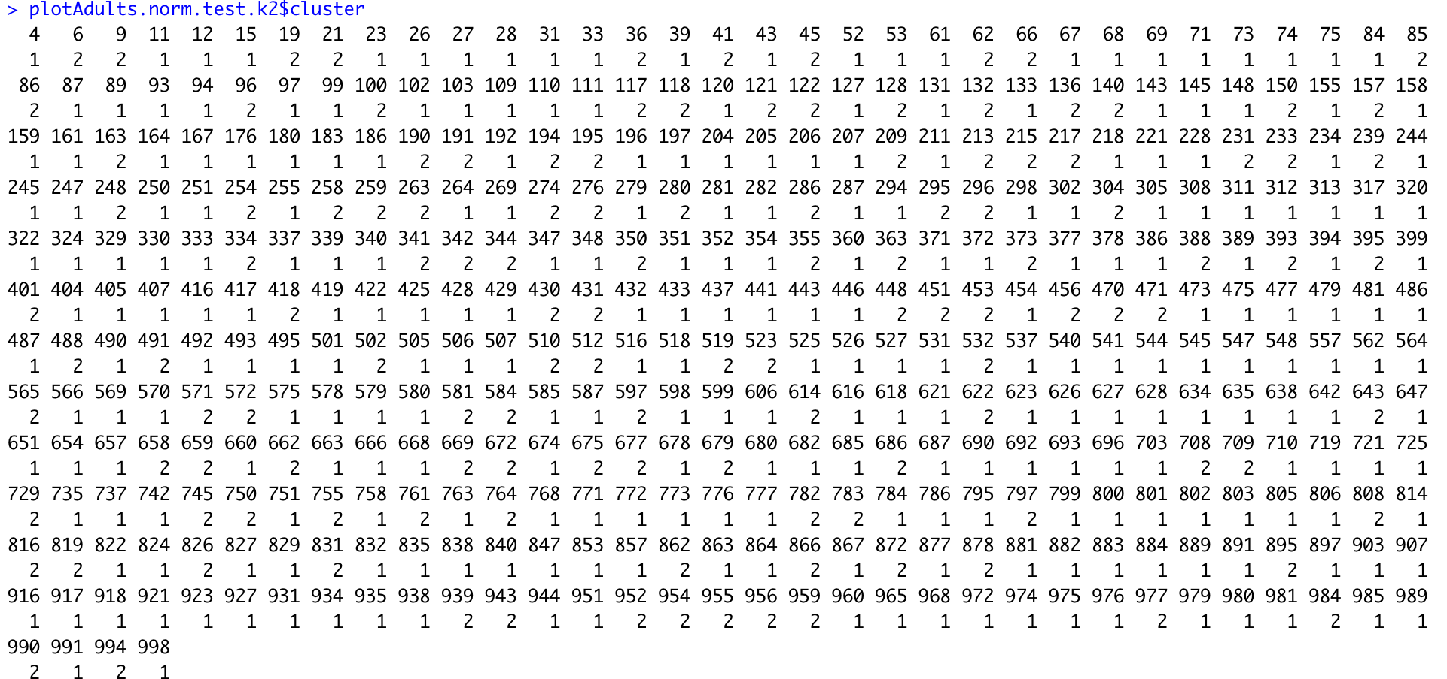

k=3

Train:

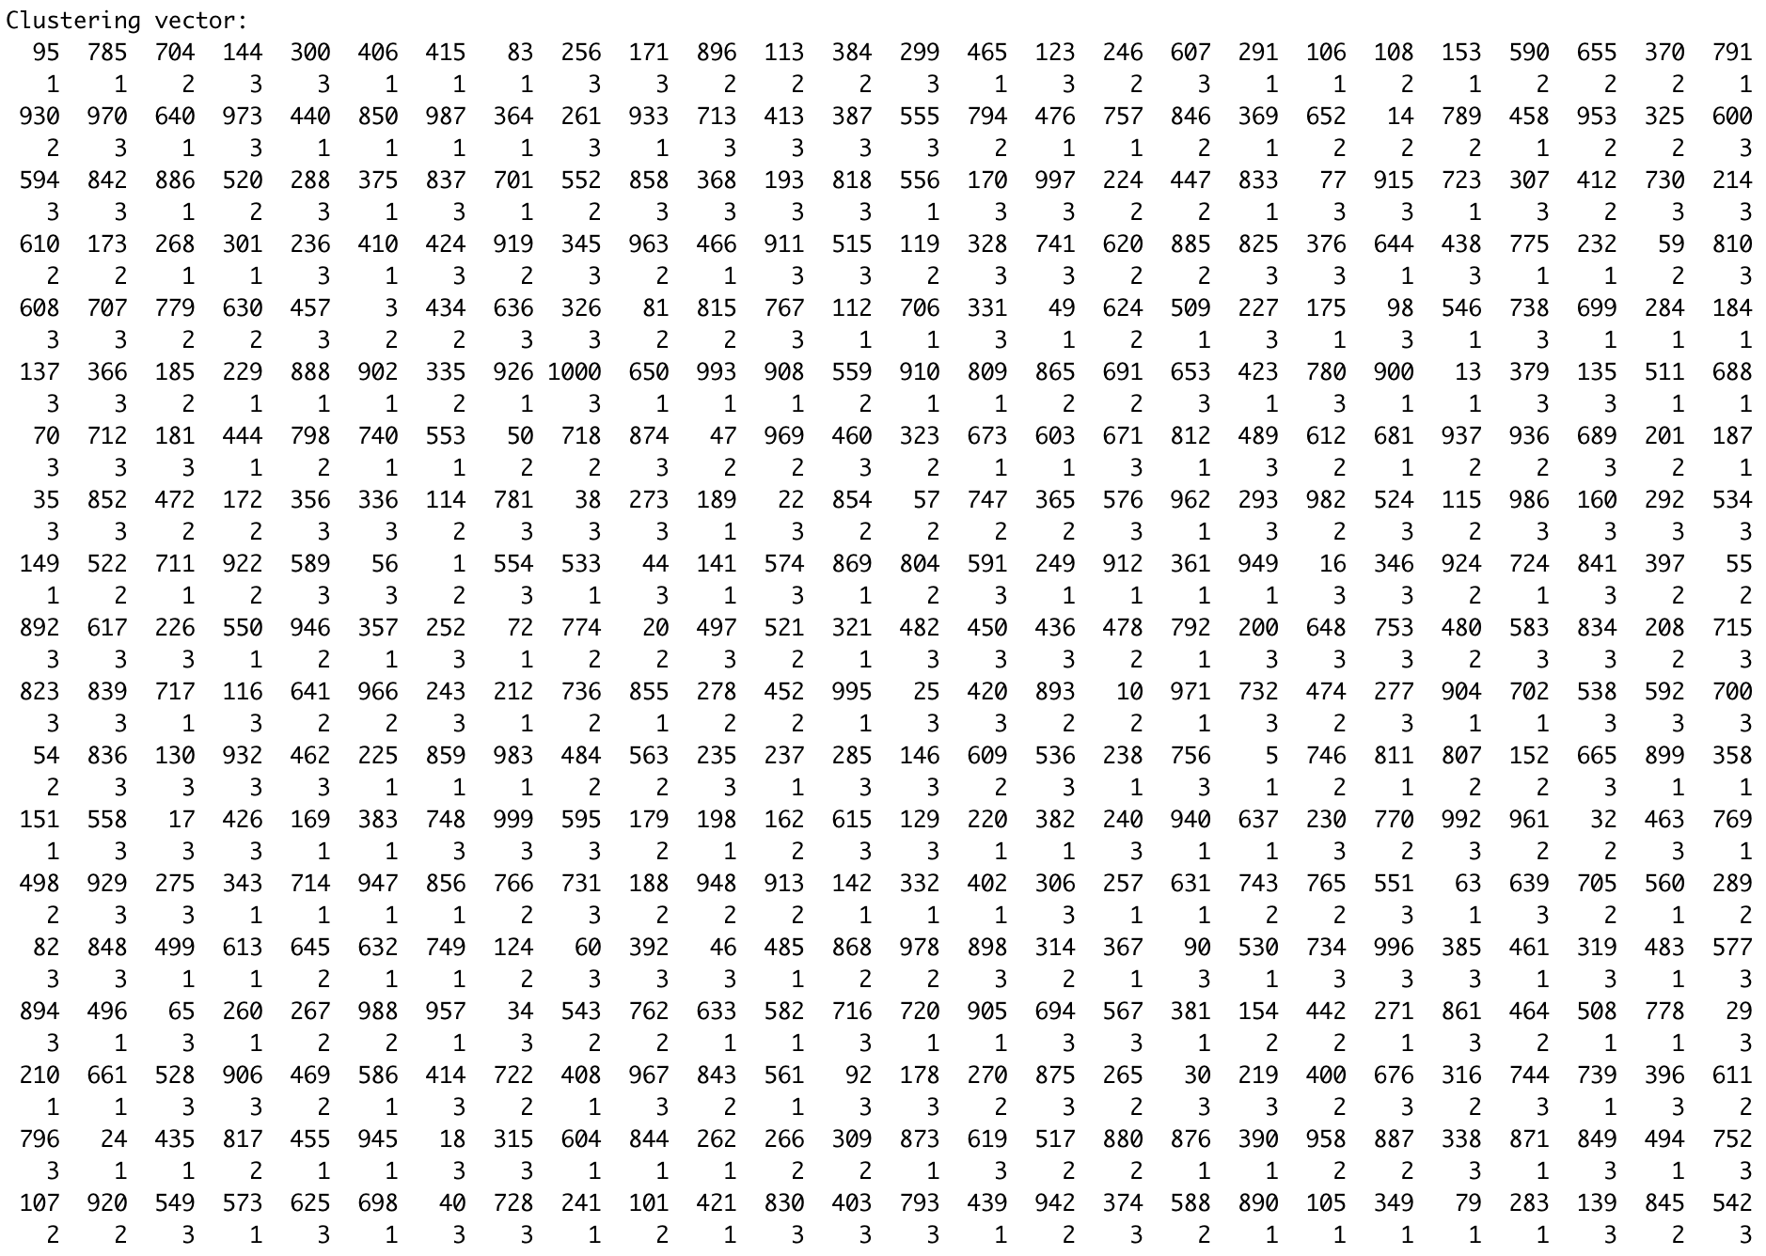

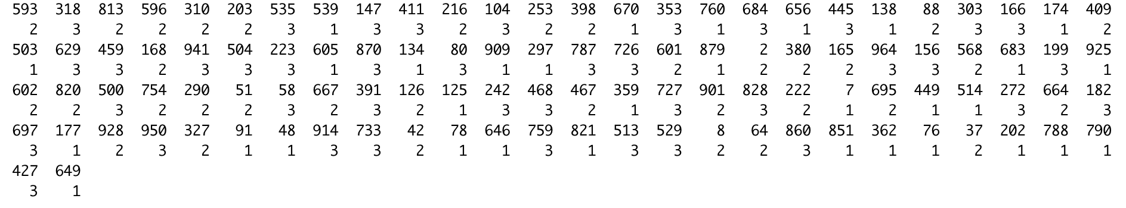

Test: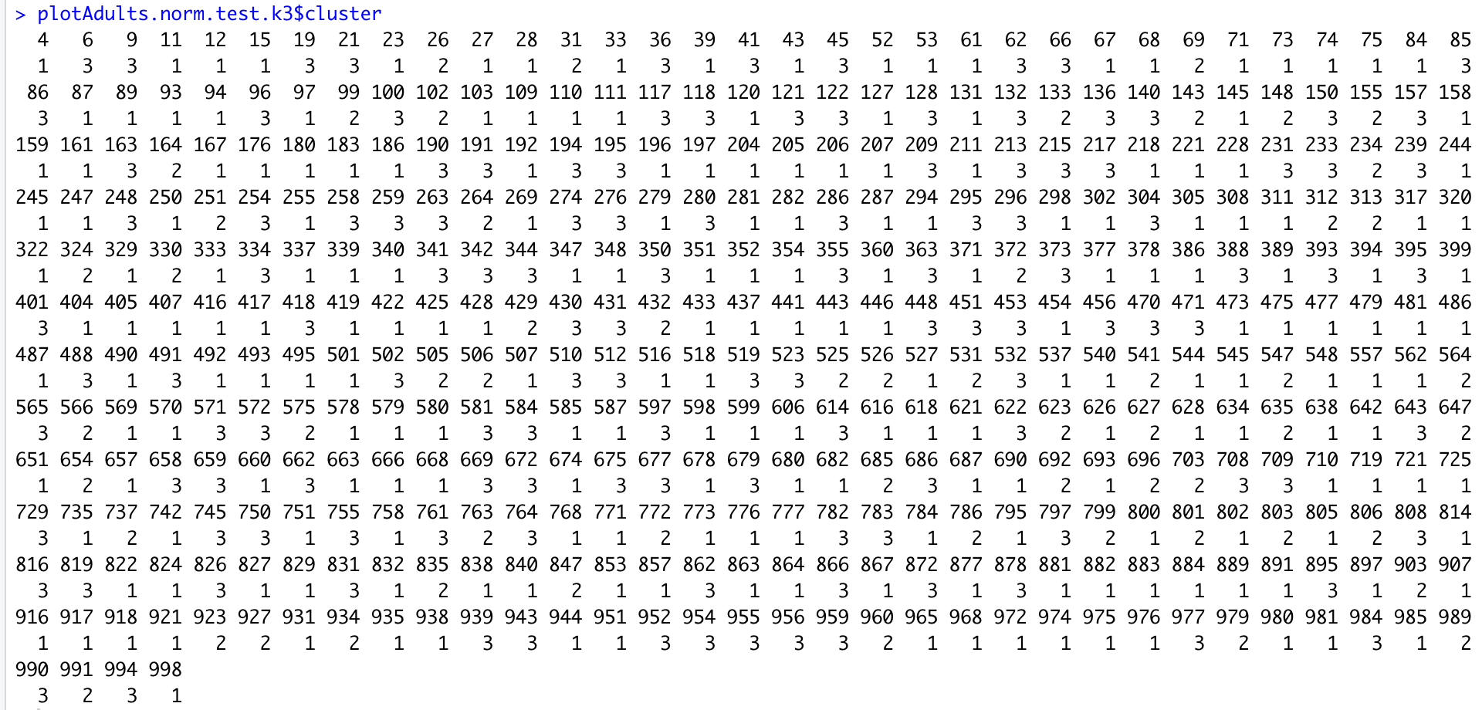

k=4

Train: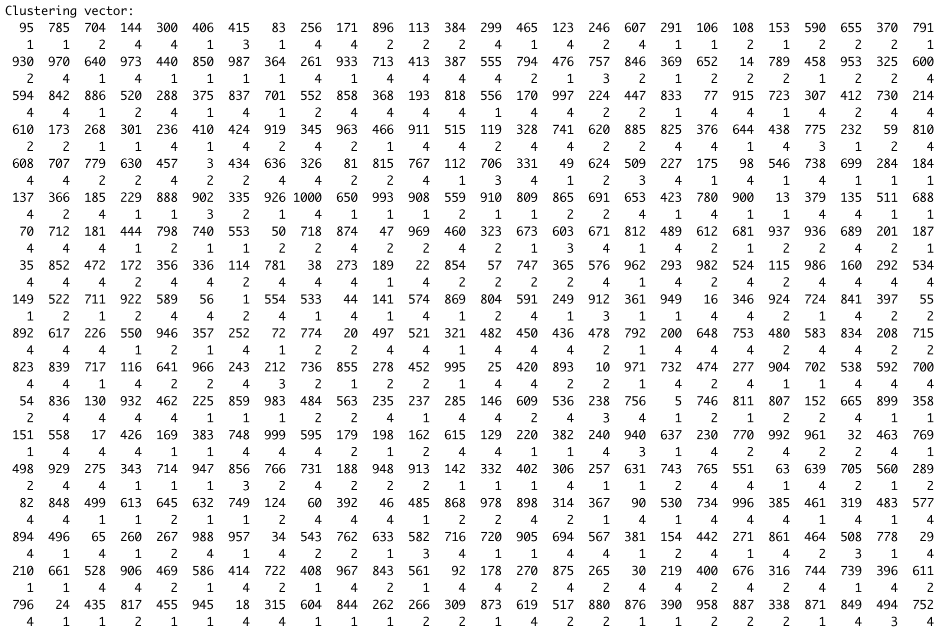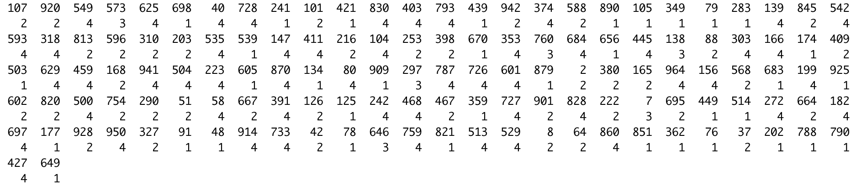

Test:

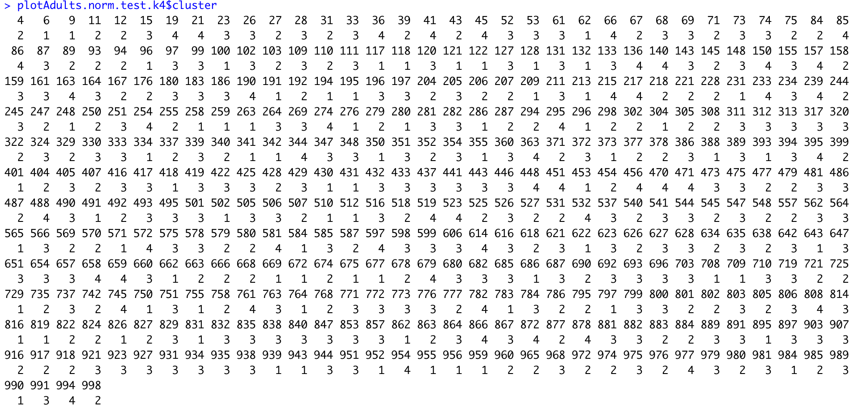

k=5

Train:

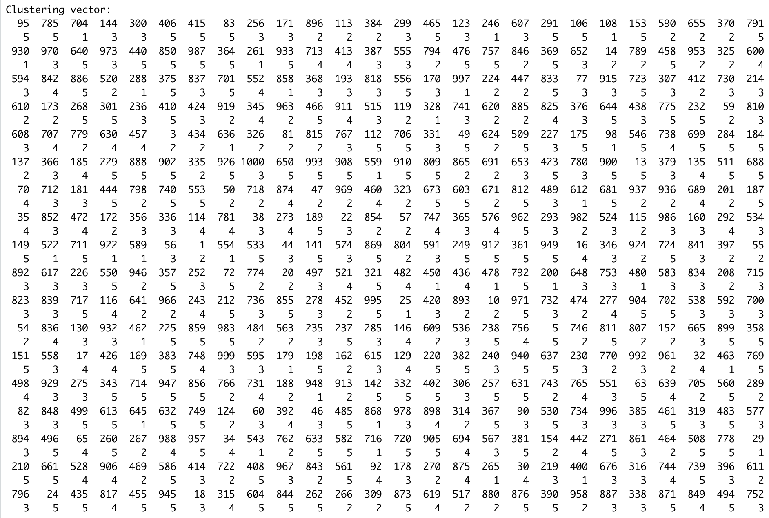

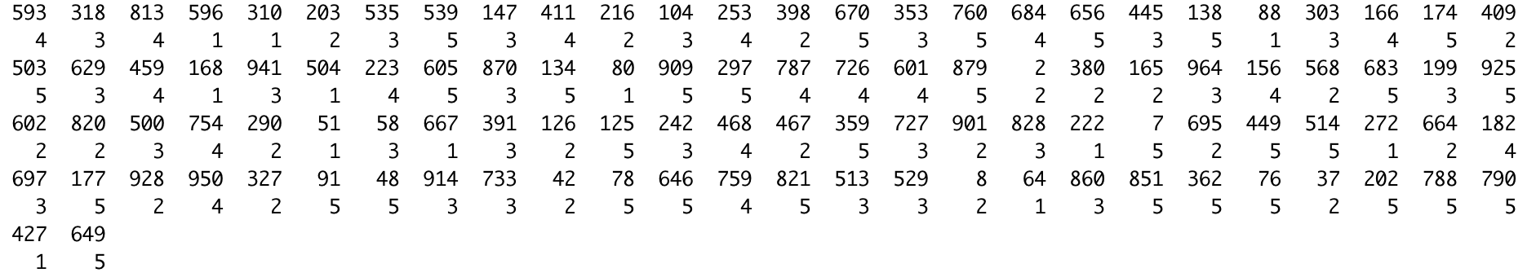

Test:

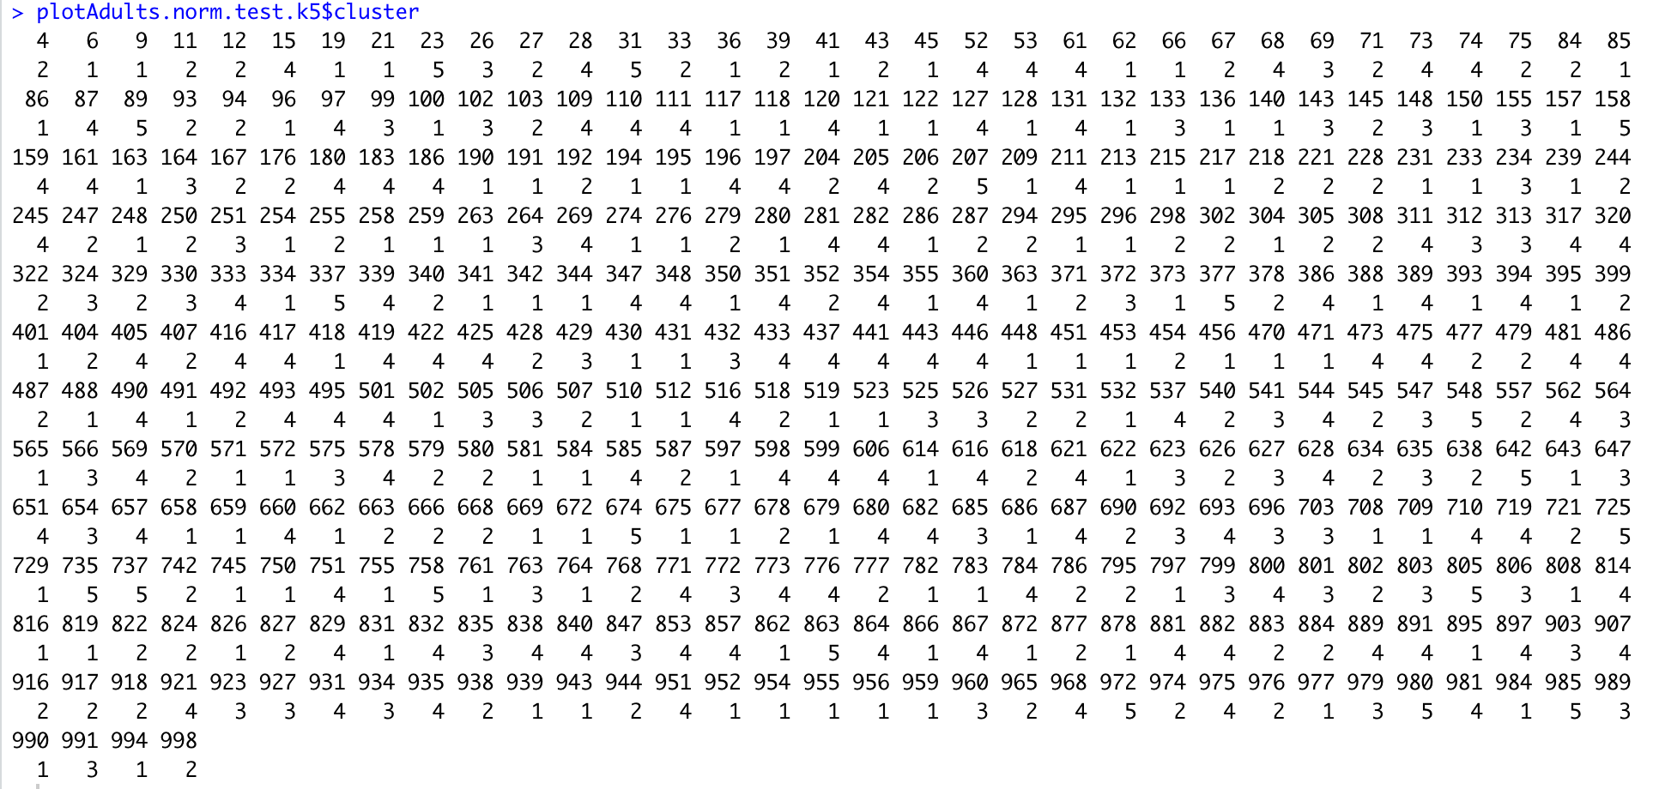

k=6

Train:

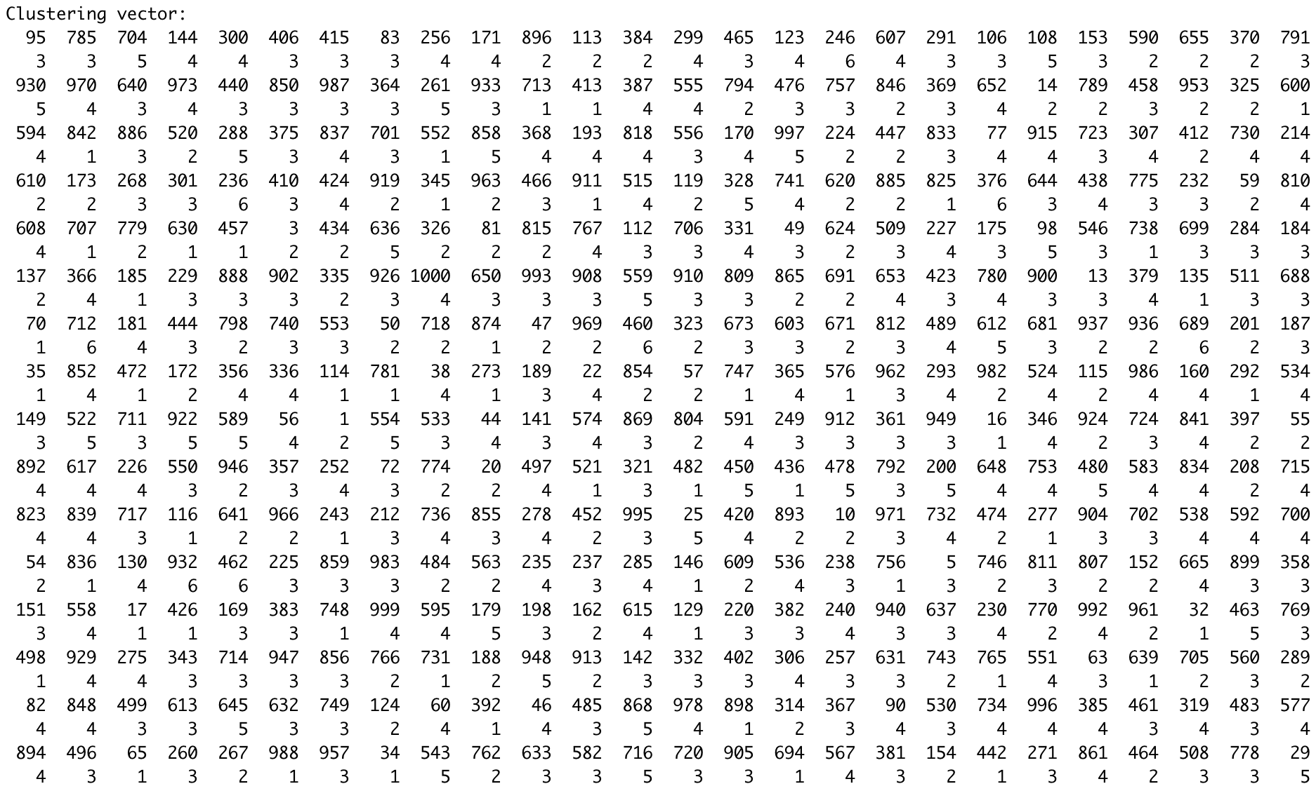

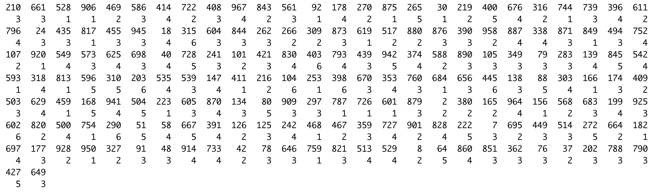

Test:

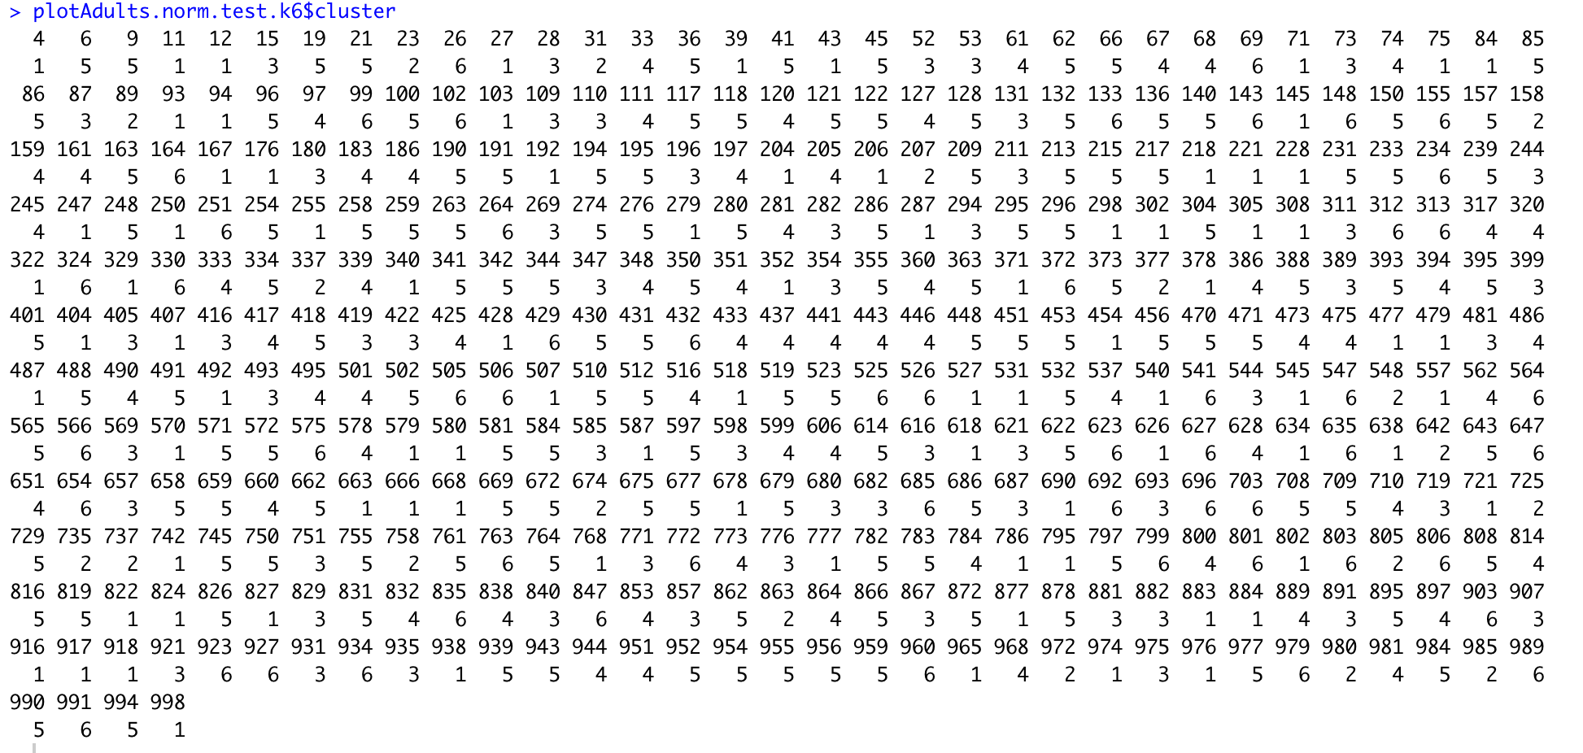

k=7

Train:

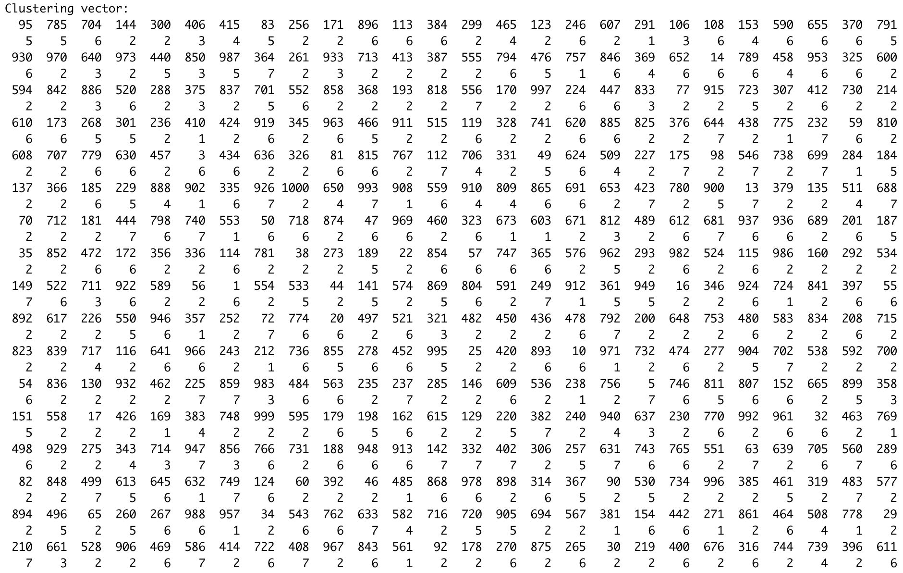

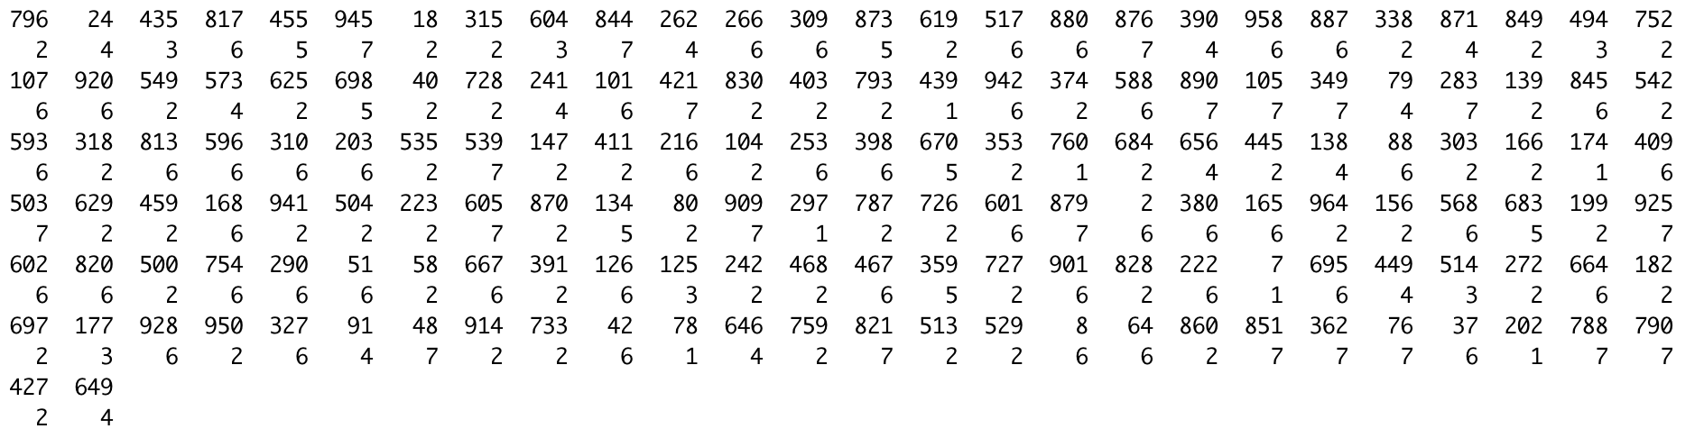

Test:

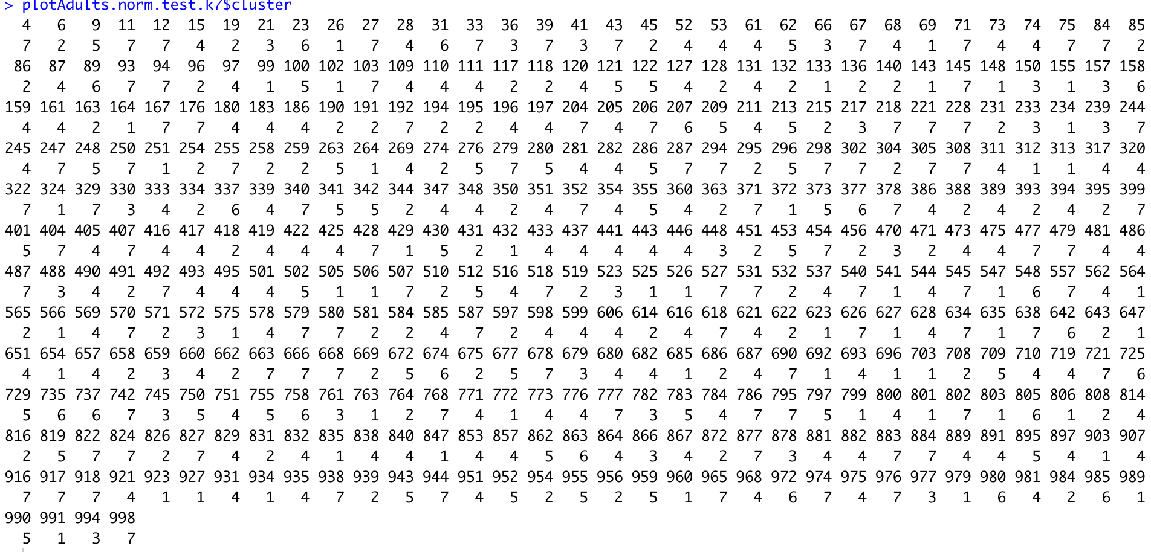

k=8

Train:

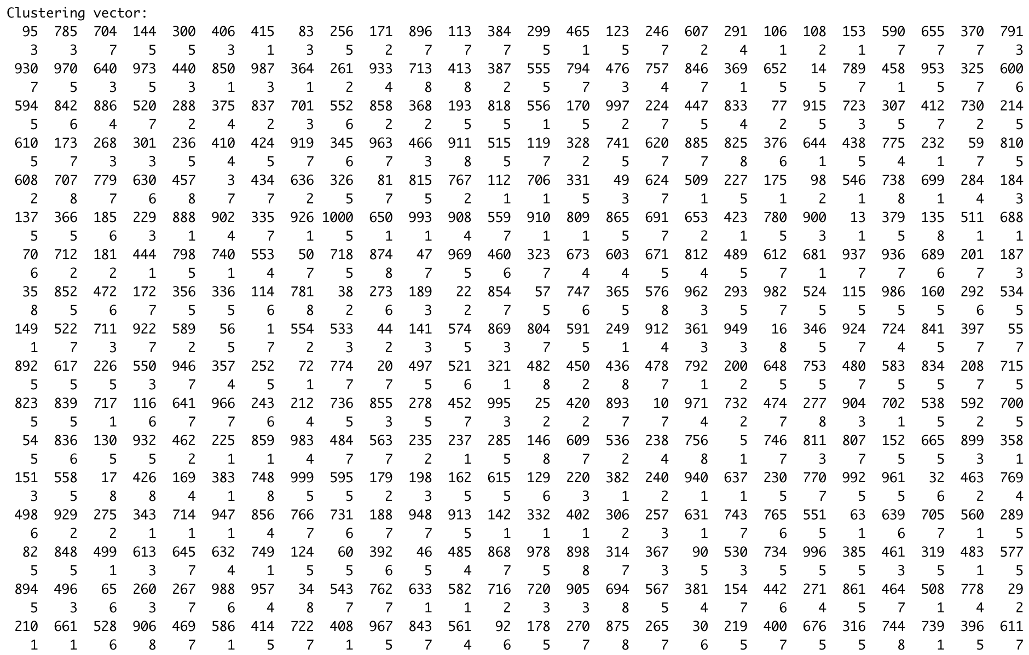

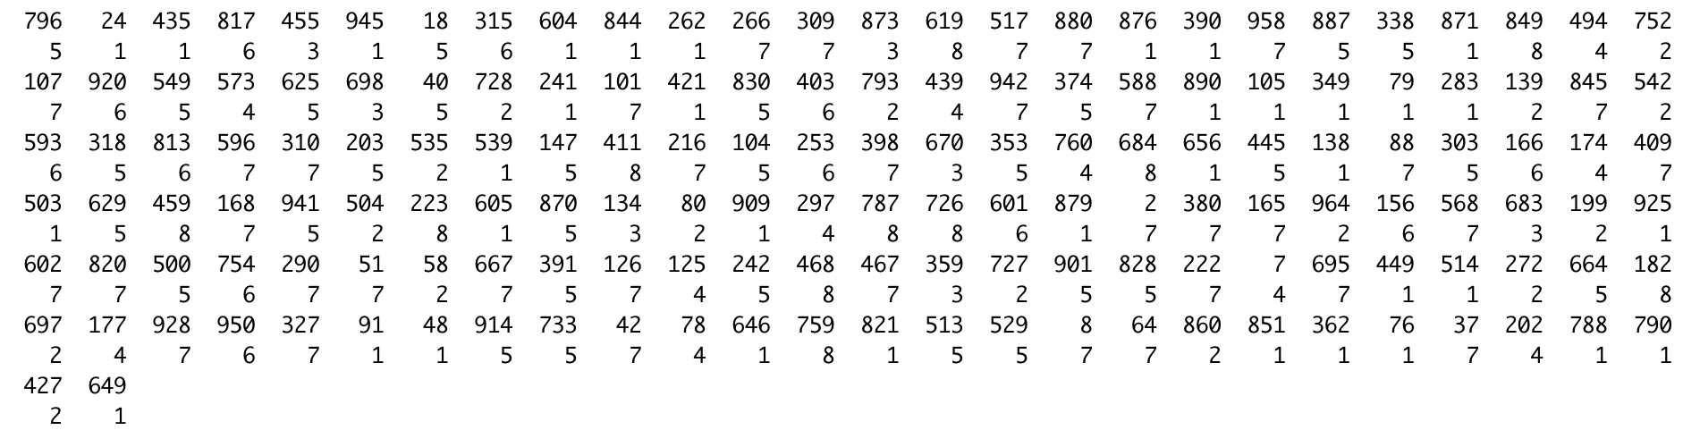

Test:

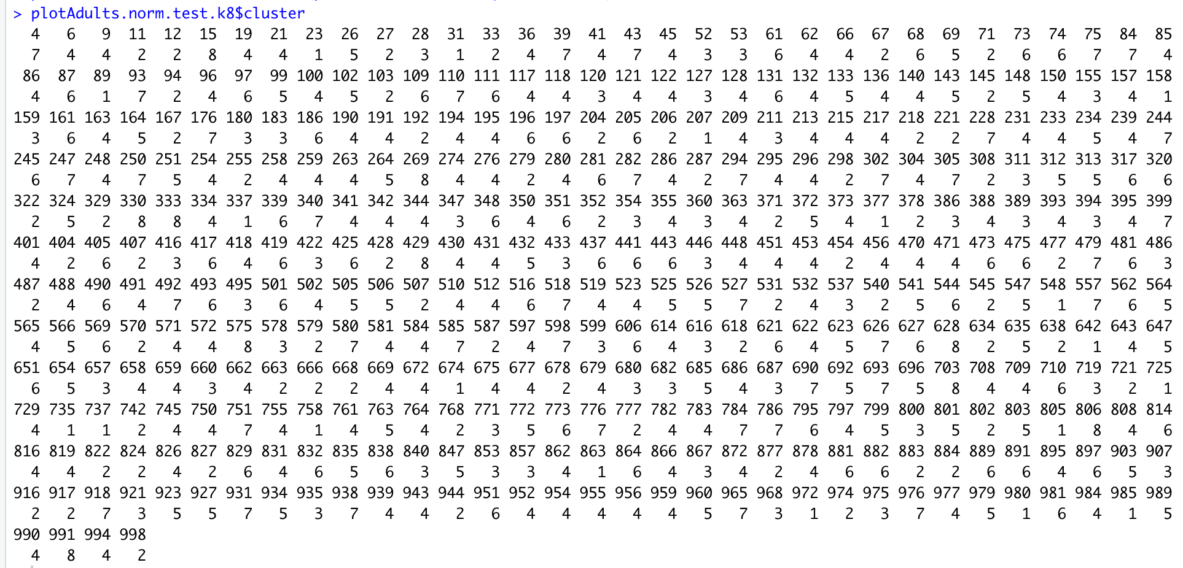

k=9

Train:

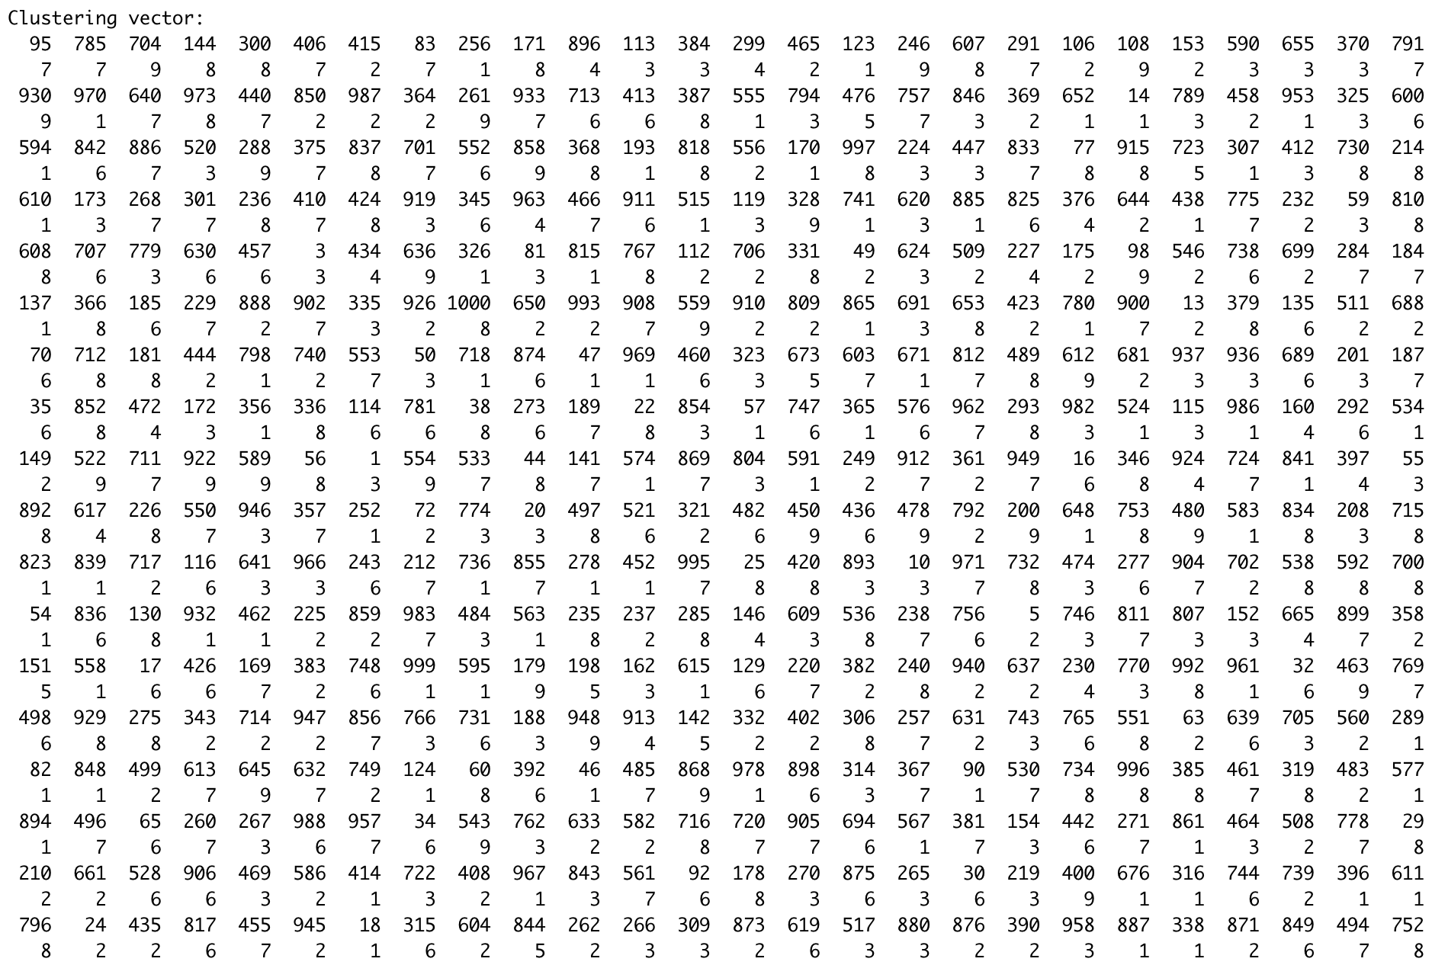

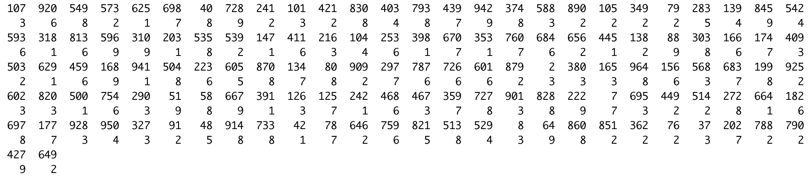

Test:

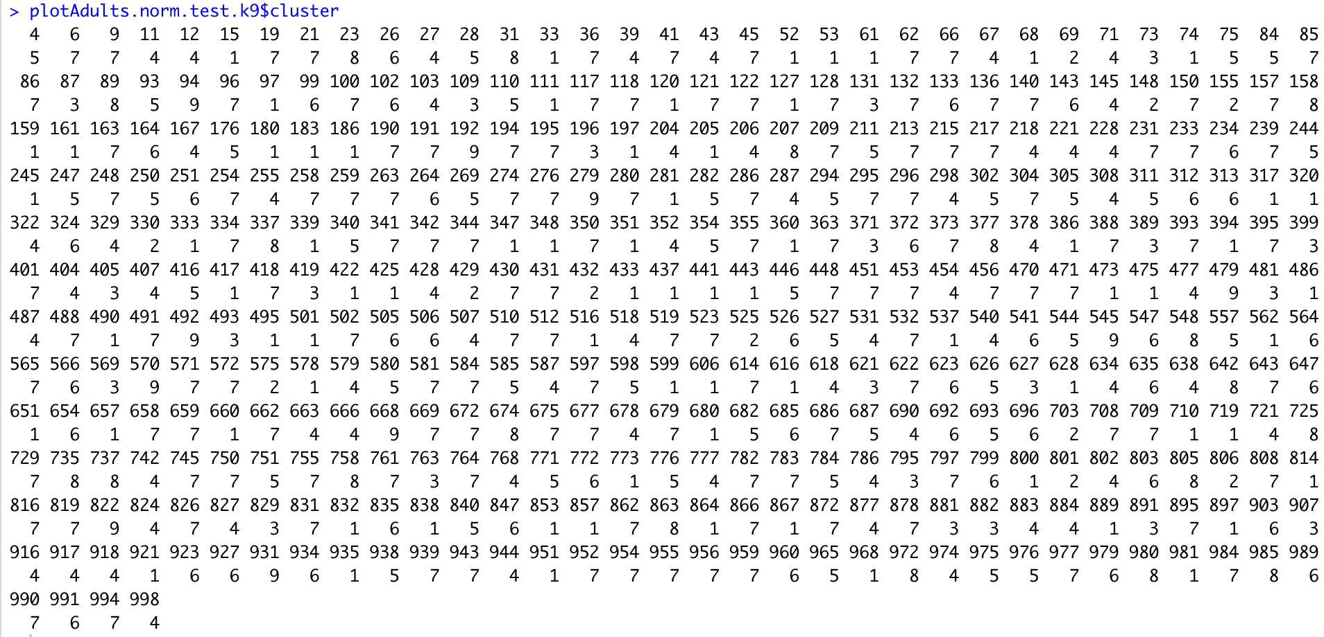

k=10

Train:

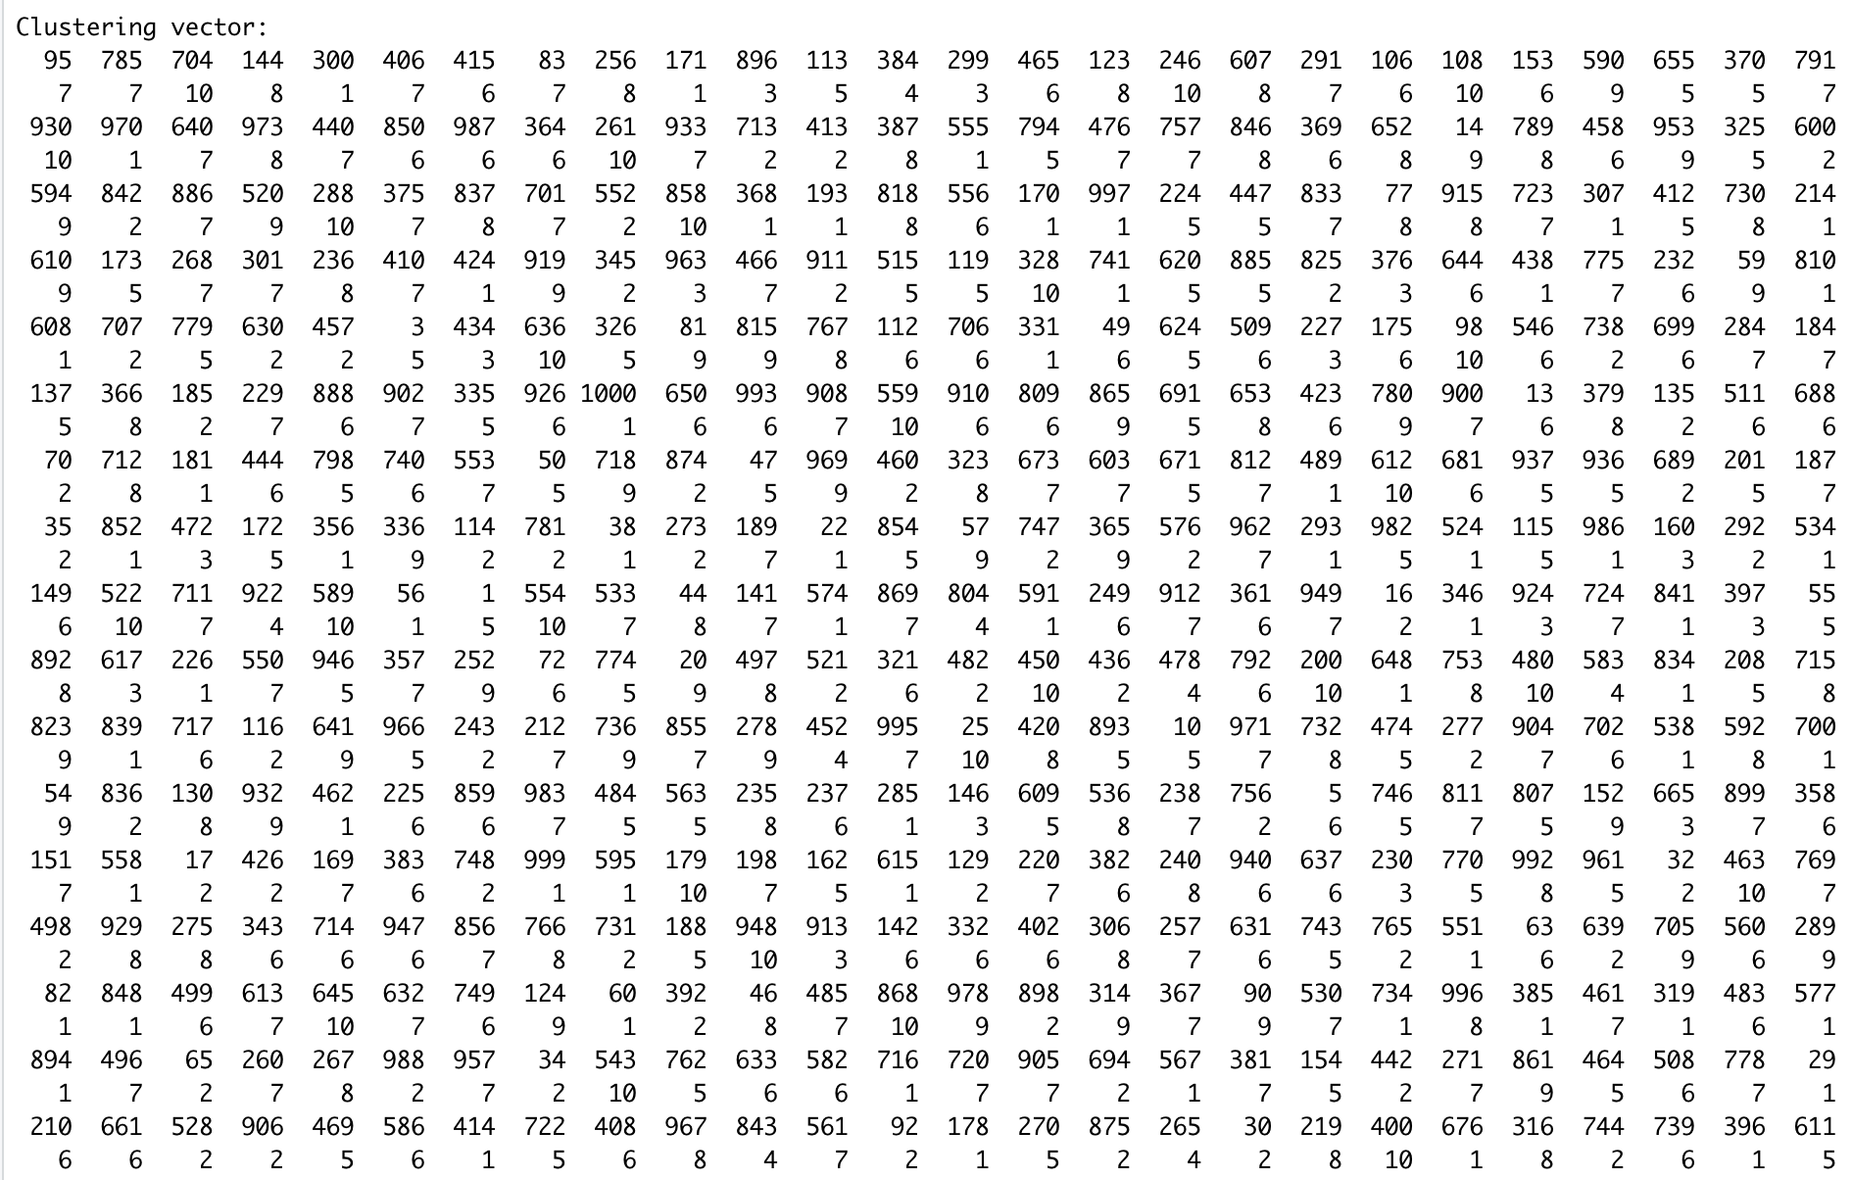

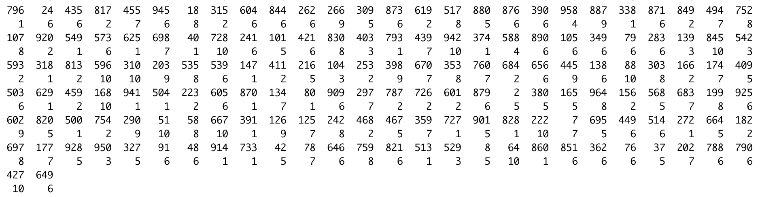

Test:

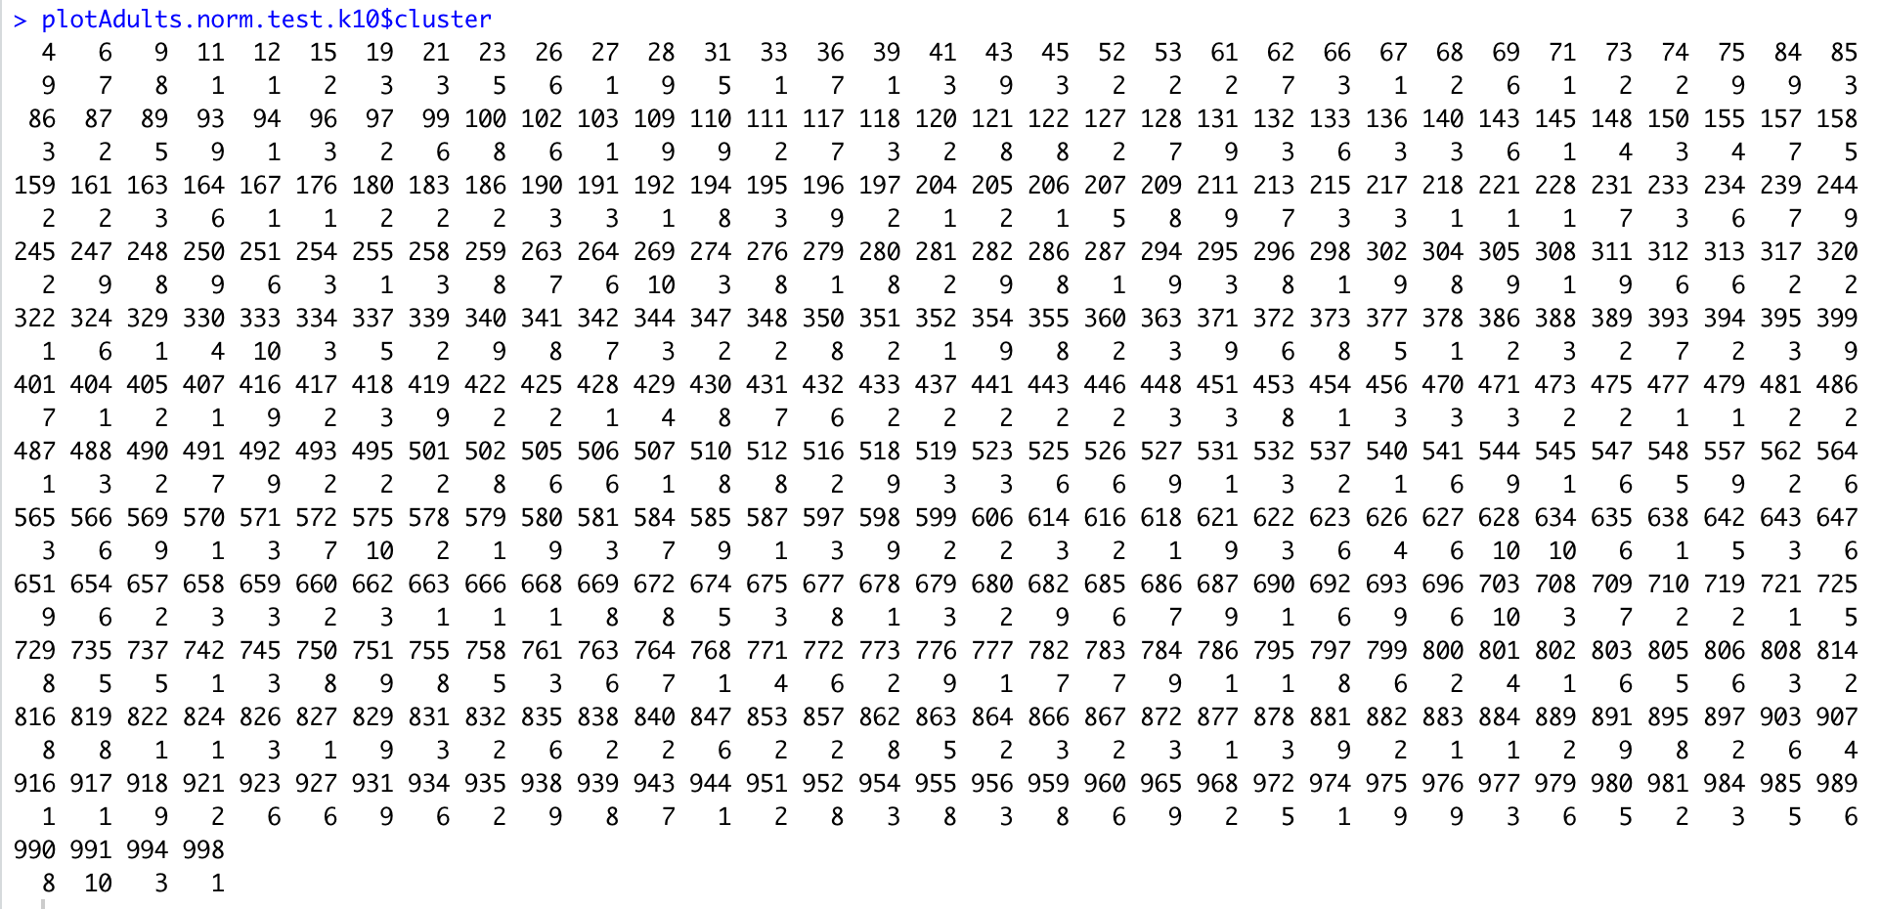

Knn 50-50 training ratio:

k=2

Train:

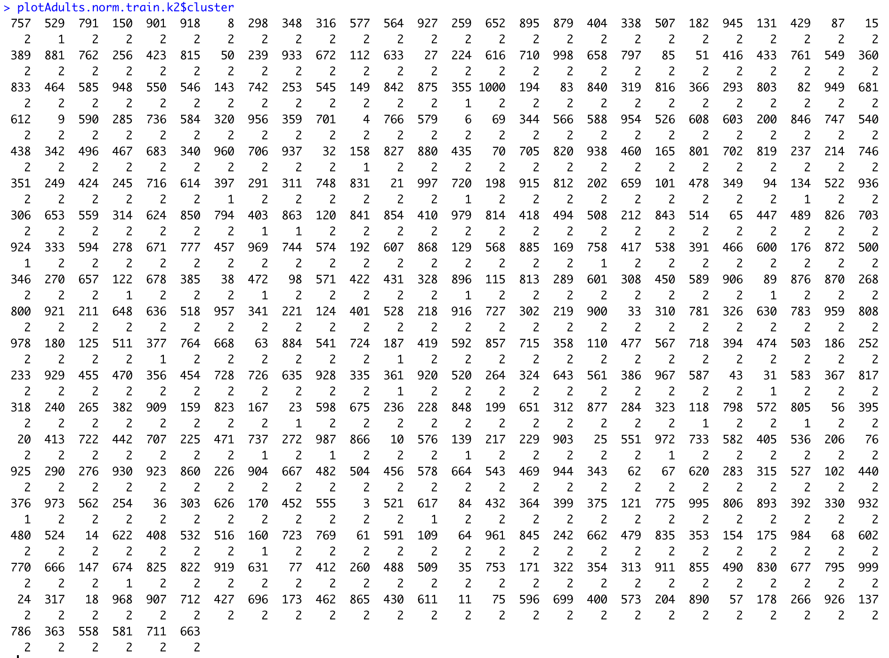

Test:

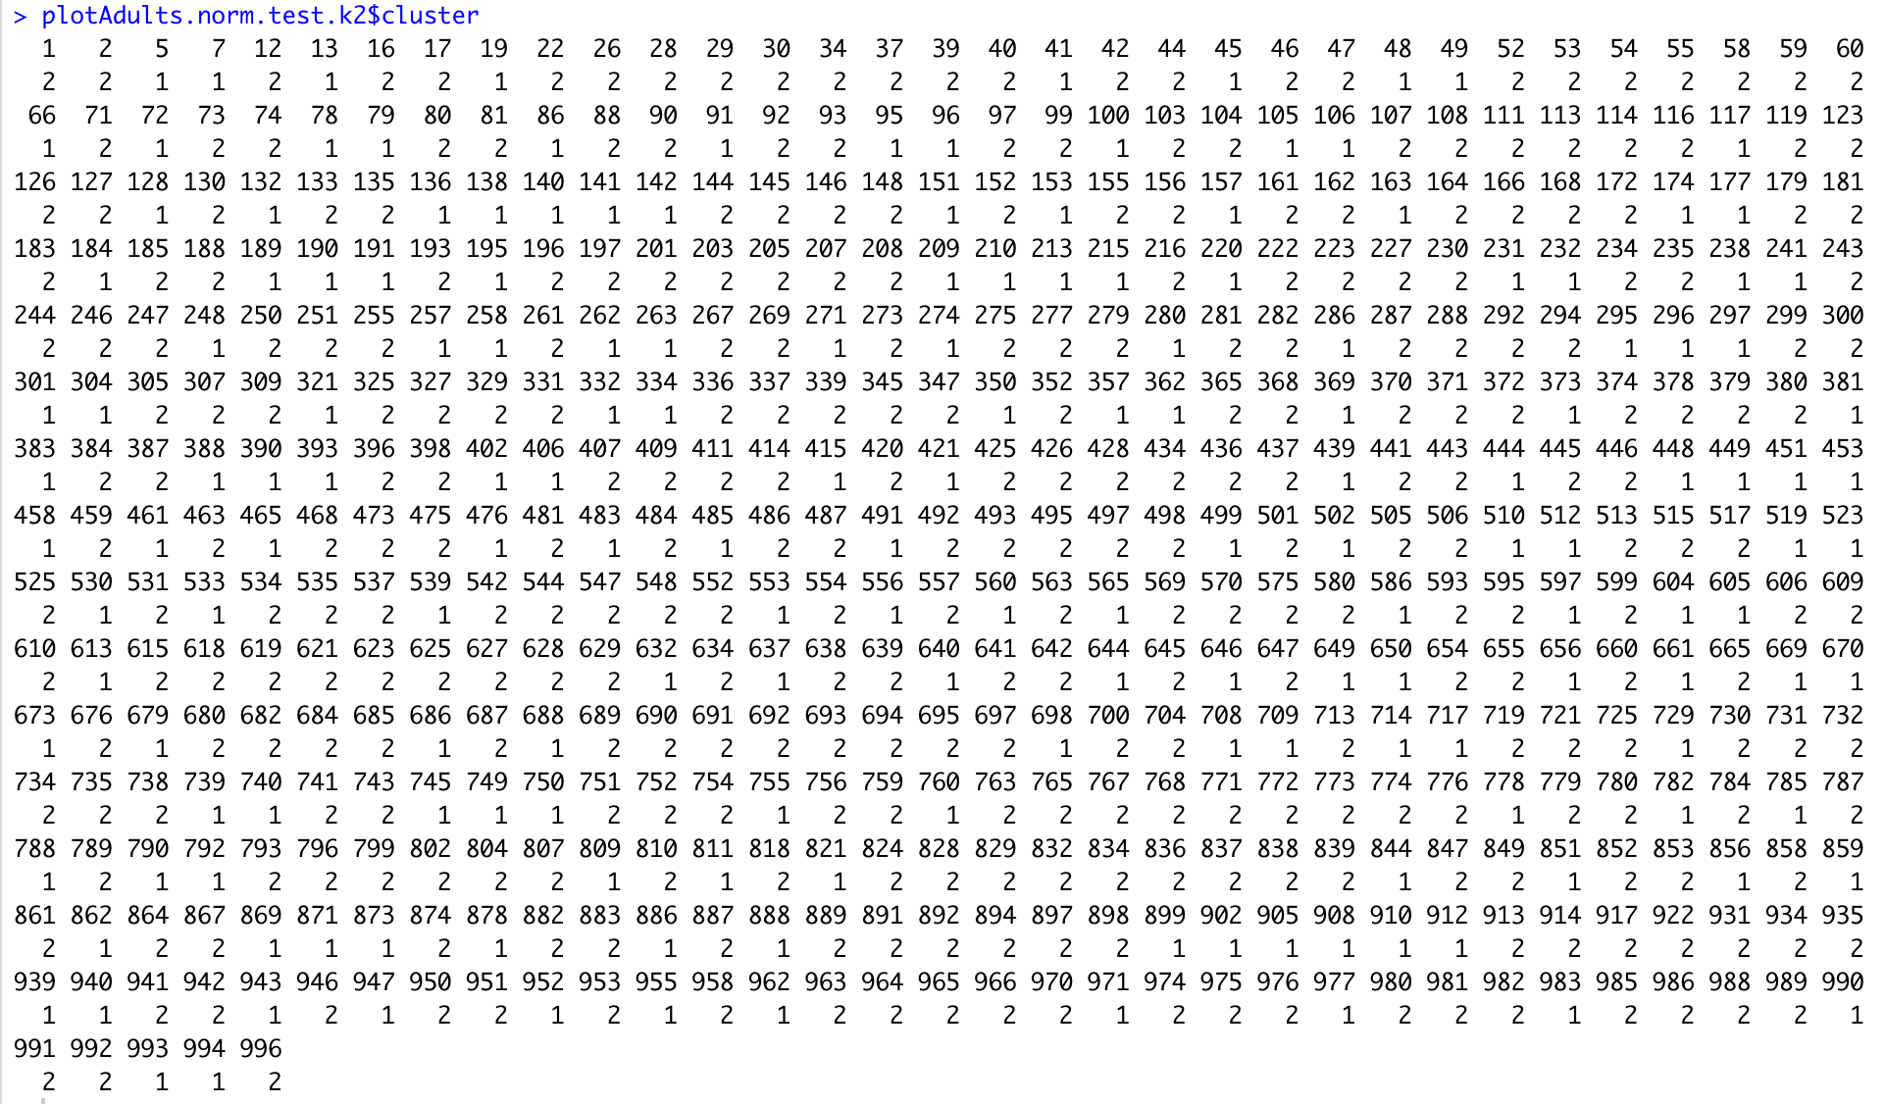

k=3

Train:

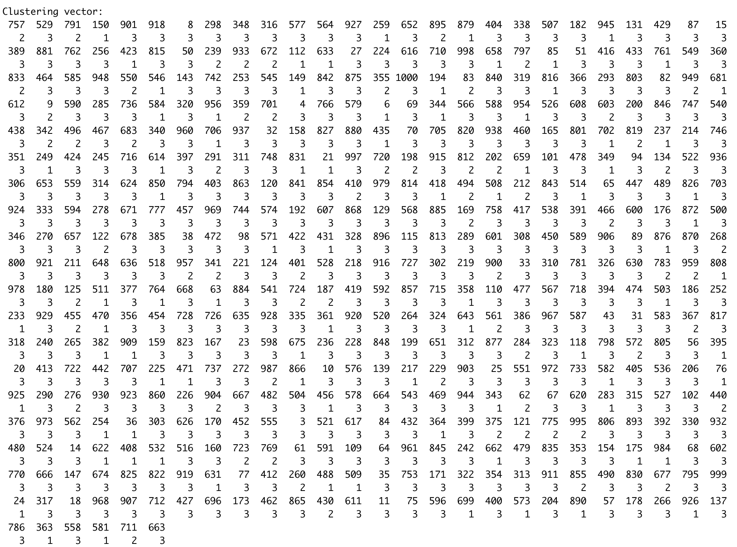

Test:

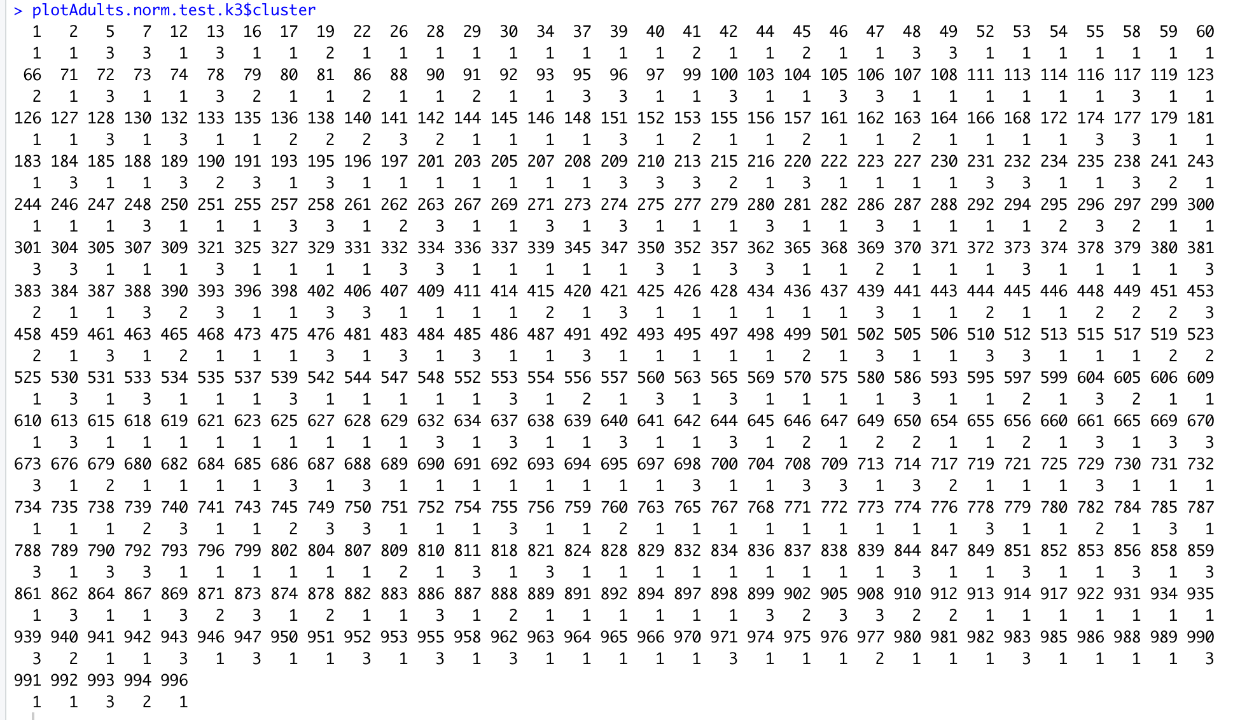

k=4

Train:

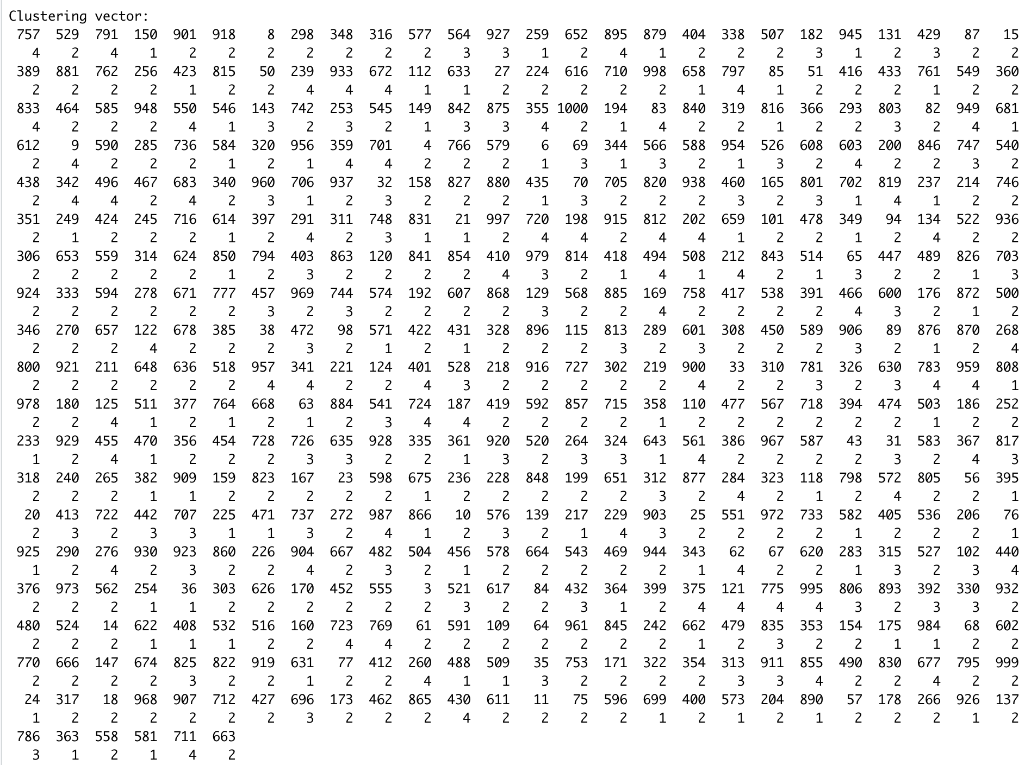

Test:

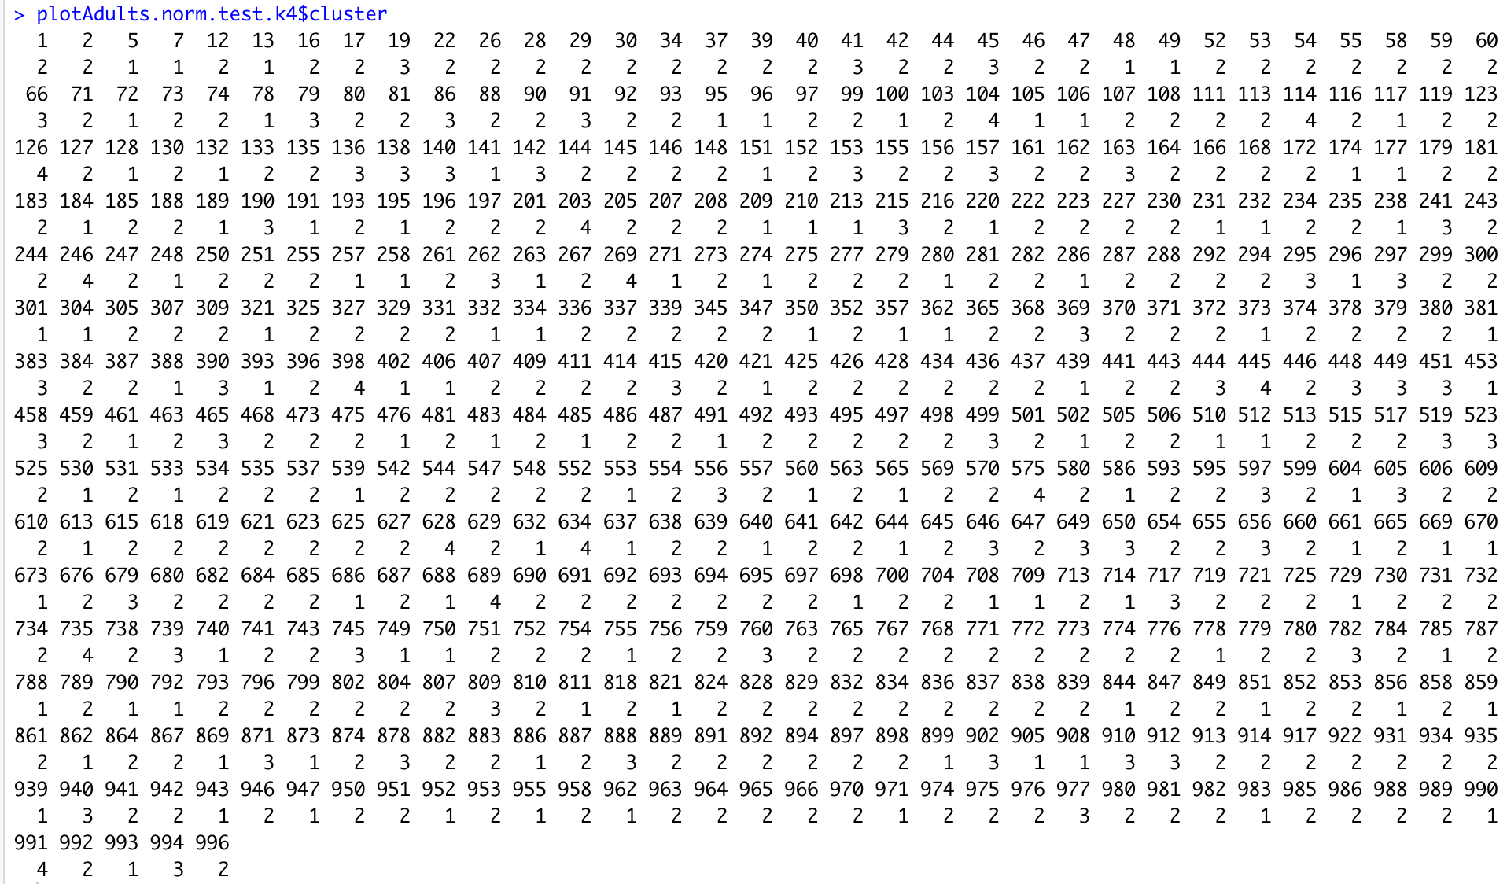

k=5

Train:

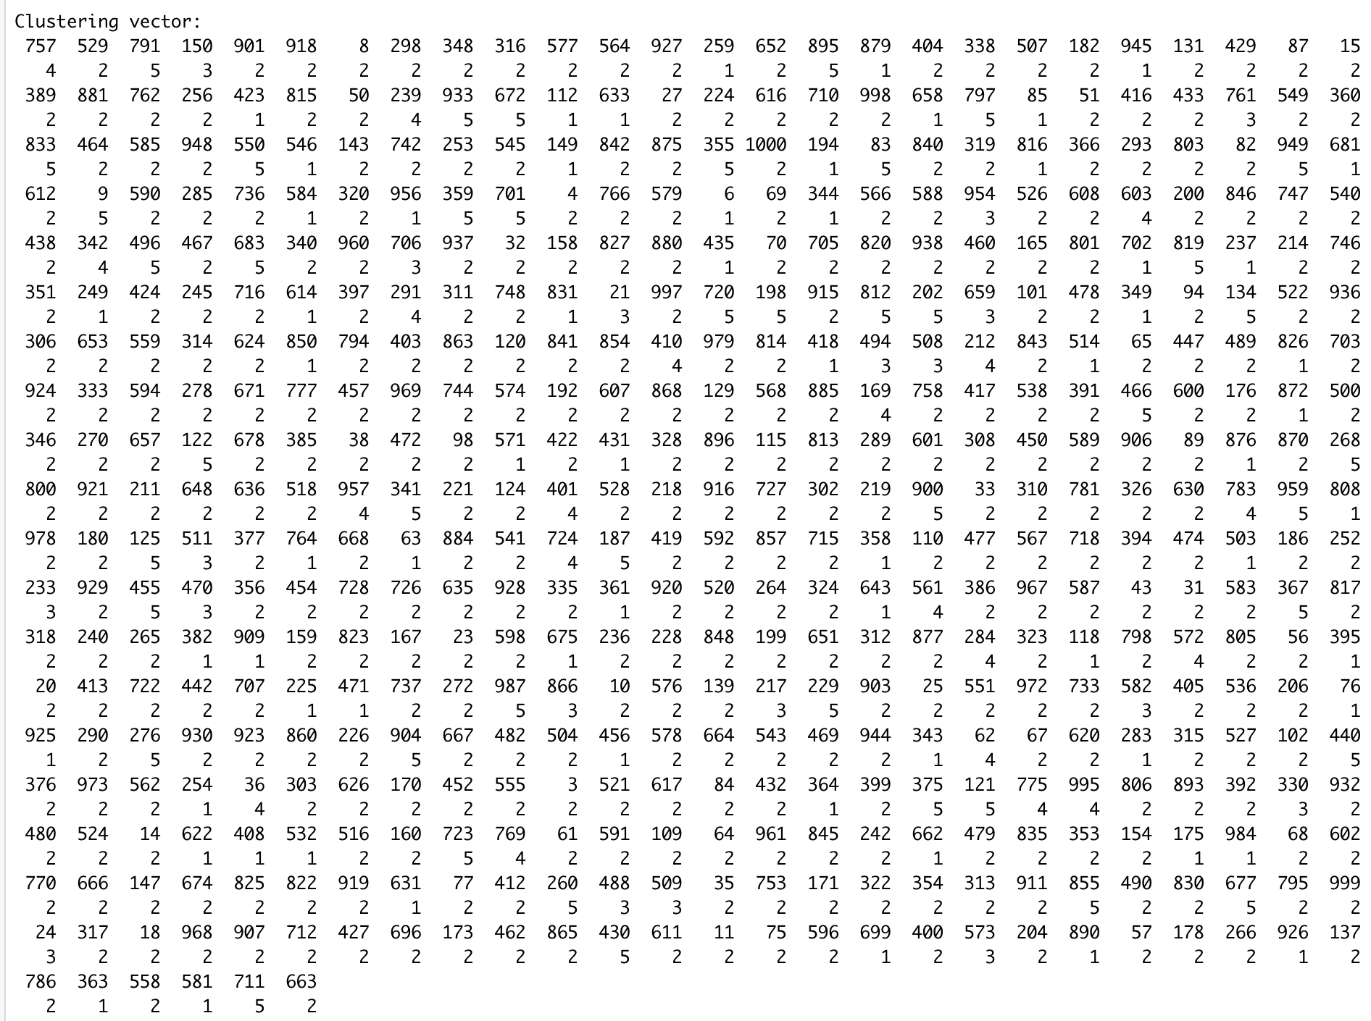

Test:

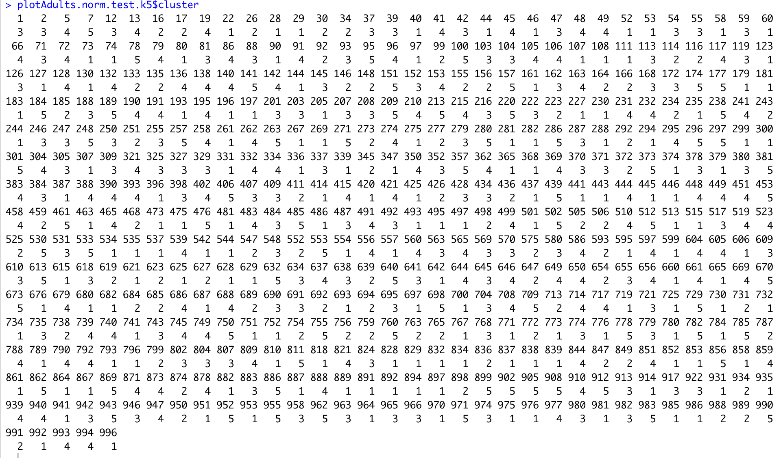

k=6

Train:

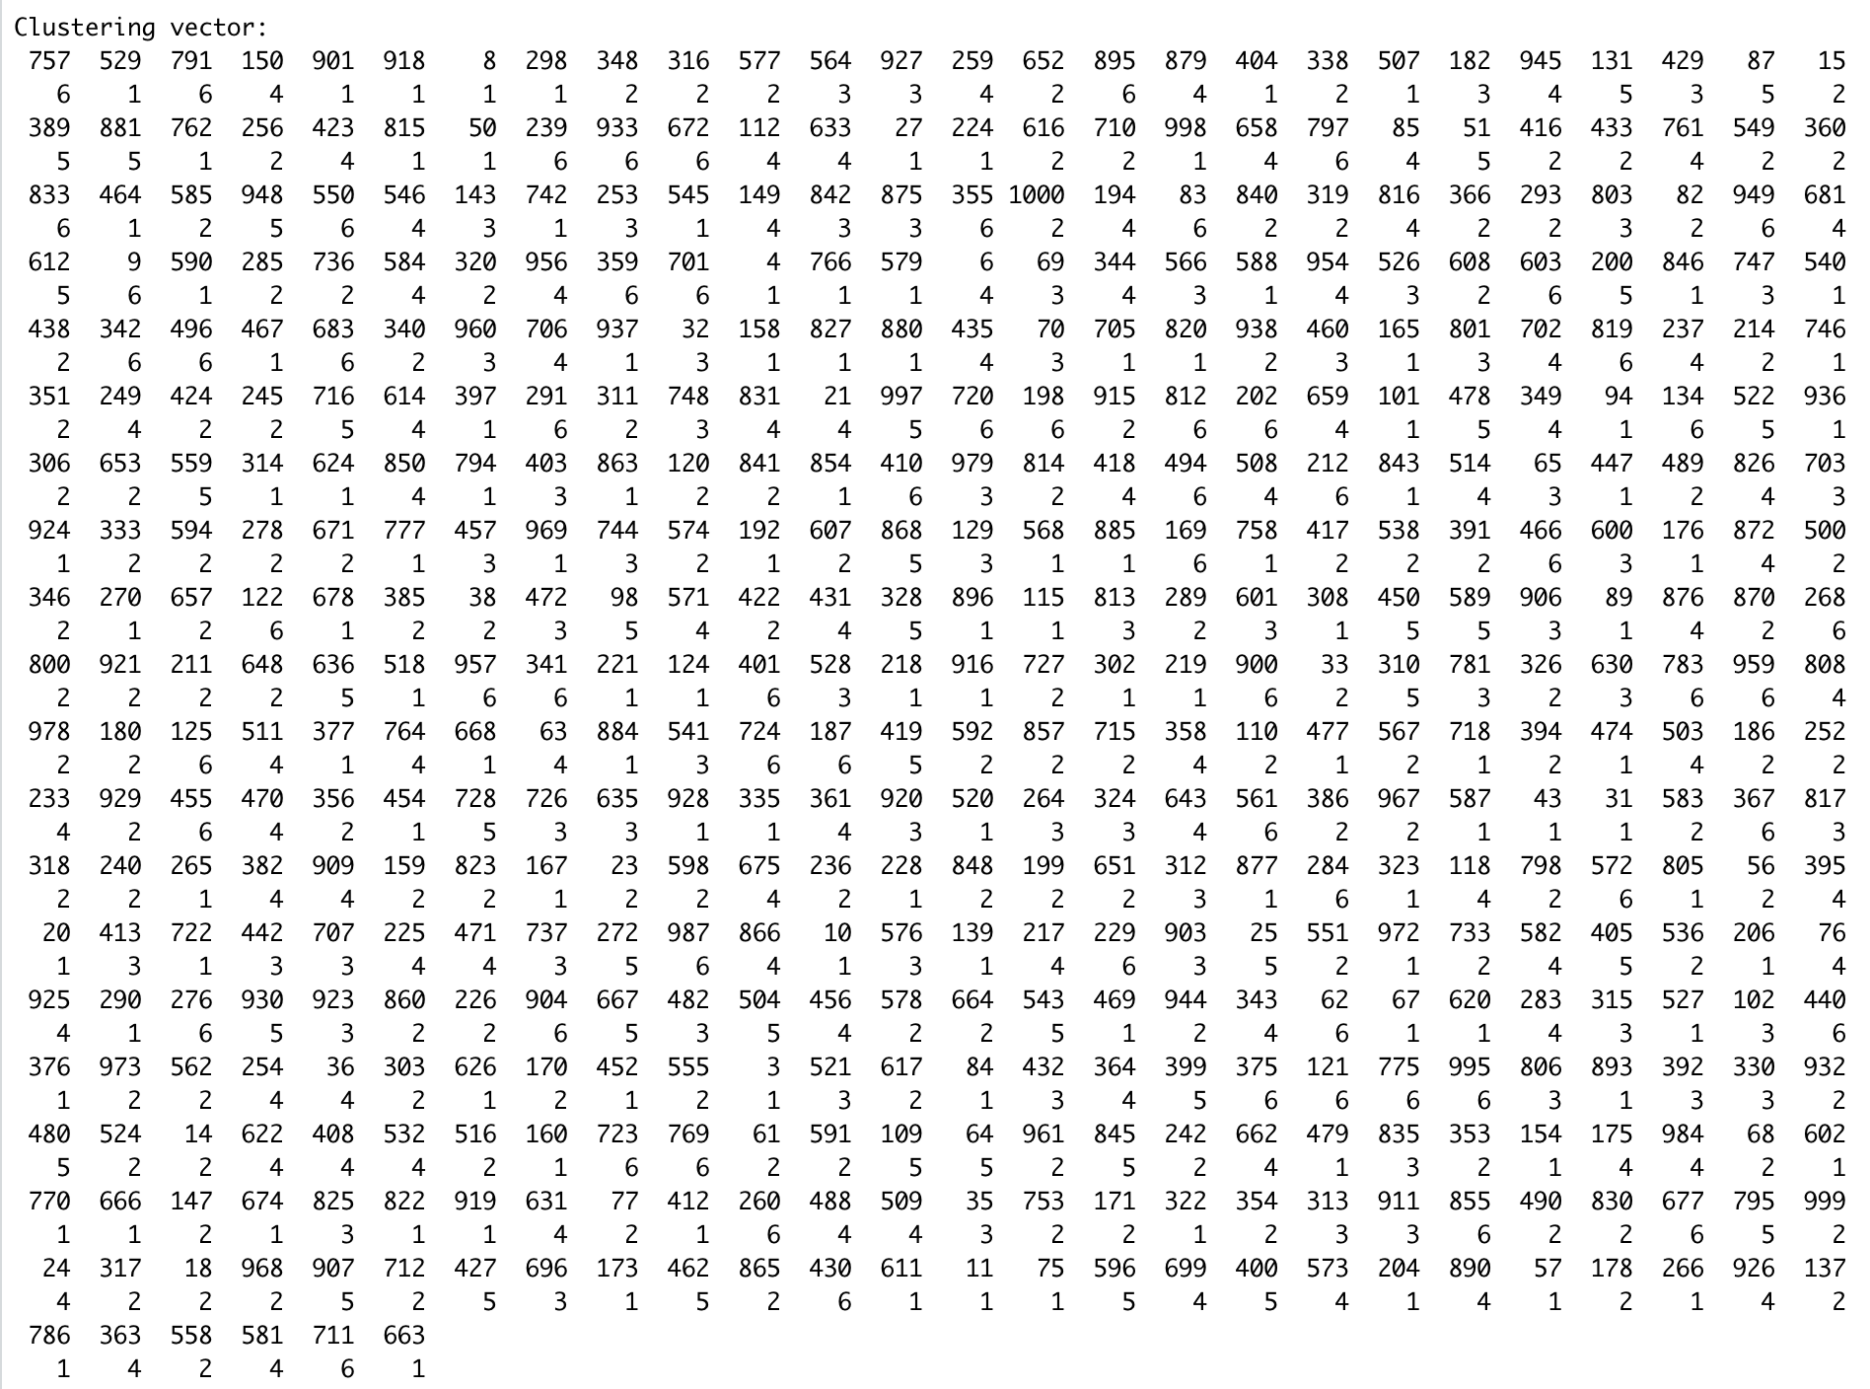

Test:

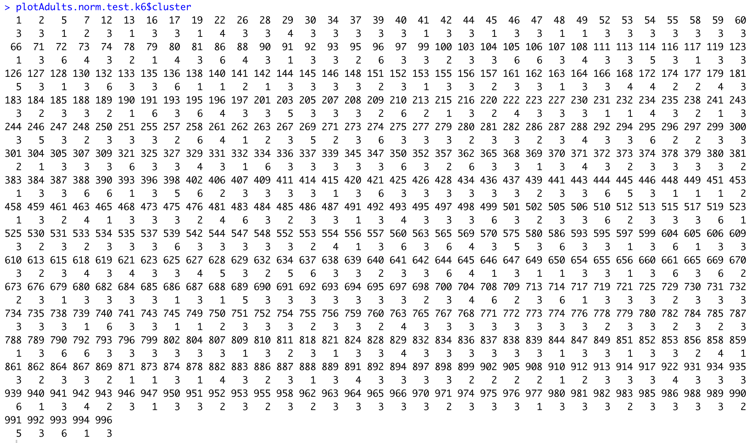

k=7

Train:

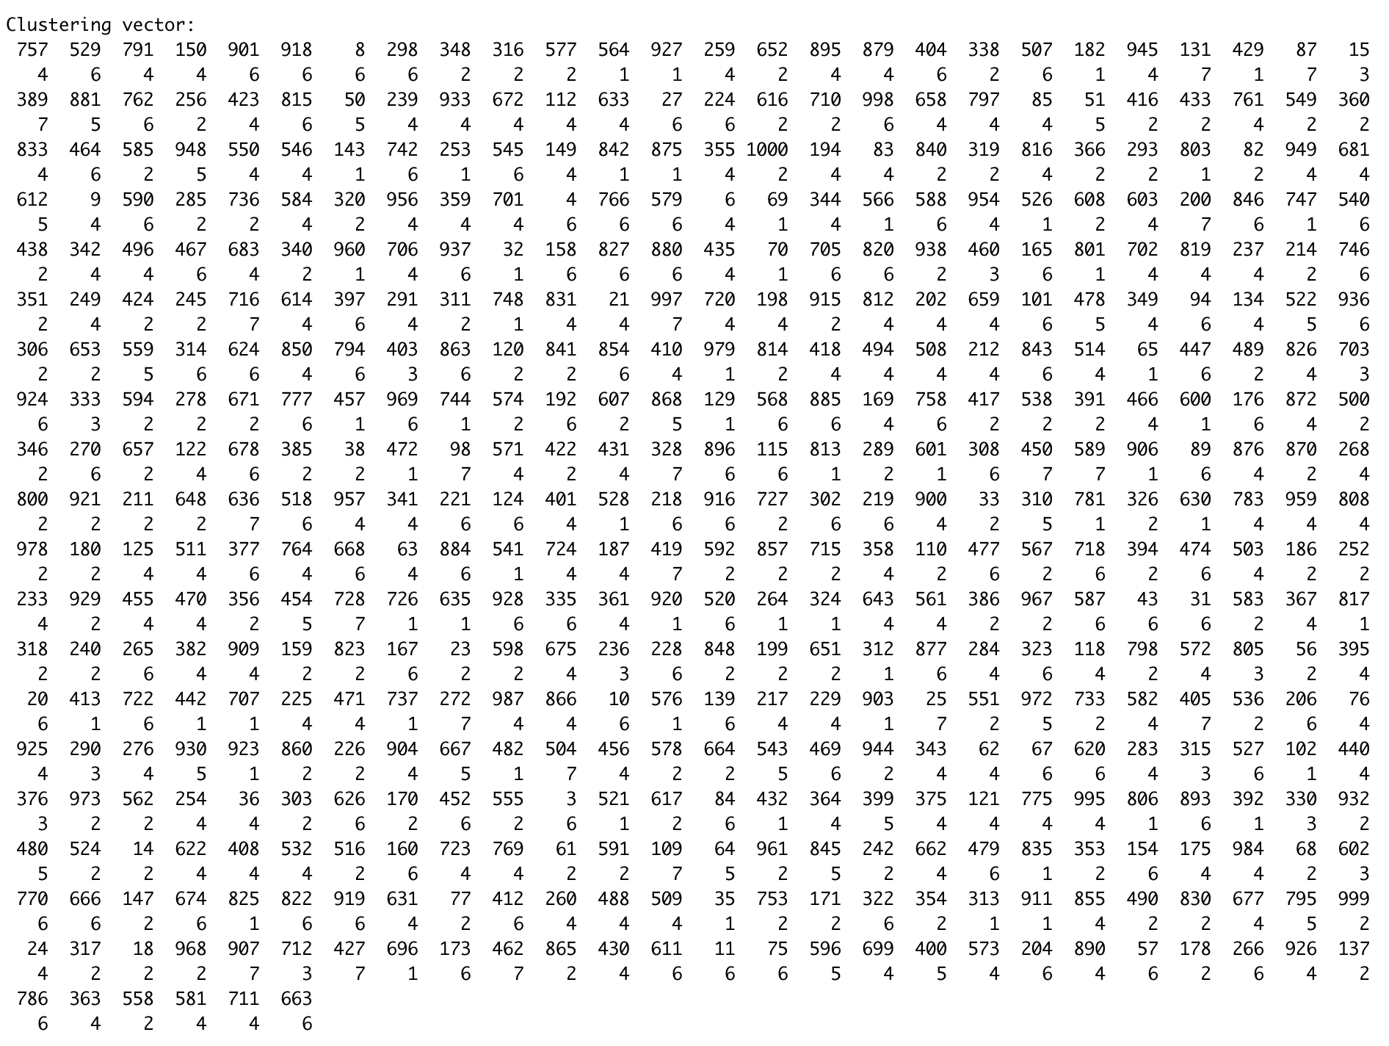

Test:

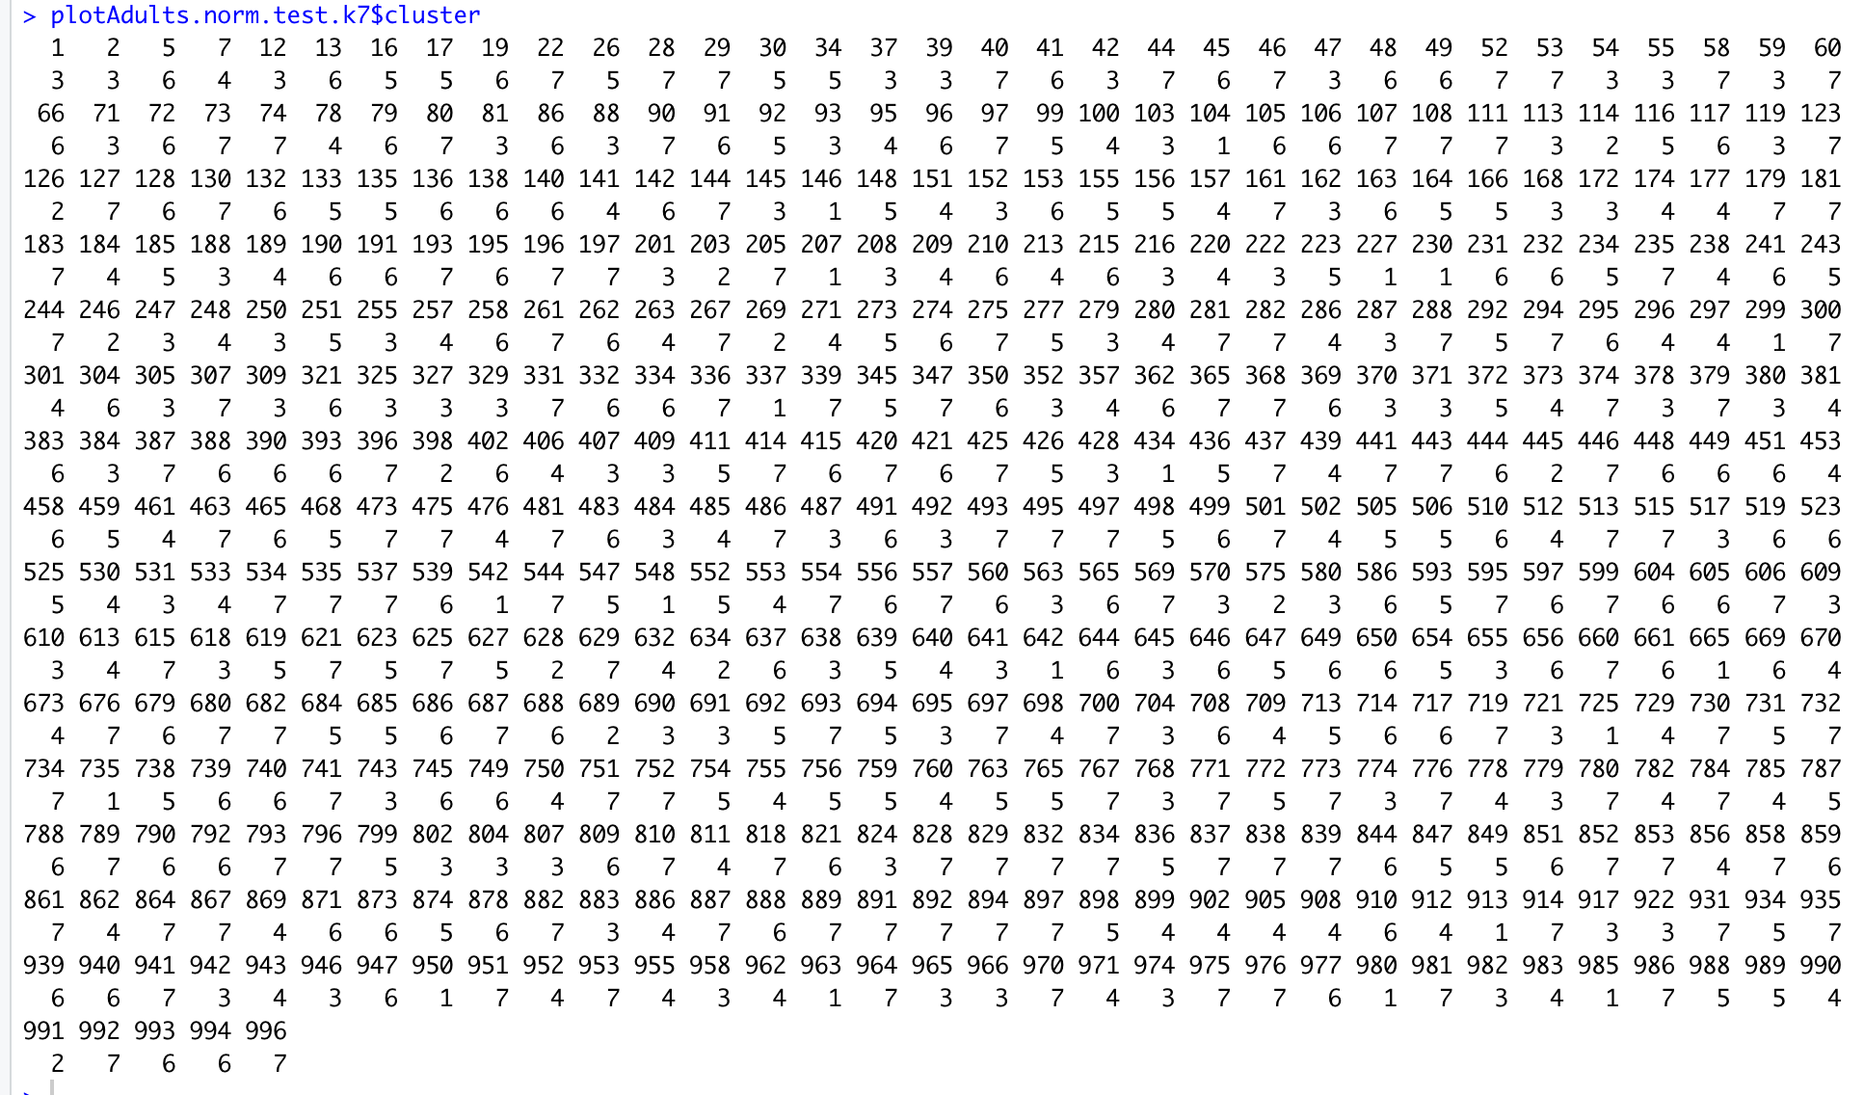

k=8

Test:

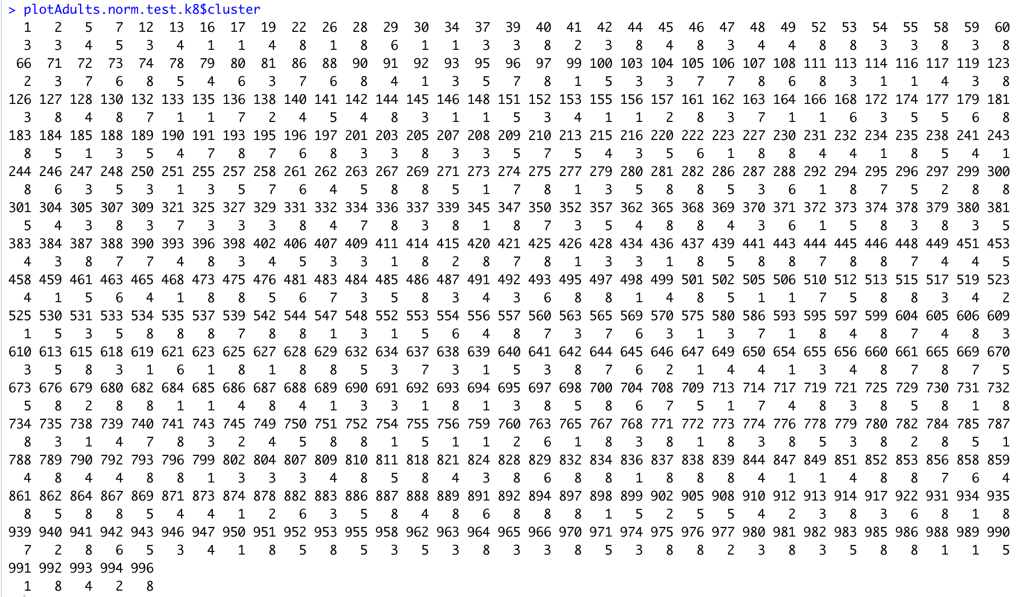

Train:

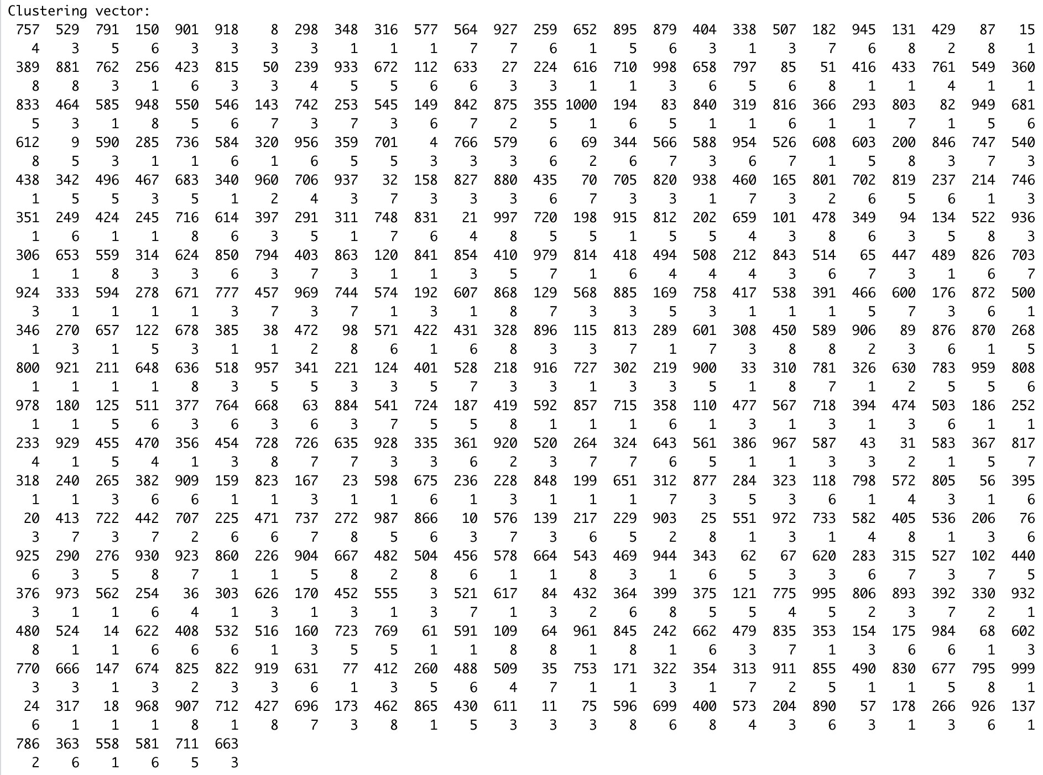

k=9

Train:

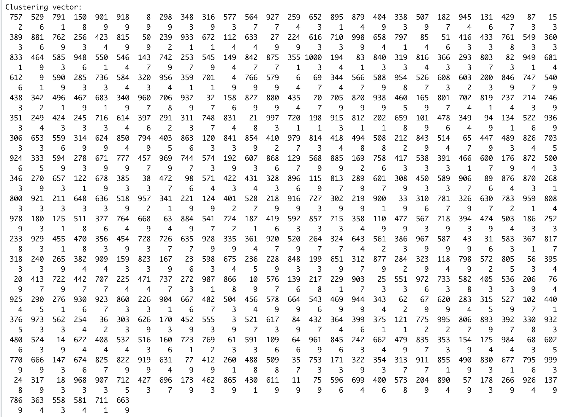

Test:

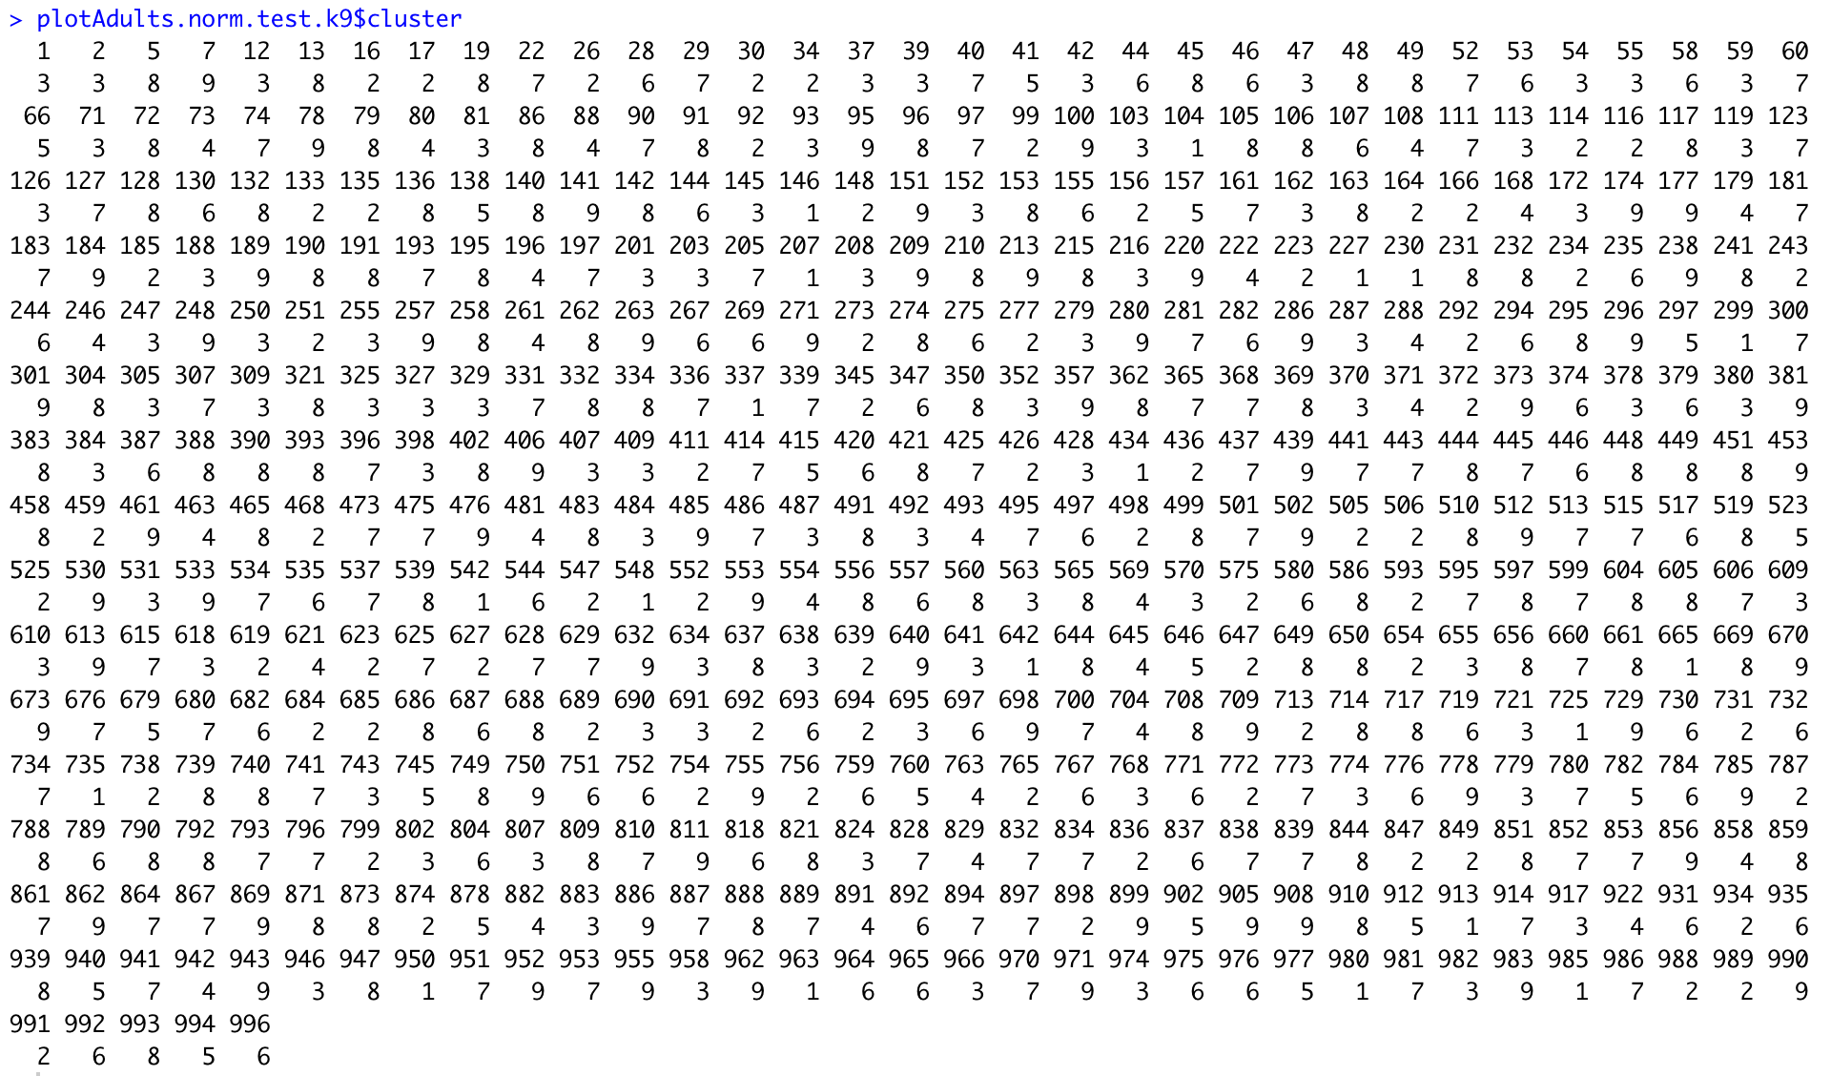

k=10

Train:

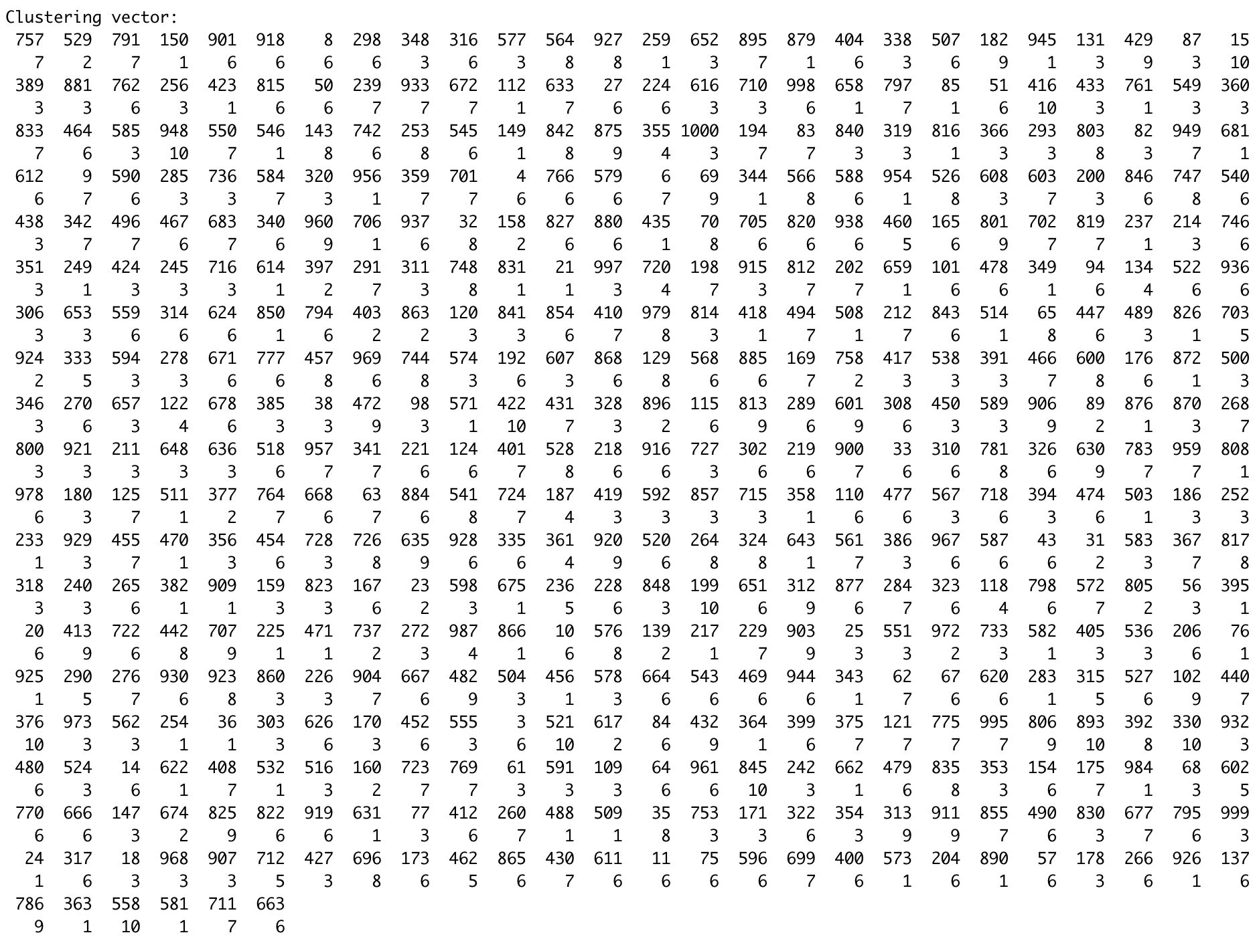

Test:

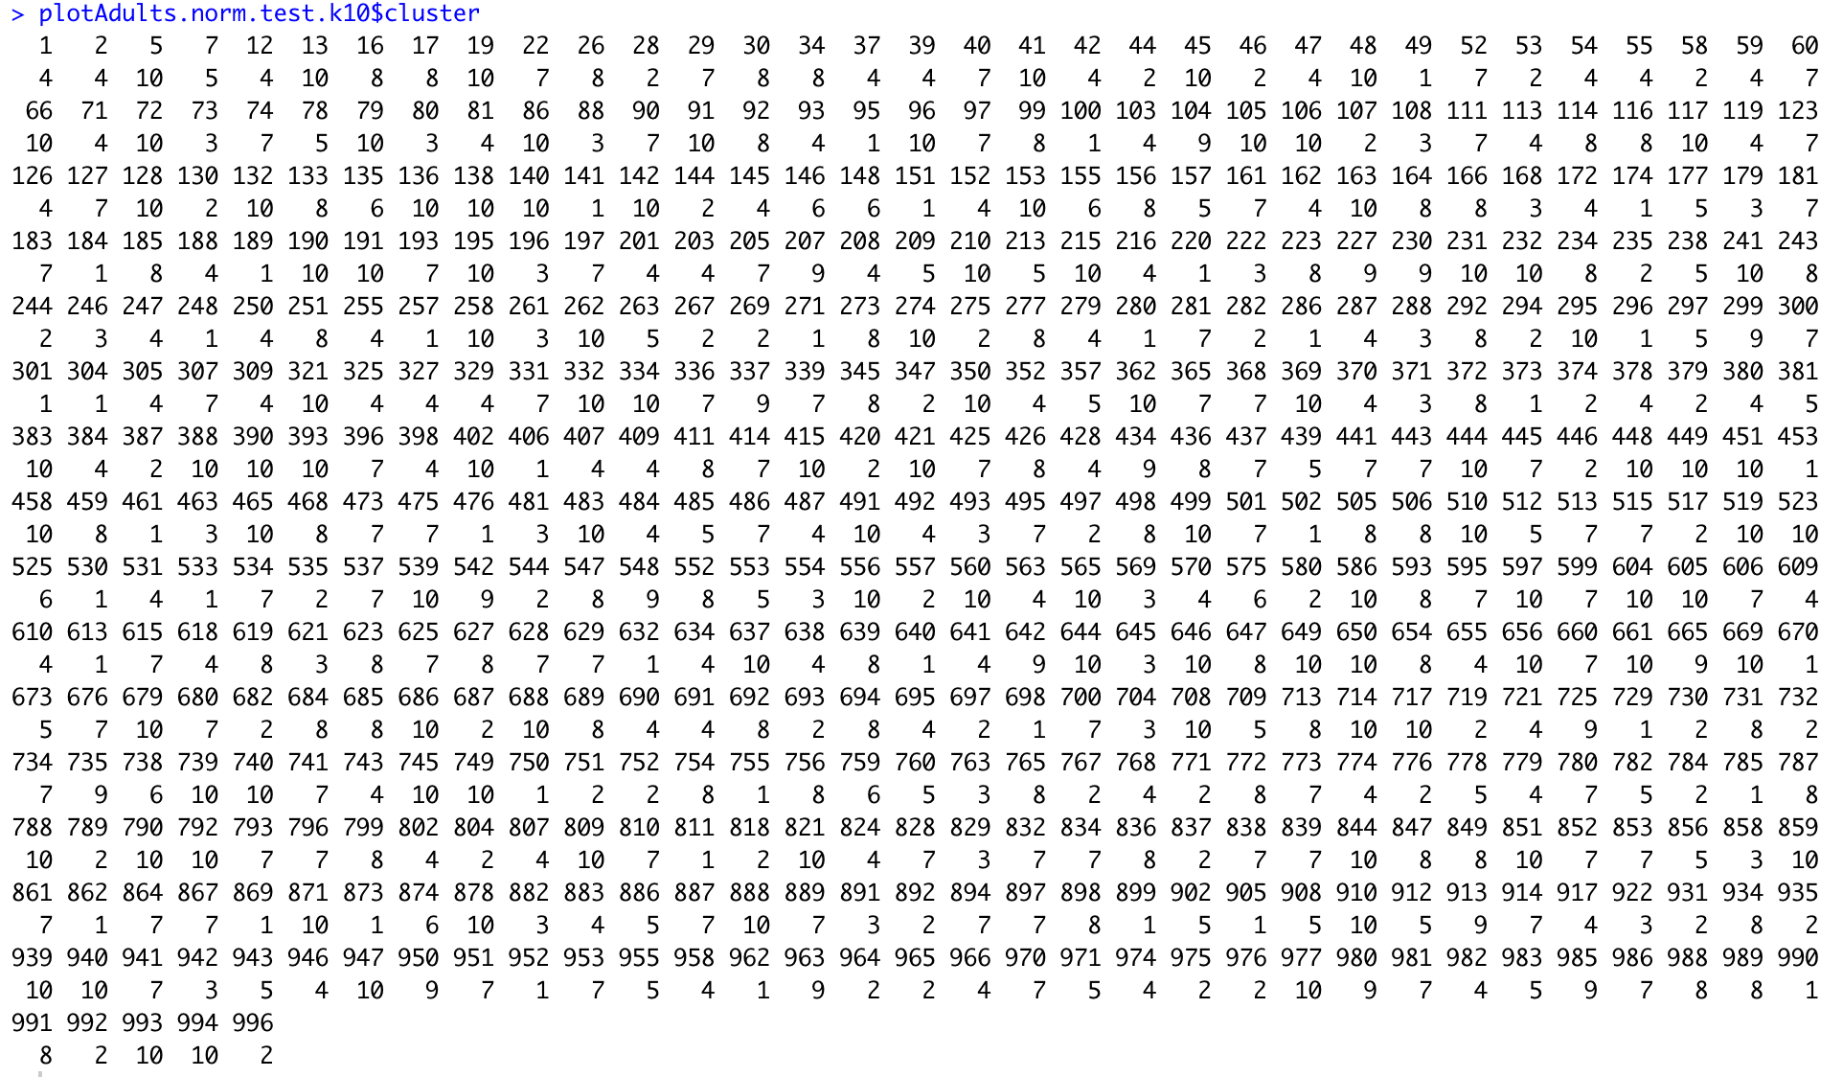

iClust:

We also ran the iClust function on k values from 2 to 10.

k=2:

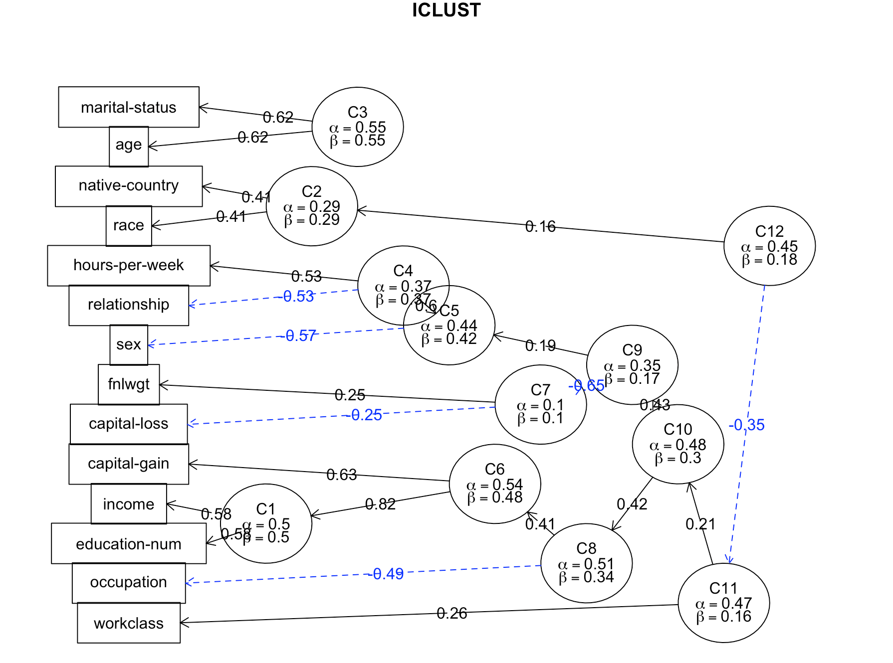

k=3:

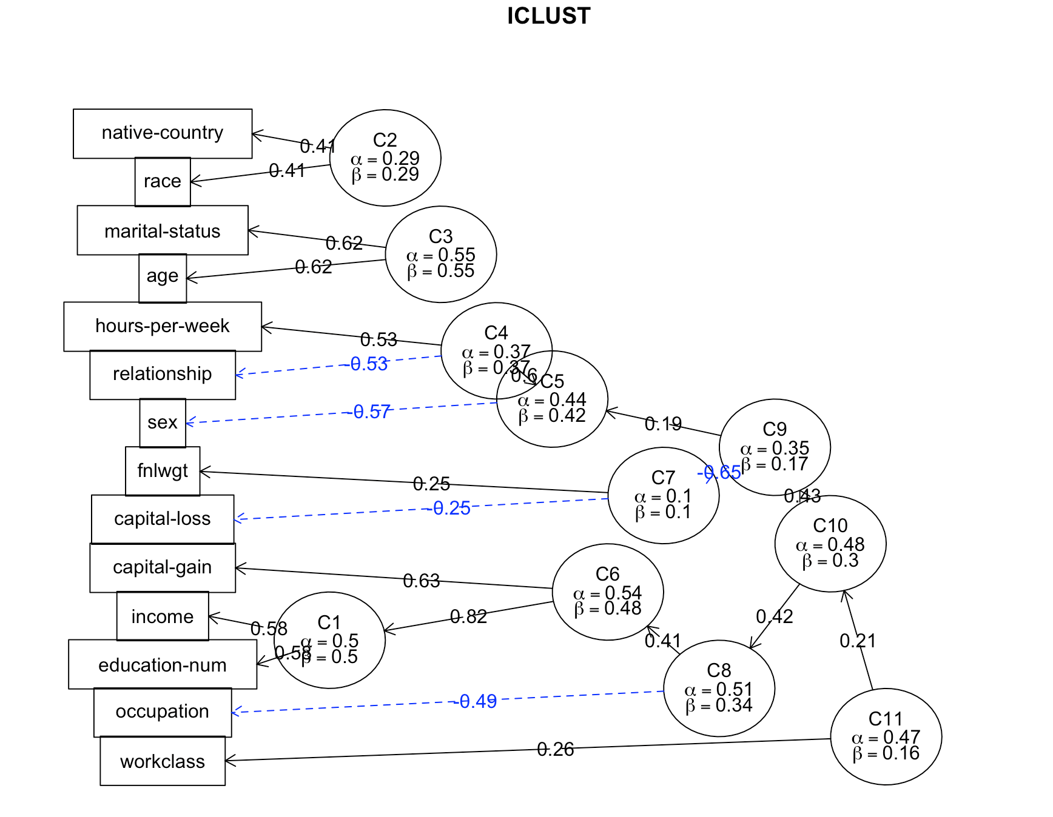

k=4:

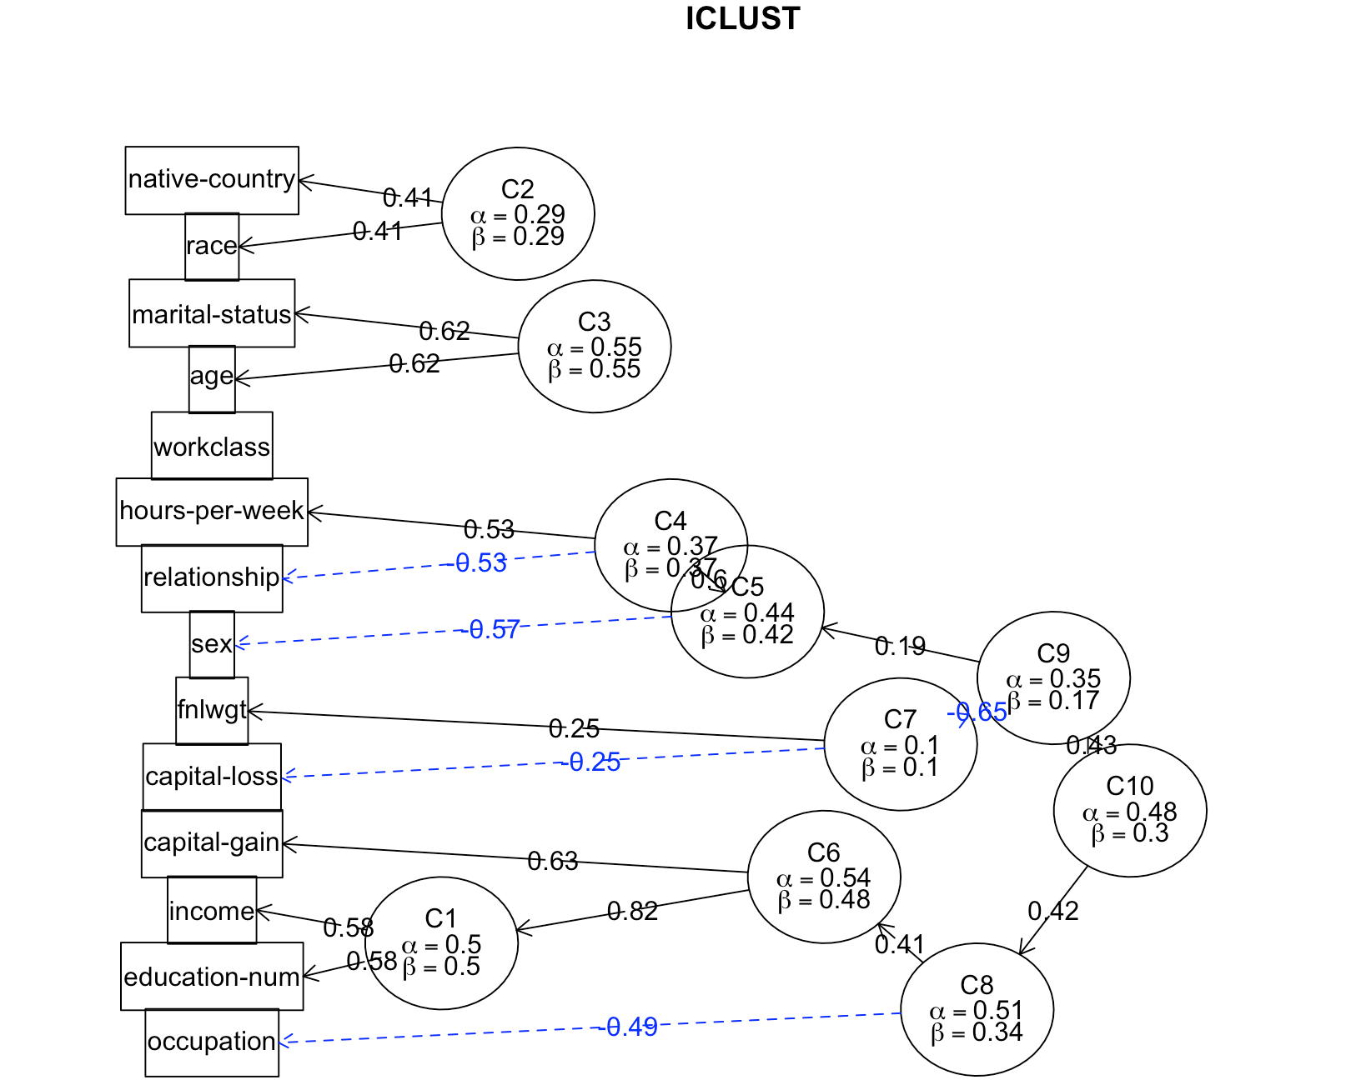

k=5:

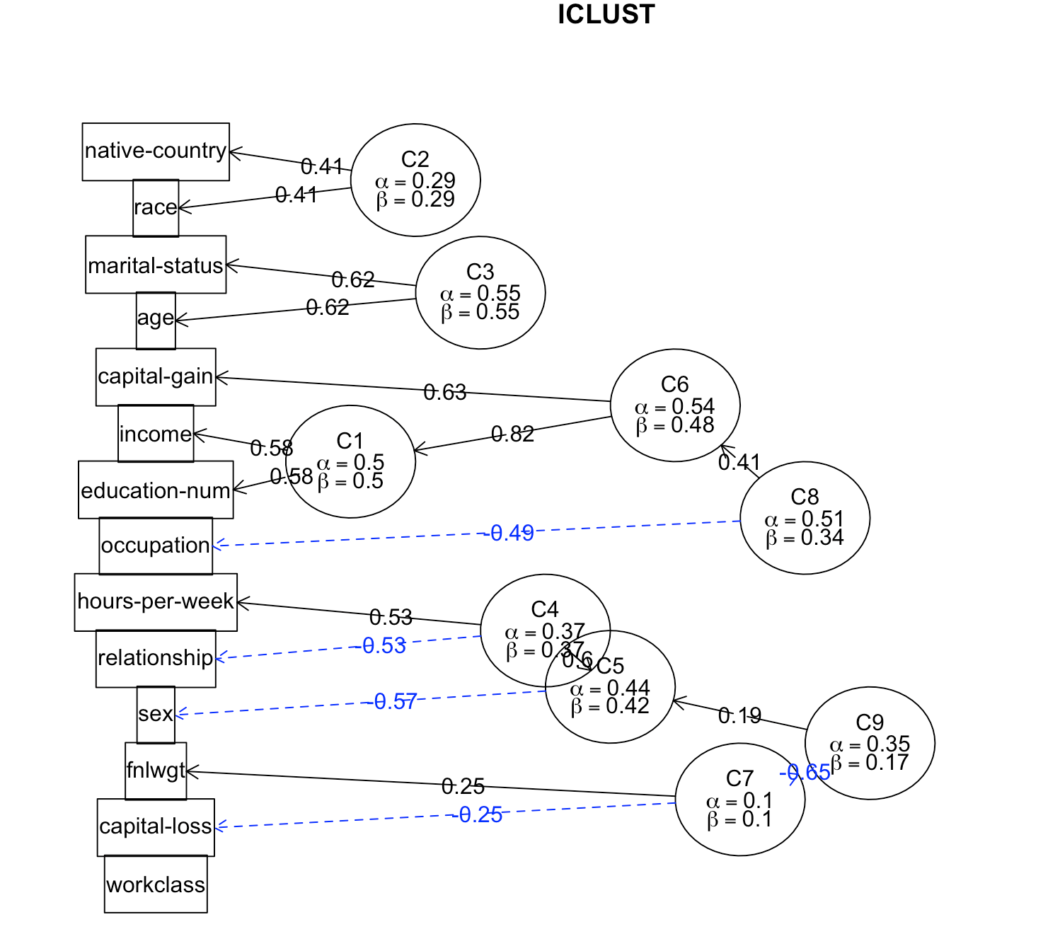

k=6: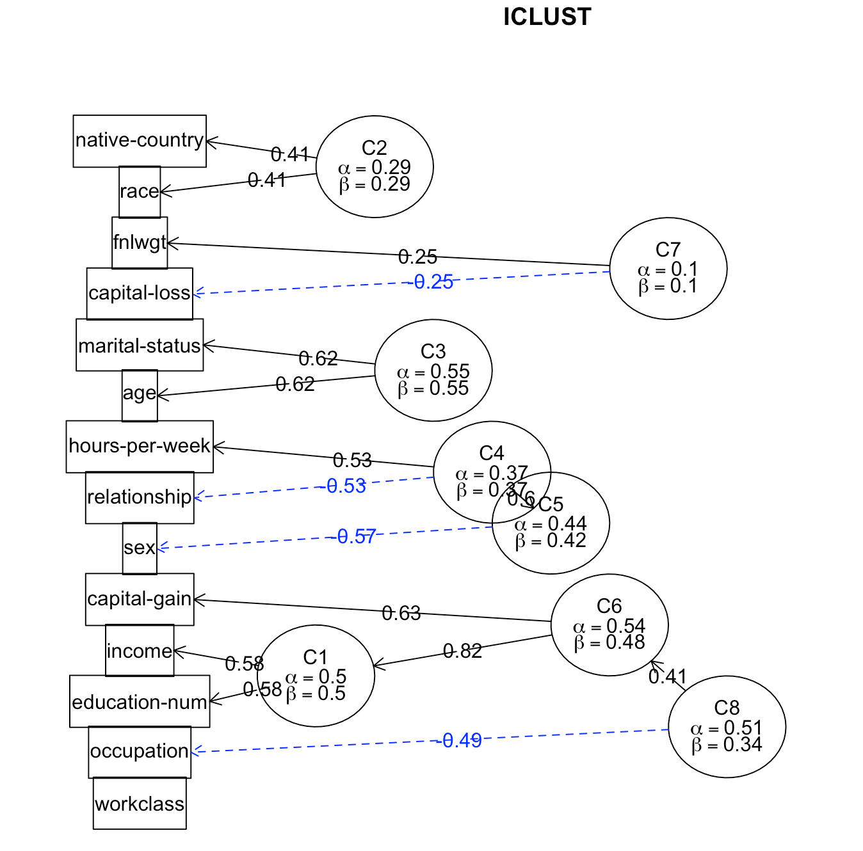

k=7:

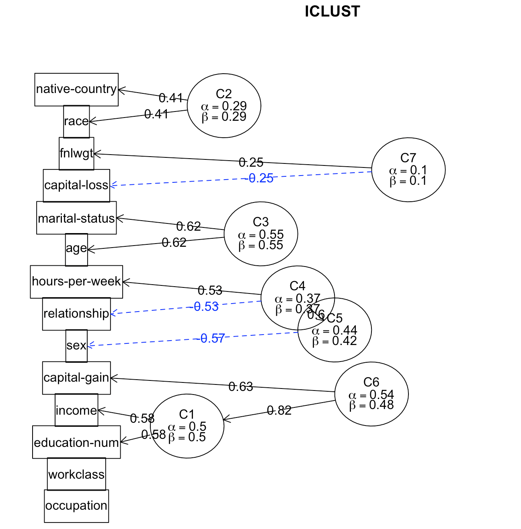

k=8:

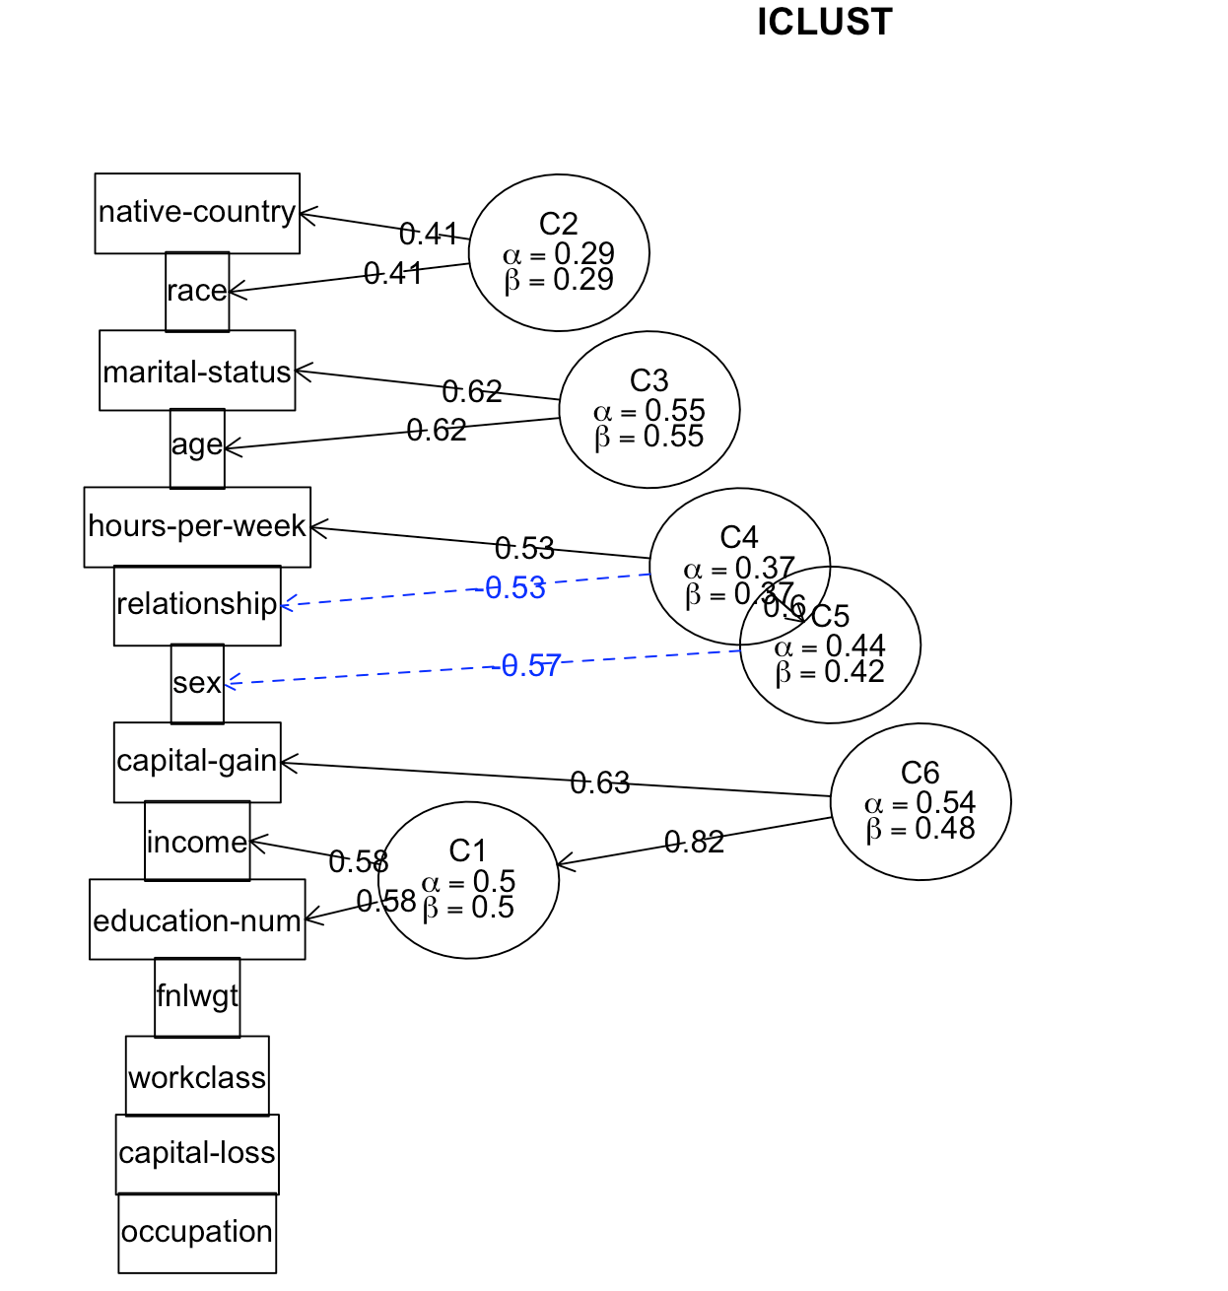

k=9:

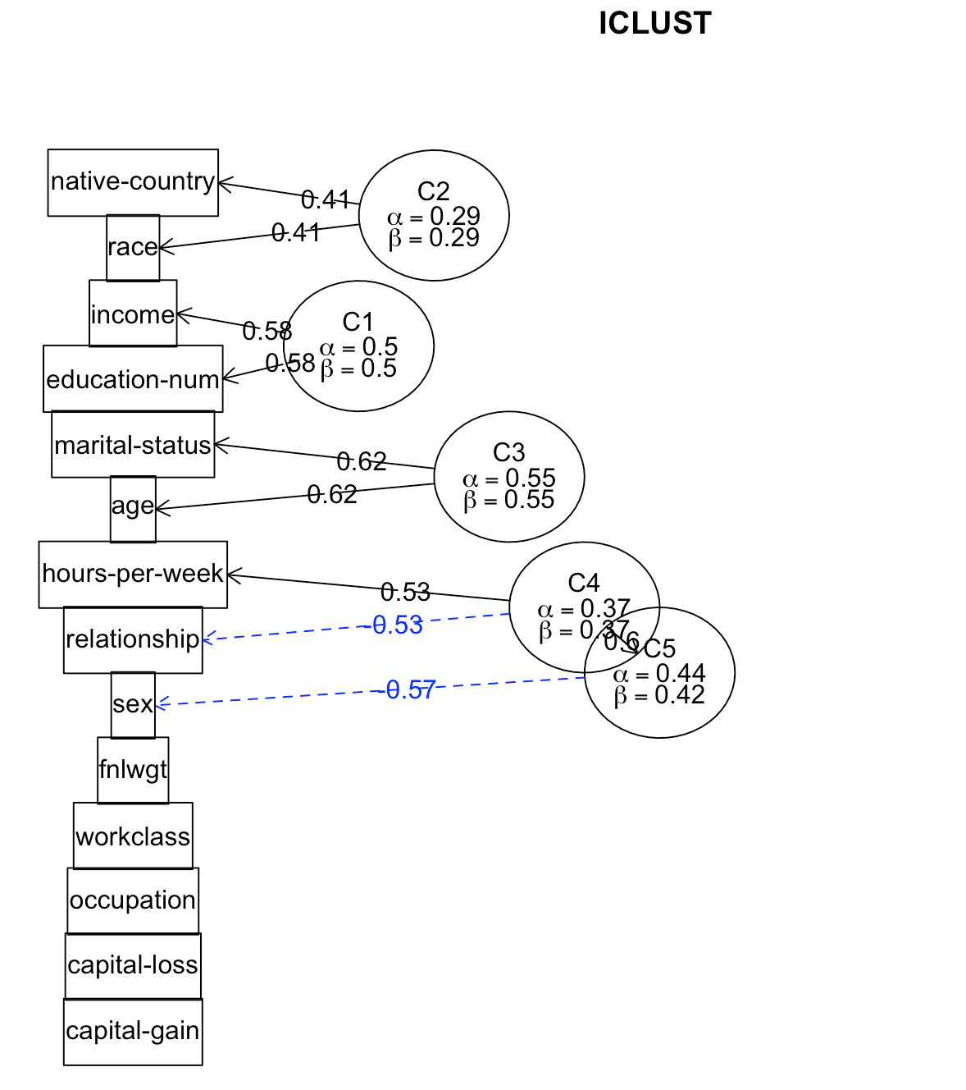

k=10:

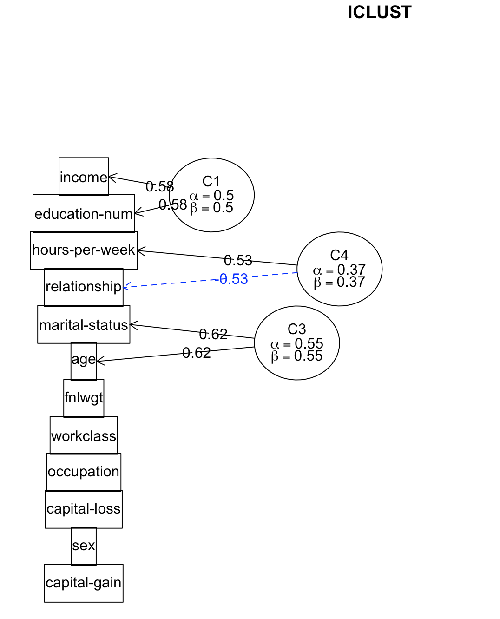

We also used factoextra::fviz_nbclust(plotAdults, FUNcluster=kmeans,print.summary=TRUE) to figure out the optimal number of clusters to use. We found that k=2 was optimal for this data set.

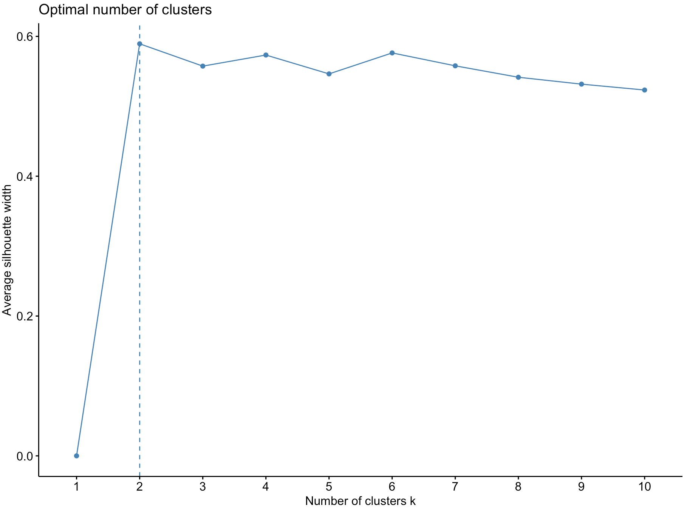

**Question 4:**

For the lm(), glm(), and predict() functions, we performed those functions on each of the training ratios in knn, 70-30, 60-40, 50-50. In addition, we evaluated 3 combinations of attributes: “Age ~ race + sex + capital.gain”, “Education ~ workclass + race”, “Education ~ capitalgain + race”.

*70 - 30:*

Age ~ race + sex + capital.gain - lm()

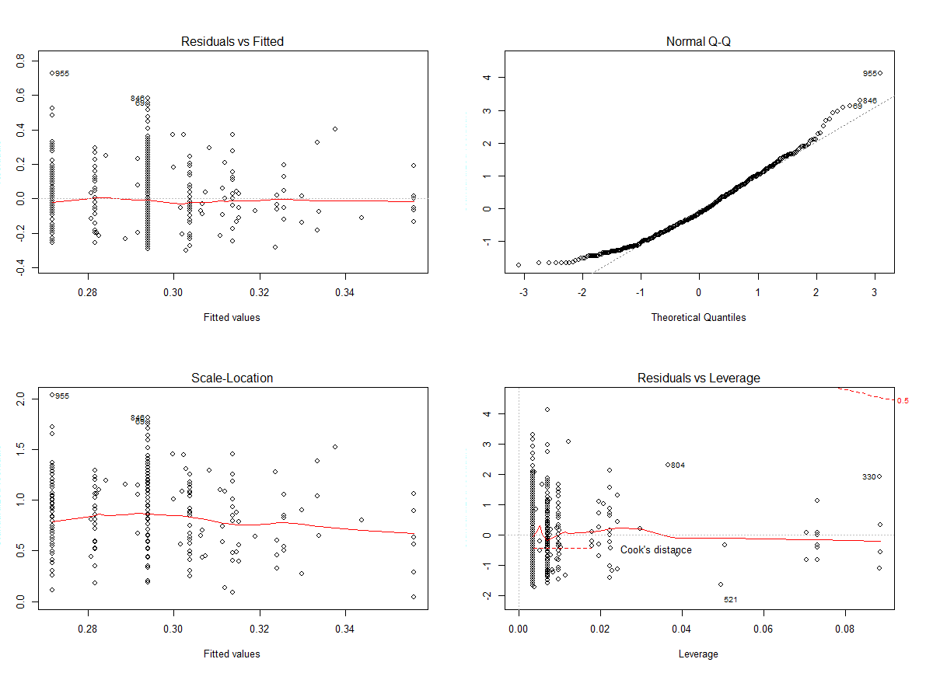

Education ~ workclass + race - lm()

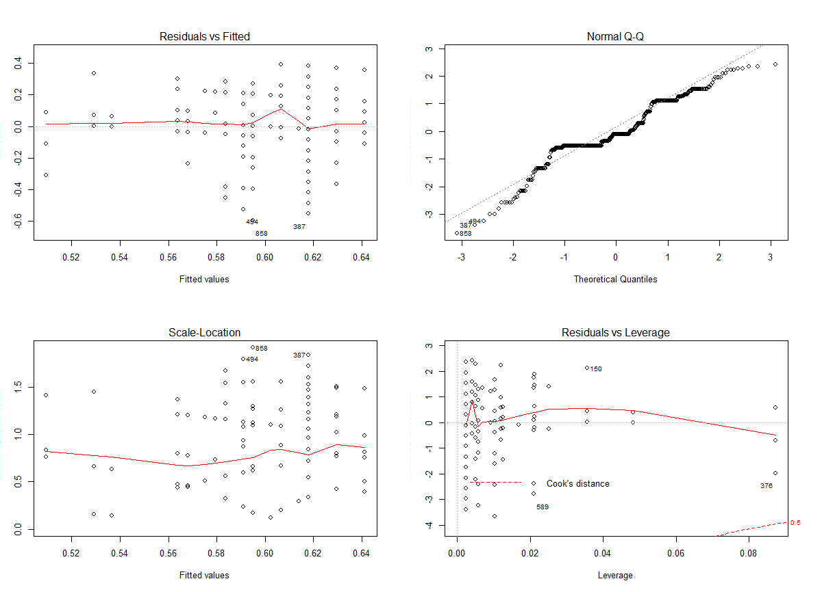

Education ~ capital gain + race - lm()

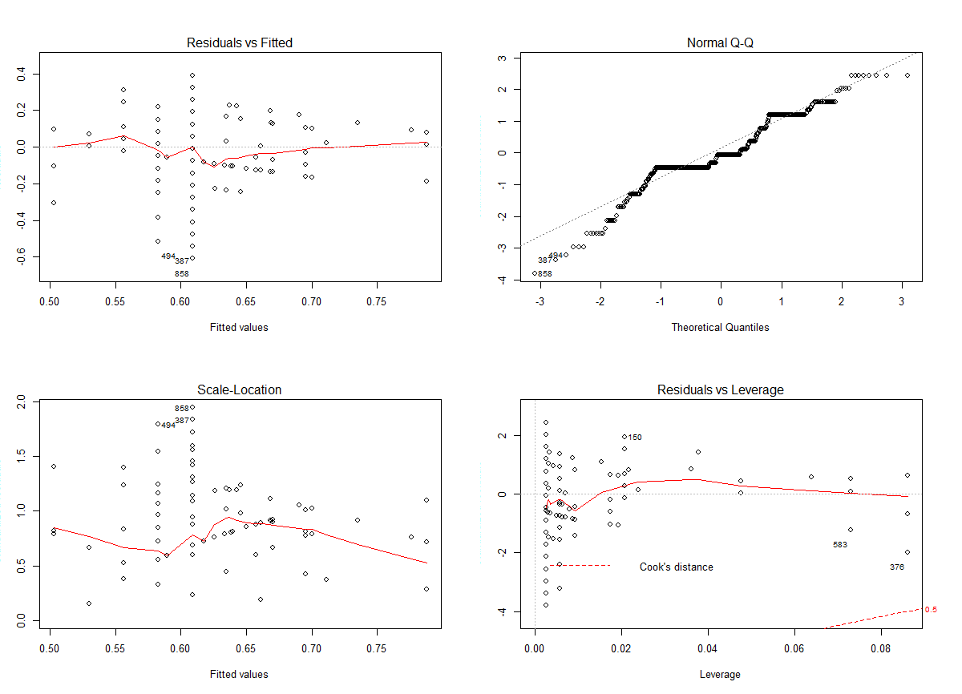

*60 - 40:*

Age ~ race + sex + capital.gain - lm()



Education ~ workclass + race - lm()



Education ~ capital gain + race - lm()

*50 - 50:*

Age ~ race + sex + capital.gain - lm()



Education ~ workclass + race - lm()



Education ~ capital gain + race - lm()



Across each ratio, it seems that these combinations are not linear and don't follow a path evenly, however, that does not mean that we cannot figure out a correlation. There may be a correlation between the above variables but the data set that we analyzed did not seem to show one. Had we had time (the professor told us to leave this out for time), we were going to run kmeans on the test set when k=2 (the optimal number of clusters) to see the different values of the test set in clusters.